**Use of freestyle libre continuous glucose monitoring in a post-bariatric surgery patient with recurrent hypoglycaemia**

**Background & Aim**

Hypoglycaemia following bariatric surgery, particularly due to late dumping syndrome, is an under-recognised but serious complication that can significantly affect patient safety and quality of life. This case study explores the role of CGM in diagnosing and managing postprandial and nocturnal hypoglycaemia in a post -sleeve gastrectomy patient with a history of gestational diabetes and pre diabetes.

**Methods**

A 35 years old woman presented with recurrent symptomatic and asymptomatic hypoglycaemia three months after sleeve gastrectomy including one episode of unconscious collapse. CGM was initiated to identify glycaemic trends and guide management. Dietary education aligned with international post-bariatric guidelines was provided, and acarbose was introduced. LibreView was used for remote monitoring by both health care team and patient’s husband, who also received education on emergency hypoglycaemia management.

**Results**

Initial CGM data showed 9% time in low range and frequent postprandial and nocturnal hypoglycaemia, with glucose levels as low as 2.9 mmol/L (Figure 1 and 2). Following dietary changes, alarm threshold adjustment and acarbose initiation, CGM data demonstrated a significant reduction in hypoglycaemia events and improved time in range (Figure 3). Patient reported with improved sleep hygiene, less fear of hypoglycaemia and was able to return back to work and normal social activities.

**Discussion/Conclusion**

This case highlights the diagnostic and therapeutic value of CGM in complex post bariatric patients. Real time CGM enabled targeted intervention, including small regular low GI diet adjustment and pharmacotherapy. Involving caregivers via LibreView and providing structured education further enhanced safety and patient confidence. This case supports CGM as a valuable tool in managing post bariatric hypoglycaemia and demonstrates the importance of multidisciplinary care in achieving sustainable outcomes.

**Figure 1**

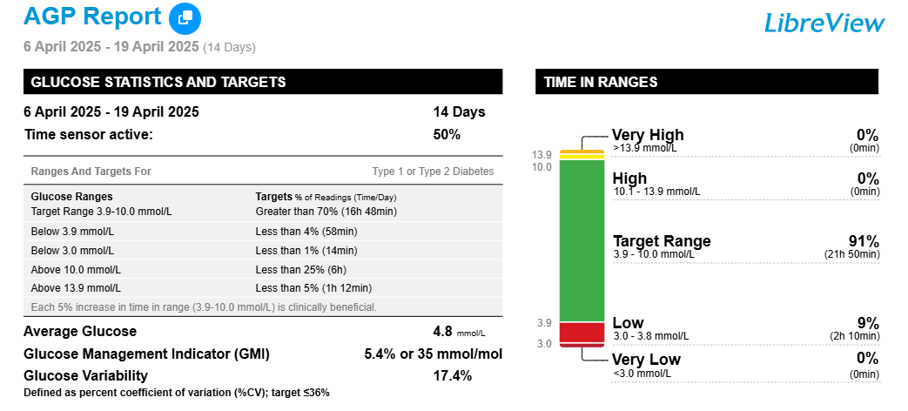

**Figure 2**

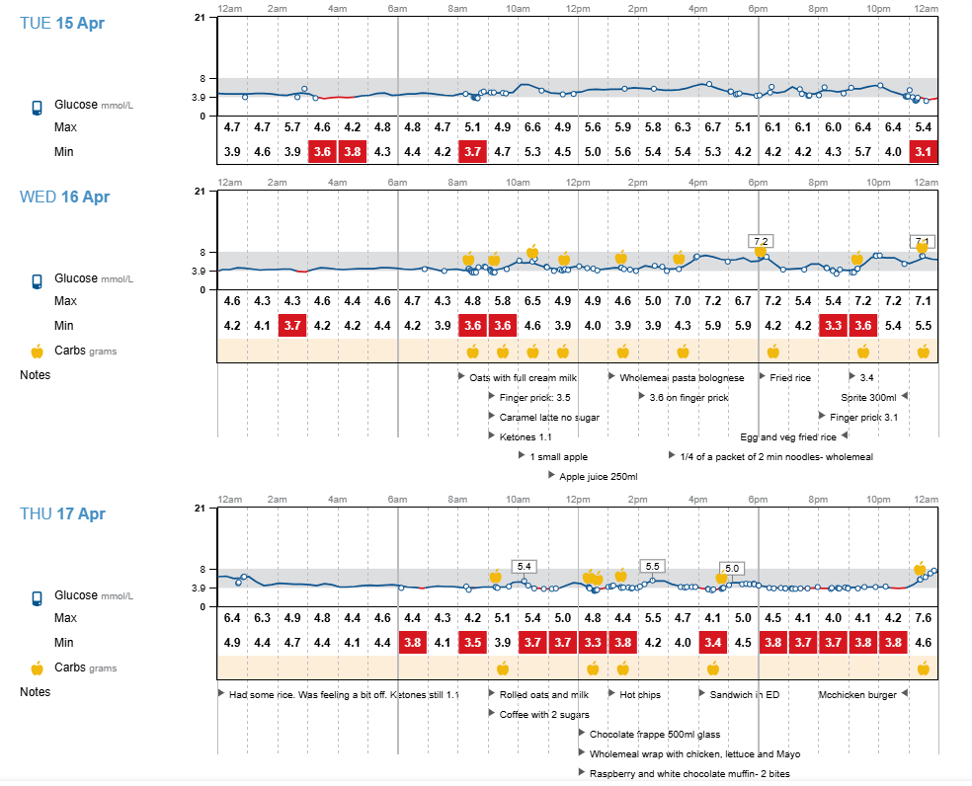

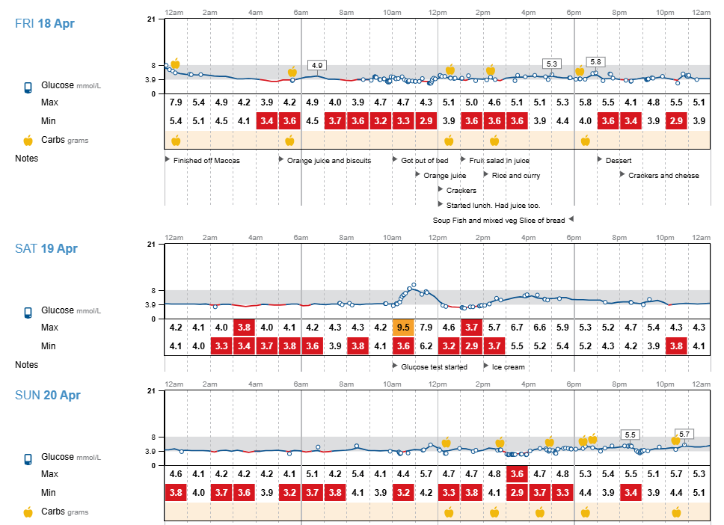

**Figure 3**

**Figure 3**

