Disseminated Nocardiosis with Pericardial Involvement in an Immunocompetent Patient

Background: Nocardia is an opportunistic pathogen that typically infects immunocompromised individuals. Disseminated nocardiosis can occur in very immunocompromised patients and can cause lung and brain abscesses with high mortality rates. Cardiac and pericardial involvement is exceedingly rare with few cases in the literature. We present an unusual case of disseminated nocardiosis occurring in an immunocompetent patient complicated by pericardial constriction and abscesses.

Case: A 65-year-old immunocompetent female presented with dyspnoea and lower limb swelling with elevated inflammatory markers. Transthoracic echocardiogram demonstrated abnormal septal wall motion, restrictive filling, and pericardial effusion with a mobile apical mass and thickened pericardium, consistent with constrictive pericarditis (Figure 1). CT chest demonstrated mediastinal abscesses and heterogeneous pericardial material consistent with collections (Figure 1). Microbiological studies remained negative. Due to development of intracranial abscesses, the patient underwent definitive management with pericardial/mediastinal abscess drainage and pericardiectomy via midline sternotomy. Nocardia exalbida was isolated in the pericardial fluid. She was commenced on complex antimicrobial therapy including imipenem/ceftriaxone/linezolid for 1 month, then Cotrimoxazole/doxycycline for 2 months, then consolidative Cotrimoxazole for 12 months. She made a full recovery with resolution of the intracranial abscesses and no recurrence.

Discussion: This is the first reported case of disseminated nocardiosis complicated by pericardial abscesses and constriction in a healthy individual. The mechanism of infection remains unclear without evidence of underlying immunodeficiency. There are limited evidence-based guidelines to direct antimicrobial therapy. This case illustrates the importance of multimodal cardiac investigations and imaging in directing management and provides insights into treatment of this rare micro-organism.

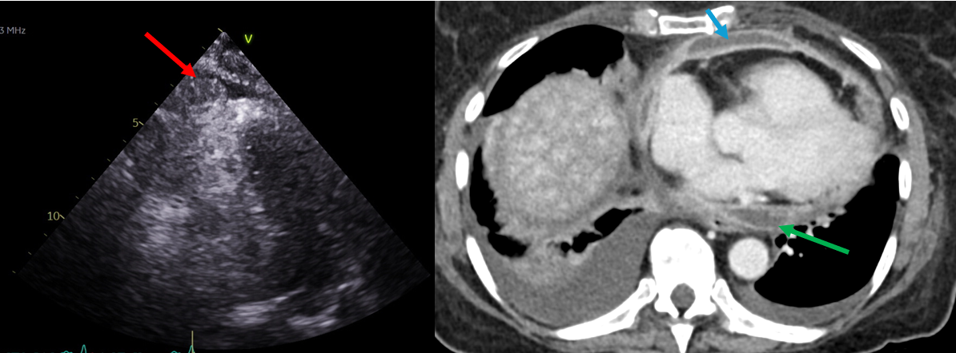
Figure 1: Transthoracic echocardiogram modified four-chamber view (left panel) demonstrating a mobile echogenic pericardial mass in the apex (red arrow) likely infective; CT axial slice demonstrating pericardial collections anteriorly (blue arrow) and posteriorly (green arrow)

