Panel
Kai Anamata mō Aotearoa – exploring future food system scenarios and impacts in Aotearoa

The food system in Aotearoa faces many challenges. Domestically, issues of food security persist, with vulnerable populations often facing barriers to accessing nutritious and affordable food. Concurrently, the export-oriented and commodity-driven nature of our food and fibre sector leaves it susceptible to global market fluctuations, while the environmental impact of intensive farming practices and greenhouse gas emissions pose significant sustainability concerns. A 5-year MBIE research programme, entitled “Kai anamata mō Aotearoa – exploring future food system scenarios and impacts” (KAMA), which started in October 2023, is tackling these challenges.

In this panel session, we will showcase the multiple workstreams of the programme, covering future food system modelling, a regional food system strategy, and novel data collection to support the role of indigenous crops in strengthened future food systems. Speakers representing Māori agribusiness, a national Centre of Research Excellence, universities and Crown Research Organisations will show how Western Science and Mātauranga Māori can come together to drive resilience and adaptation of the food system for a region and Aotearoa.

The Riddet Institute co-lead the KAMA programme with Wakatū Incorporation (Wakatū), in collaboration with Lincoln University, University of Canterbury, Manaaki Whenua Landcare Research, Massey University, and AgResearch. Wakatū is a hapū-owned organisation based in Te Tauihu, representing more than 4,000 owners (Te Ātiawa, Ngāti Rārua, Ngāti Tama, Ngāti Koata) and their whānau. Its 500-year intergenerational vision (Te Pae Tawhiti) focuses on reconnecting whānau to whenua and protecting and enhancing taonga for the benefit of current and future generations. This programme aligns key elements of their intergenerational vision including whenua ora (land and water wellbeing), tangata ora (human wellbeing), and rawa ora (prosperity). The Riddet Institute, a national Centre of Research Excellence in food and nutrition, have extensive experience developing food systems models to understand what is possible, practical, and optimal from the future food system to ensure nutrition for all.

The programme addresses the challenges to the food system in Aotearoa through three interconnected work strands.

The first strand involves the development of a computational food system model that can simulate current and future food system dynamics at both a regional and national level. The intention of this model is to aid decision makers to plan for future adaptation to climate change, dynamic international markets, and changing populations.

The second strand involves a focus on practical Māori-led research designed to test the scalability of indigenous crop species in Te Tauihu. Traditional management practices and new knowledge are being woven together to drive tikanga led regenerative farming outcomes for the research māra, while collecting novel data on these crops to inform future modelling.

The third strand will bridge gaps in our current national and regional data collection efforts to ensure the model and programme capture the breadth of food system impacts on whenua ora and tangata ora.

An outcome of the programme will be the development of a tool able to simulate and analyse various scenarios, policies, and interventions aimed at reducing carbon emissions, increasing wellbeing, and promoting sustainability. Consideration is given to how best to monitor the performance of indigenous crops and species, environmental health and other indicators.

The entirety of the programme is supported by extensive engagement with national and regional food system stakeholders, with close involvement of tangata whenua across Te Tauihu and beyond. A series of wānanga in the region, supported by the novel data collection and mathematical modelling, is shaping a new food systems strategy for Te Tauihu, emphasising tūpuna pono (being good ancestors).

The programme and our wānanga series come at a time when food is at the forefront of national discourse, with food prices, the impact of farming on the environment, and recent unprecedented climatic and supply chain events widely discussed in popular media. Three interrelated strands of work are illustrated in the figure below.
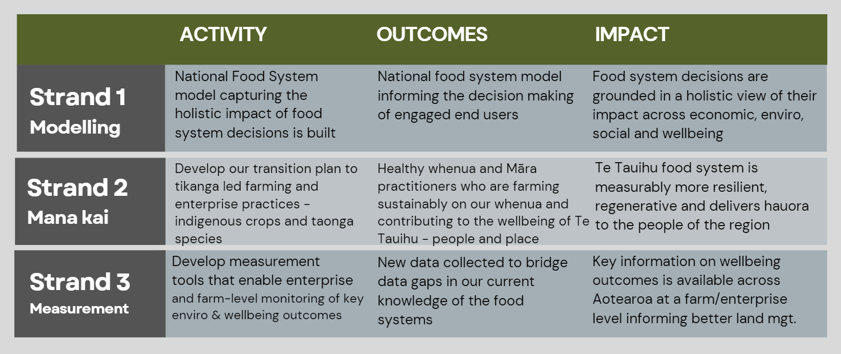
A series of presentations will be given that align with these three strands of research which collectively will contribute to Accelerating Adaptation Action and show close alignment to the conference themes of Indigenous Innovation and Leadership, Food, Water and Land Security, and Health, Wellbeing, and Future Generations.

INDIVIDUAL PANELLIST CONTRIBUTION

Moderator Details
Full Name: Miriana Stephens
Organisation: Wakatū Incorporation
Bio sketch:
Miriana belongs to the tribal groups of Ngāti Rārua, Ngāi Te Rangi, Ngāti Ranginui. She is a director for Wakatū Incorporation who are guided by their 500-year vision, Te Pae Tawhiti. Miriana co-leads KAMA, a five-year programme advancing research on tikanga led farming practices and indigenous / taonga species providing a future platform for sustainability and resilience in food production.

Panellist 1
Full Name: Nick Roskruge
Organisation: Wakatū Incorporation
Bio: Nick belongs to the tribal groups of Te Ātiawa, Ngāti Tama-ariki, and Ngāti Porou. He is a retired Professor in Ethnobotany and Horticulture (Massey University) and is currently working with Wakatū researchers/practitioners as part of the Kai Anamata mō Aotearoa research programme. He is well-known for a wide range of Māori and Pacific horticultural projects and has played a key role in establishing māra in Motueka.

Title of Presentation 1
Kai Anamata mō Motueka – a indigenous foods, tikanga led farming practices and a local food strategy.

Panellist 1 Contribution:
Introduction
External shocks to Aotearoa-New Zealand’s food system are increasing in frequency and severity and will escalate due to challenges like climate change, with impacts that are felt locally. As such, both local and national strategies are needed to direct adaptation.
Objectives
To explore how tikanga-led farming practices and indigenous foods can contribute to greater climate resilience, improved intergenerational wellbeing, and a healthy relationship with Papatūānuku.
Methodology
Our methods include case studies our māra (food garden) exploring tikanga-led land use opportunities with a focus on feeding whānau, and then the scalability of current, new, and indigenous species, implementing tikanga led farming practices. Monitoring crop performance and practices against our Hoea ki Te Pae Tawhiti, intergenerational wellbeing outcomes framework is part of the project. In addition, a series of wānanga are ongoing engaging regional stakeholders to shape a strategy document.
Findings
Wānanga to date and fieldwork results focusing on testing indigenous crops will be presented as the first stage in building the evidence base for a food system strategy for our region, Te Tauihu. Fieldwork was informed by wānanga investigations focusing on how to translate tikanga-led regenerative farming on whenua Māori into practice in a sustainable and scalable manner. Production of current, new, and indigenous foods, in line with Te Pae Tawhiti and our Te Tauihu regional strategy will provide knowledge-intensive employment, further connecting whānau to whenua.

Panellist 2
Full Name: Conal Smith
Organisation: Kōtātā Insight
Bio:
Conal is a Wellington-based economist with interests spanning the economics of well-being, social capital, and the behavioural drivers of economic outcomes. He led development of the first international guidelines on measuring subjective wellbeing at the OECD and has worked on policy applications of well-being measures in New Zealand and internationally.

Title of Presentation 2
Understanding the land: data needs, gaps, and priorities for understanding land use in Aotearoa

Panellist 2 Contribution:
Introduction
Making good decisions about land use means understanding the impact of land use change across the full range of outcomes that we care about, both for current and future generations.
Objectives
There are three main objectives for this work: (1) to document the range of data needed to assess the impact of land use decisions on environmental and human wellbeing; (2) to describe data gaps where needed information is not currently available; and (3) to identify priorities for initiatives to fill data gaps within the context of Kai Anamata mō Aoetearoa (KAMA).
.
Methodology
A framework for measuring intergenerational wellbeing is described drawing on the Te Tauihu Intergenerational Strategy, the Treasury’s Living Standards Framework, and the OECD’s How’s Life? The ability to measure each of the wellbeing outcomes identified in the framework is assessed in terms of whether robust measurement instruments are known, whether New Zealand data exists, whether data coverage across time and geography is sufficient, and whether the data is accessible. Drawing on the results from to KAMA stakeholder workshops and a wānanga held in Motueka as well as an assessment of the relative costs of different options priorities for collecting new data are described.
Findings
Significant gaps exist in Aotearoa’s ability to measure the outcomes of land use change. These gaps are particularly significant with respect to te taiao and some aspects of human wellbeing. However, scope exists to address some of these gaps through innovative use of existing official social and economic data and by farm and enterprise level data collection.

Panellist 3
Full Name: Nick Smith
Organisation:
Bio:
Dr Nick Smith’s expertise is in modelling of complex systems. He is a Senior Research Officer at the Riddet Institute’s Sustainable Nutrition Initiative®, providing evidence for the sustainable food system debate and ensuring that human nutrition is seen as a key aspect of sustainability.
Title of Presentation 3
Mathematical modelling of future national and regional food system scenarios

Panellist 3 Contribution: (Maximum 250 words, excluding references)
Introduction
Sustainability in Aotearoa New Zealand's food system is essential for environmental health (taiao ora) and human well-being (tangata ora). However, achieving resilience in our food system faces significant cross-sector challenges, requiring strategy that addresses environmental, economic, and social pressures¹.
Objectives
This work aimed to develop a computational model of Aotearoa New Zealand's food system with national and regional resolution, integrating key factors into a decision support tool. This will support food system resilience by offering an accessible platform to inform decisions to strengthen preparedness for shocks, while also providing insights to enhance everyday food security.
Methodology
The KAMA model leverages existing and newly collected data spanning agriculture, environment, and human wellbeing. It uses a flow-state modelling approach, which allows for flexible configuration of land uses and ensures that the model can adapt to future technologies and climate change scenarios. The model captures the resources required, outputs produced, and wellbeing outcomes of food system activities.
Findings
The first version of the model captures 11 major land uses, suitability of land to support these uses, and production inputs and outputs (including labour, financial, and environmental quantities) at a national and Te Tauihu level. Example scenarios of land use change demonstrate the trade-offs between these quantities which must be considered in resilience planning. The model will be made publicly accessible online to allow any interested individual to explore the future of the food system.

- Renwick A, Dynes R, Johnstone P, King W, Holt L & Penelope J (2019) Sustainability 11, 4912.

