Paper
A targeted approach for heat illness prevention: Mapping high-risk population at 1 km grid resolution and policy implications for adaptation in Japan

Introduction
Recently, heat illness mortality in Japan has often exceeded 1,000, sometimes 1,500 annually, surpassing those from natural disasters, which cause 100–200 deaths in most years¹. With the progression of climate change, heat illness risk may even rise, particularly among elderly people². Wet-bulb globe temperature (WBGT), a widely used index for heat illness control, is currently monitored and projected at about 840 points across the country^{3,4}. However, estimating the size of high-risk elderly populations nationwide and evaluating adaptation cost-effectiveness remain challenging.

Objectives
Based on the challenges mentioned in the Introduction, we aim to estimate the following under various climate scenarios using our novel hourly WBGT projection at 1 km grid resolution:
1. Size, distribution, and exposure duration of high-risk populations to WBGT ≥33°C
2. Adaptation cost-effectiveness including benefit-cost ratio (B/C)

Methodology
A machine-learning downscaling model was applied to climate data from NIES2020⁵ to project hourly WBGT for 2030–2059 and 2060–2089. The WBGT and population data⁶ (65+ years) were integrated to estimate the high-risk population exposed to WBGT ≥33°C.
As adaptation measures, we considered providing air conditioners (ACs) and electricity subsidies to high-risk households without ACs. Costs included installation (US$700/household, over 10 years) and annual subsidies (US$167/household). Benefits assumed a 25% reduction in deaths (US$1.33M/person⁸) and emergency transport cases (US$300/case⁹) for indoor heatstroke, considering that about 25% of heatstroke deaths in Tokyo occurred without AC⁷. This reduction was applied to the average indoor deaths¹⁰ (863/year, 2010–2022) and transport cases¹¹ (37,824/year, 2010–2024), as future heatstroke mortality projection is not yet available. A 4% discount rate (standard for Japan’s public works) was applied, with 2025 as the base year. A cooling shelter scenario, where high-risk populations are accommodated, was also considered.

Findings
1.The size of high-risk population ranged from 16.7–23.8 million (45.4%–63.8% of elderly) in 2030–2059, and from 10.1–30.7 million (33.9%–93.8%) in 2060–2089. The maximum exposure duration ranged from 40–90 hours/year in 2030–2059 and 40–300 hours/year in 2060–2089（Figure）. These results emphasize the need for long-term adaptation strategies, as the size of the population may fluctuate, while the exposure duration could increase significantly.

2. The costs ranged from US$2,488–3,544 million in 2030–2059 and US$451–1,541 million in 2060–2089, with B/C of 0.93–1.32 and 0.66–2.25, respectively. Accommodating high-risk population in cooling shelters reduced costs to US$2,276–3,289 million in 2030–2059 and US$401–1,431 million in 2060–2089, with B/C of 1.00–1.44 and 0.71–2.53, respectively. The results suggest that adaptation measures may be cost-effective in a low emission scenario such as SSP1-1.9, with cooling shelters further enhancing cost efficiency.

Significance of the work for policy and practice
This study is the first to project the high-resolution spatial distribution of heat illness risk across Japan and to estimate the B/C of adaptation measures. The findings provide a basis for policymakers to implement efficient targeted interventions. Moreover, the proposed method is adaptable globally with similar climate and population projections.

References
1. Ro, C. Can Japan really reach “zero deaths” from heat stroke? BMJ 378, o2107 (2022).
2. Nakamura, S., Kusaka, H., Sato, R. & Sato, T. Heatstroke Risk Projection in Japan under Current and Near Future Climates. Journal of the Meteorological Society of Japan 100, 597–615 (2022).
3. Ministry of the Environment. Heat Illness Prevention Information. https://www.wbgt.env.go.jp/en/.
4. Oyama, T. & Takakura, J. Future hourly wet-bulb globe temperature dataset for 842 cities in Japan. Environmental Data Initiative https://doi.org/10.6073/pasta/a34e743f786d30a04aac4ae2e333eb3a (2024).
5. Ishizaki, N. Bias corrected climate scenarios over Japan based on CDFDM method using CMIP6, Ver.1.2. https://www.nies.go.jp/doi/10.17595/20210501.001.html (2021) doi:10.17595/20210501.001.
6. National Institute for Environmental Studies. Population scenarios by shared socio-economic pathways (SSP) in Japan (version 2).
7. Tokyo Metropolitan Medical Examiner’s Office. Summer Heat Stroke Fatalities (in Japanese). https://www.hokeniryo.metro.tokyo.lg.jp/shisetsu/jigyosyo/kansatsu/heatstroke.
8. Fujimi, T., Kono, T., Tatano, H. & Kakimoto, R. Meta-Analysis on Value of Statistical Life in Japan. Japanese Journal of JSCE 79, (2023).
9. Tokyo Metropolitan Government. A Functional Balance Sheet - The Role of Emergency Services and Balance Sheets - (in Japanese). https://www.zaimu.metro.tokyo.lg.jp/documents/d/zaimu/20040727_kinousurubaransusiito-kyuukyuujigyou-honbun (2004).
10.Ministry of Health, Labour and Welfare. Number of deaths due to heat stroke (in Japanese). https://www.mhlw.go.jp/toukei/saikin/hw/jinkou/tokusyu/necchusho22/index.html.
11.Fire and Disaster Management Agency. Heat Stroke Information - Emergency Transport Status (in Japanese). https://www.fdma.go.jp/disaster/heatstroke/post3.html.

 | SSP1-1.9 | SSP5-8.5
2030-2059 | 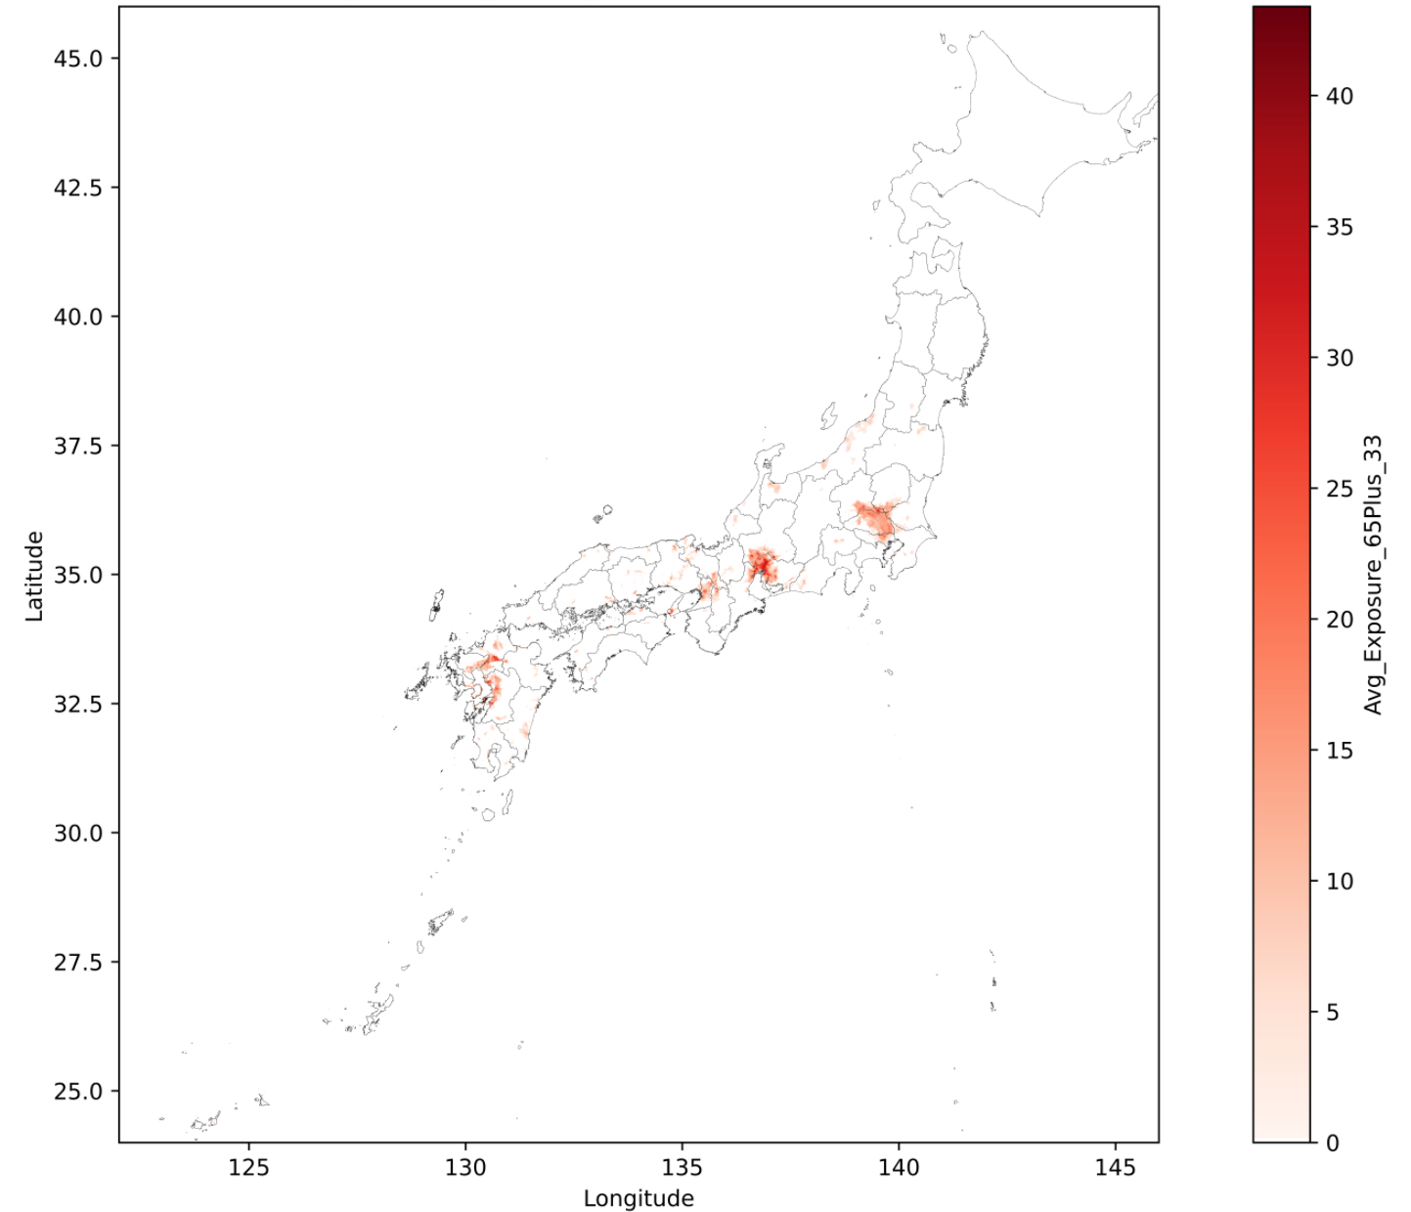 | 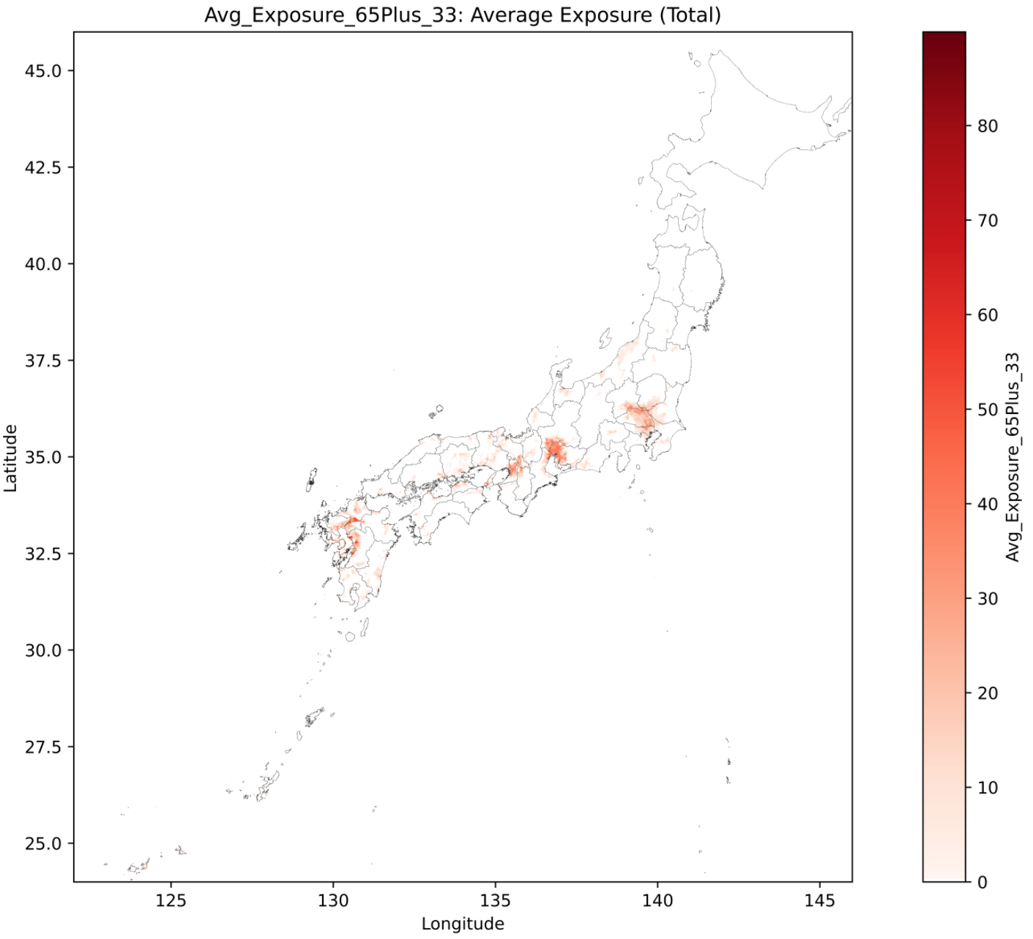
2060-2089 | 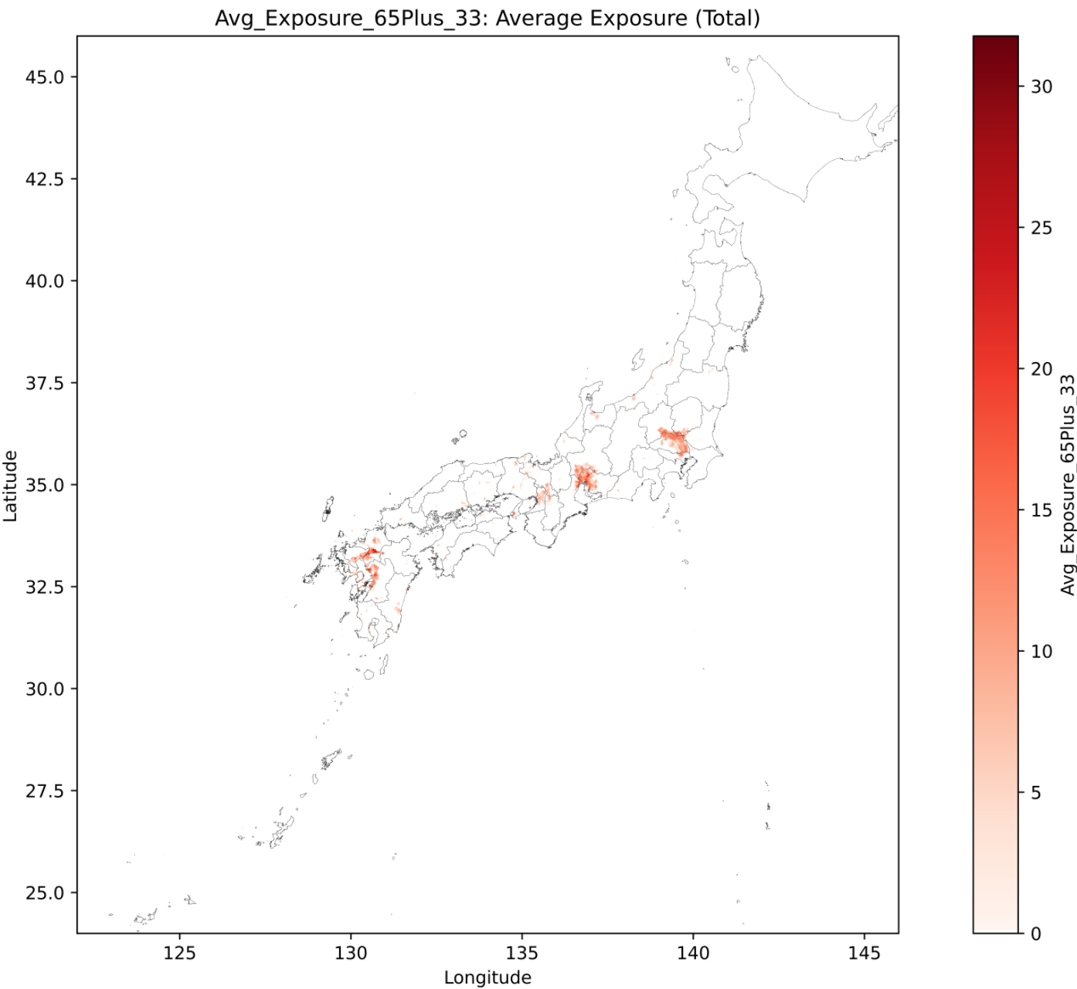 | 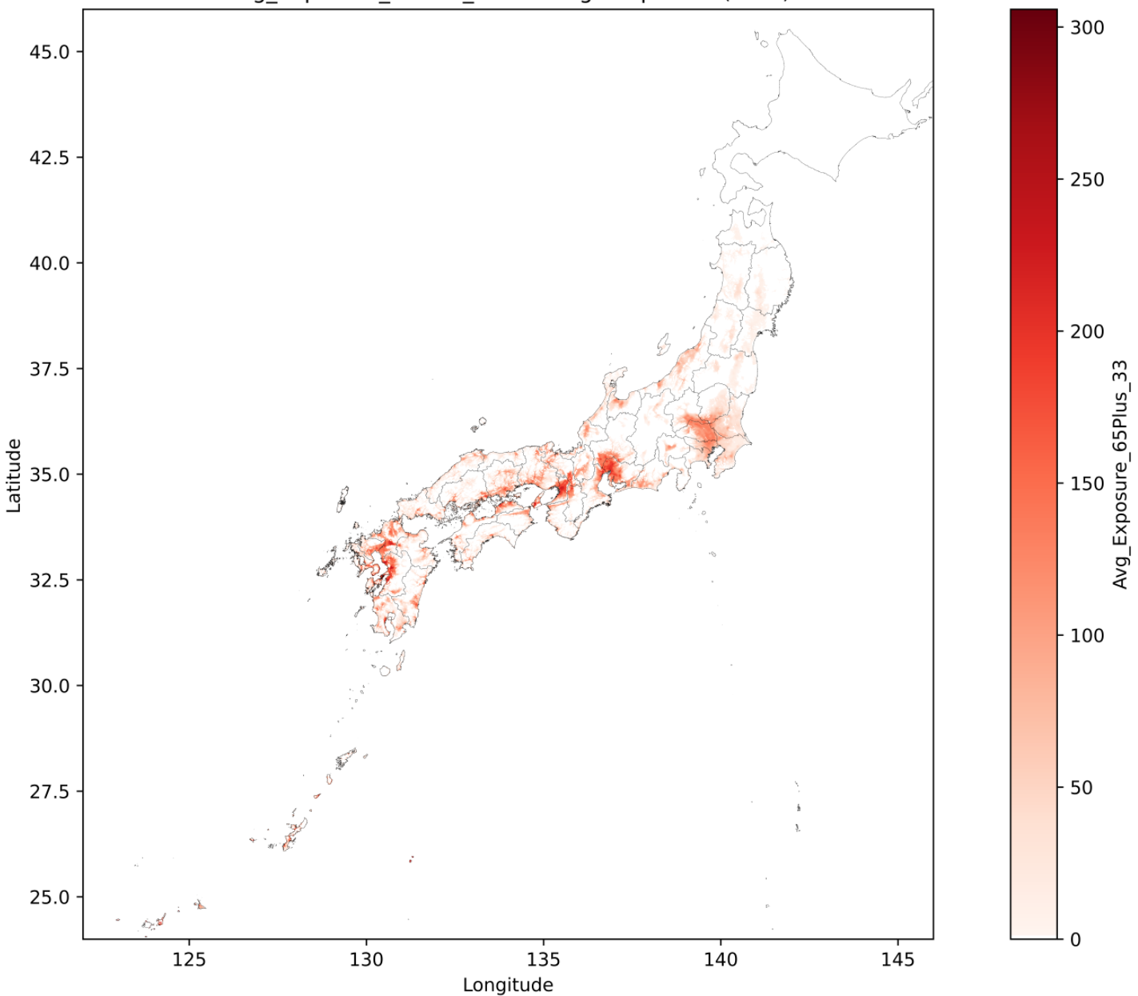
Figure. Projected annual exposure time to WBGT ≥33°C at 1 km grid resolution
（hour, period: 2030-2059, 2060-2089; SSP: SSP1-1.9, SSP5-8.5）

