Emphysema and Lung Nodule Correlations Using LDCT Chest
Wing Kwan Winky Lo ¹ ² , Katrina Tonga ¹ ² ³ , Christopher Rofe ¹ ⁴ , Elizabeth Silverstone ⁵ , Brad Milner ⁵ , Eugene Hsu ⁵ , Duy Nguyen ⁵ , Ian Yang ⁶ ⁷ , Henry Marshall ⁶ ⁷ , Annette McWilliams ⁸ ⁹ , Fraser Brims ¹⁰ ¹¹ , Renee Manser ¹² ¹³ ¹⁴ , Kwun M Fong ⁶ ⁷ , Emily Stone ¹ ² ¹⁵
- School of Clinical Medicine, St Vincent’s Healthcare Clinical Campus, UNSW Medicine & Health, UNSW Sydney, Sydney, NSW, Australia
- Department of Respiratory Medicine, St Vincent's Hospital, Sydney, NSW, Australia
- Northern Clinical School, University of Sydney, Sydney, NSW, Australia
- Kids Cancer Centre, Sydney Children’s Hospital, Sydney, NSW, Australia
- Department of Medical Imaging, St Vincent’s Hospital, Sydney, NSW, Australia
- Department of Thoracic Medicine, The Prince Charles Hospital, Brisbane, QLD, Australia
- Thoracic Research Centre, University of Queensland, Brisbane, QLD, Australia
- Department of Respiratory Medicine, Fiona Stanley Hospital, Perth, WA, Australia
- Faculty of Health and Medical Sciences, University of Western Australia, Perth, WA, Australia
- Department of Respiratory Medicine, Sir Charles Gairdner Hospital, Perth, WA, Australia
- Curtin Medical School, Curtin University, Perth, WA, Australia
- Department of Respiratory and Sleep Medicine, Royal Melbourne Hospital, Melbourne, VIC, Australia
- Department of Medicine (RMH), The University of Melbourne, Melbourne, VIC, Australia
- Department of Internal Medicine, Peter MacCallum Cancer Centre, Melbourne, VIC, Australia
- The Kinghorn Cancer Centre, Sydney, NSW, Australia
Introduction/Aim:
Smoking is a risk factor for lung nodules and emphysema. However, there is conflicting data regarding the relationship between lung nodules and emphysema. We aimed to evaluate the regional relationship between lung nodules (≥3mm) and emphysema extent in the NSW, Australia cohort of the International Lung Screening Trial (ILST).

Methods:
Candidates who met lung cancer screening criteria for the ILST had baseline low-dose computer topography (LDCT) chest performed. Lung nodules were reported by thoracic radiologists. Emphysema was quantified using automated software and standardised threshold of -950 Hounsfield Units. Emphysema extent was calculated as the ratio between emphysema volume and lung volume(% low attenuation area, %LAA). Emphysema extent was determined by %LAA thresholds of ≤1%(LAA₁), between 1%-5%(LAA₁₋₅) and >5%(LAA₅). Univariate binary logistic regression was performed to correlate lung nodules with emphysema extent in each lung lobe.

Results:
A total of 307 participants (49% male, 47.4±5.2 smoking pack-years) were included (LAA₁ n=103, LAA₁₋₅ n=134, LAA₅ n=70). Lung nodules were detected in 163 participants (53%). The overall mean %LAA was highest in the right middle lobe(RML) yet the RML had the least number of participants with lung nodules(11%)(Table 1). There was less emphysema in both upper lobes(UL) compared to the RML but a greater proportion of participants had lung nodules in the RUL(22%) and LUL(15%). Participants with LAA₅ had the highest number of lung nodules in all lobes. Lung nodules had no correlation with emphysema extent or location.

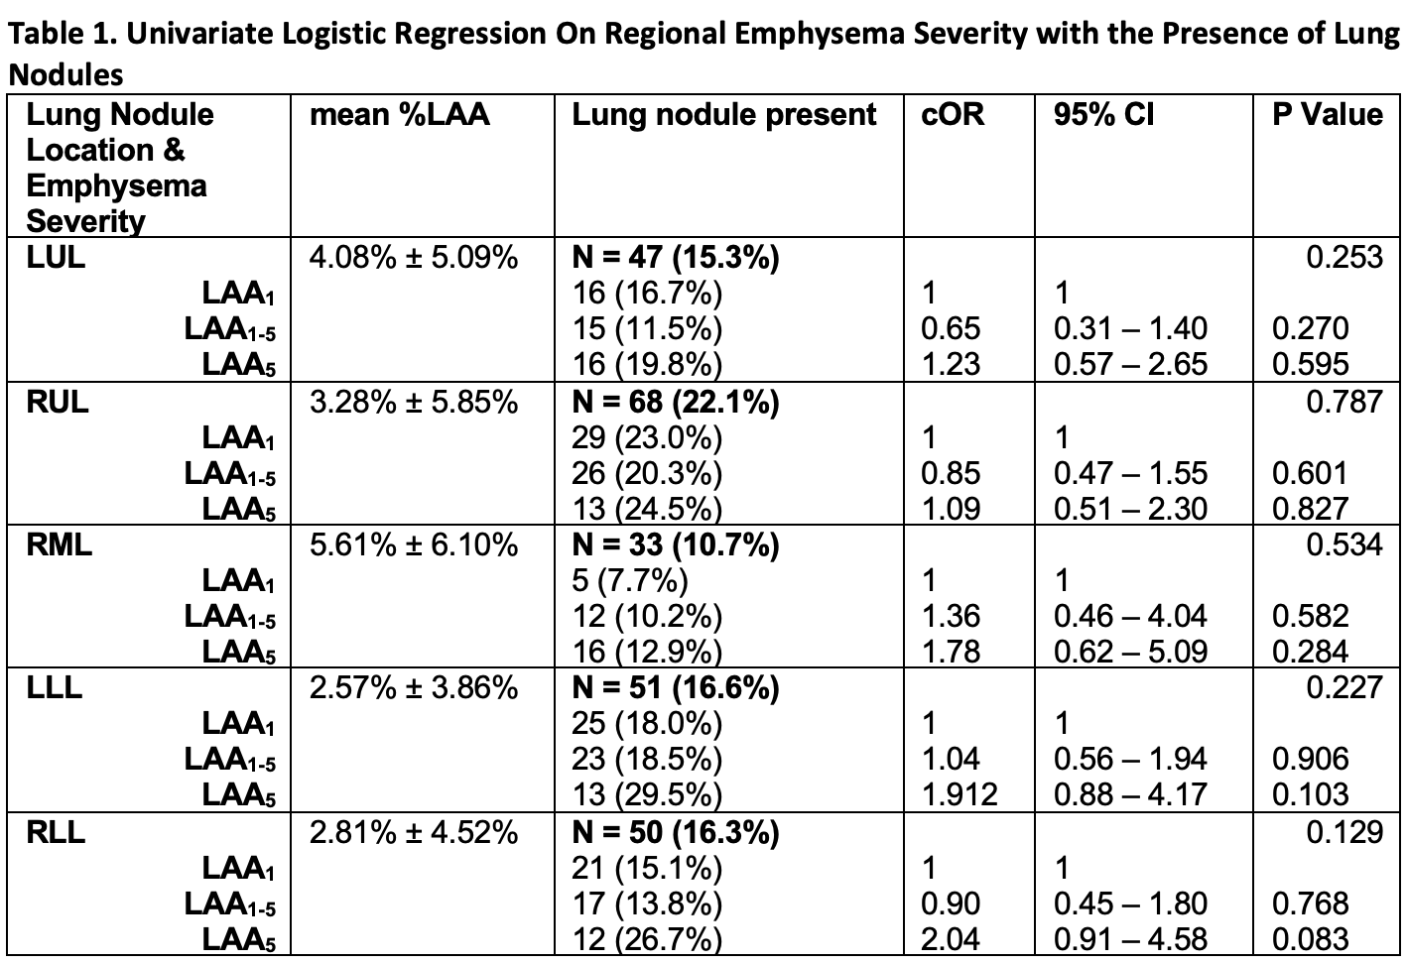

Conclusion:
The lack of a relationship between lung nodule and emphysema location and extent suggests the underlying pathology due to smoking may be different. Higher amounts of emphysema were not observed in the upper lobes as expected. The utility of automated software to quantify emphysema using LDCT for lung cancer screening needs further evaluation.

