Acute fibrinous organising pneumonia: atypical presentation as multiple spiculated opacities
Jake Brennan¹, James Brown¹
¹ Thoracic Department, Cairns Base Hospital, Queensland Australia
Case: The authors present a case of a 49-year-old gentleman presenting with three weeks of generalised decline and cough, with a five day course of small volume haemoptysis. His background was limited to heavy tobacco and marijuana smoking, EtOH excess, and previous IVDU, with no other significant medical history. Clinical exam: Examination revealed saturations of 94% on room air with nil cyanosis or clubbing. Note was made of poor dental hygiene. On auscultation there were scattered crepitations to the lower zones which cleared on coughing. Investigations: Initial chest radiograph demonstrated multiple nodular opacities across bilateral lung fields, and subsequent cross-sectional imaging revealed multiple spiculated lung lesions throughout the lung parenchyma (Figure 1). A low-grade eosinophilia was demonstrated (0.40). CRP was 127 on presentation, peaking at 193. Blood cultures were negative and transthoracic echocardiogram was negative for infective endocarditis. The decision was made to pursue percutaneous biopsy, which revealed a diagnosis of acute fibrinous organising pneumonia (AFOP). Management: The patient was commenced on course of high dose oral prednisone 50mg daily, weaning over a course of three months. Outcome: Repeat cross sectional imaging at two months revealed an interval improvement with complete resolution of most lesions and substantial regression of the remaining lesions. Cough and haemoptysis had resolved. Discussion This case demonstrates a rare presentation of nodule-dominant AFOP, successfully treated with oral corticosteroids alone. The case is compared to previous descriptions in the literature.

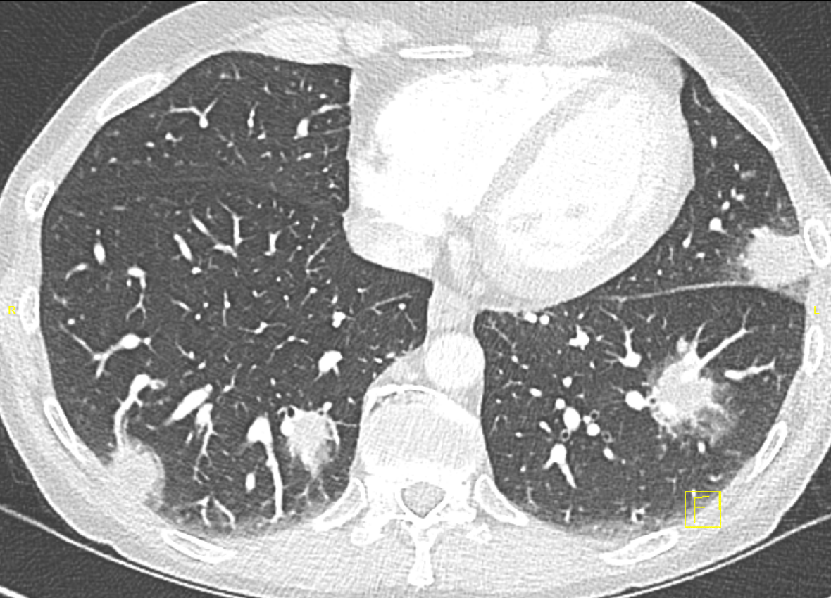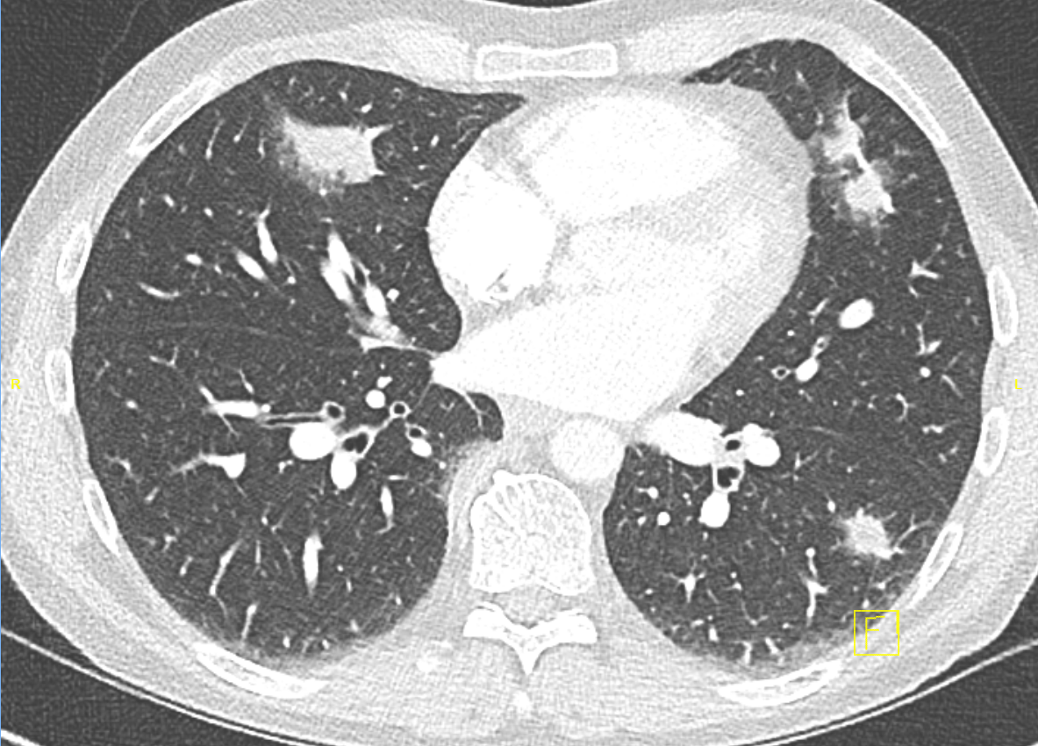
Figure 1. Bilateral spiculated opacities demonstrated on initial cross-sectional imaging.

Key words: AFOP, Organising Pneumonia, COP

