Paper
A Multi-Stakeholder Initiative to Improve Shrimp ​Aquaculture Across a Whole Jurisdiction:​ The Shrimp Improvement Program (SIP) ​in Banyuwangi, Indonesia​

Introduction: Banyuwangi has been known for its shrimp fisheries production potential. It is the largest shrimp producer in East Java and contributes to approximately 8% of total shrimp production in Indonesia. However, the impact of unaccounted growth frequently contributes to environmental issues, such as habitat loss, land conversion, disease outbreaks, and contaminated water quality from effluent.
Objectives: A jurisdictional approach (JA) to aquaculture improvement can see sustainability by aligning incentives amongst markets, governments, and producers. Sustainable production can support economic growth, increasing outputs while minimizing negative practices and production risks. Thus, we will present challenges and opportunities during three years of JA implementation, known as Shrimp Improvement Program (SIP) in Banyuwangi Regency, East Java.
Methodology: During more than three years of implementation (2022-2024), we established an agreement among stakeholders involved to develop a Banyuwangi shrimp sustainability roadmap—a document that outlines common goals, activities, and evaluation metrics for improvement. Moreover, we provided capacity building and direct assistance, especially to small-scale farmers. Examples consist of legality of shrimp farm business licenses, farm certifications, formation of cooperatives and farmer organizations, and water quality monitoring—in collaboration with local universities.
Findings: As the Shrimp Improvement Program in Banyuwangi continues to evolve and adapt to its local context, exciting challenges and opportunities have arisen. The valuable lessons learned will be shared during this poster session, enabling others to build on the project's success and further advance the growth of a more productive, resilient, and responsible aquaculture sector.
Significance of the work for policy and practice: Through SIP, we bring a new perspective of JA in aquaculture and seascape commodities, which previously focused on terrestrial commodities to address deforestation from agriculture and livestock production. We hope that JA in aquaculture and the good practices for co-management can be implemented in other regions in Indonesia. Finally, for next intervention plan, we will implement a nature-based solution—a combination between shrimp ponds and mangroves restoration for sustainable shrimp development in the Banyuwangi region.

References:
- East Java Central Bureau of Statistics (2023). Production and Production Value of Grouper, Shrimp, and Other Fish Aquaculture by Regency/City and Main Commodities in East Java Province, 2021
- Goto et al. (2023). A Jurisdictional Approach to Responsible Shrimp Aquaculture. Infofish International 3/2023.
- WWF & Conservation International. (2023). Developing Jurisdictional Initiatives for the Seafood Sector: Full Guidelines.

Images:

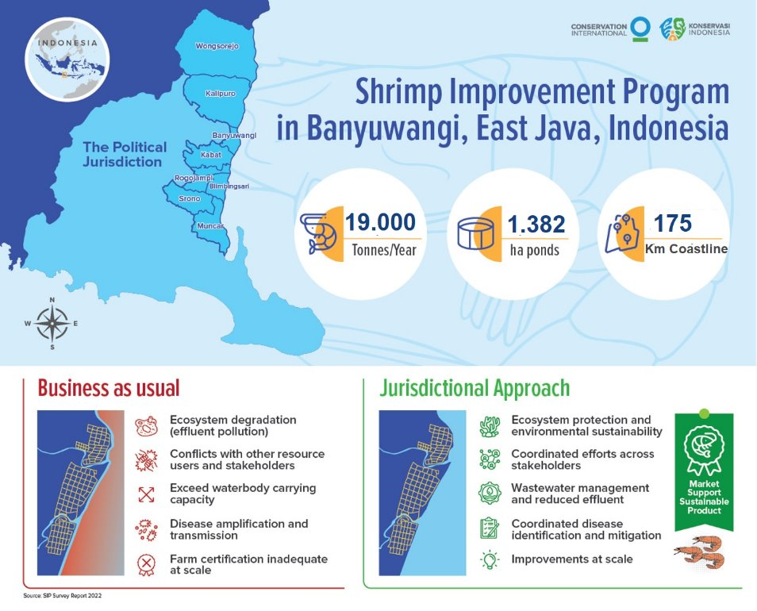
Figure 1. Shrimp Improvement Program and isdictional Approach Strategy in Banyuwangi, Indonesia
Source: Conservation International & Konservasi Indonesia

