Impact of respiratory outreach service in the remote Aboriginal communities of the Top End Northern Territory of Australia
Siji Issac¹, Raelene Messenger¹, Winda Lisuallo¹, Ara Perez¹, Subash Shanthakumar Heraganahally^{1,2,3}
¹ Department of Respiratory and Sleep Medicine, Royal Darwin Hospital, Darwin, Northern Territory, Australia
² Flinders University - College of Medicine and Public Health, Adelaide, South Australia, Australia
³ Darwin Respiratory and Sleep Health, Darwin Private Hospital, Darwin, Northern Territory, Australia
Introduction/Aim: In the Northern Territory (NT) approximately 30% of the population are Aboriginal Australians. The population profile is spread over vast geographical area and 80% of the Aboriginal Australians in the NT live in remote or very remote communities. The respiratory/sleep service based at the Royal Darwin Hospital, Darwin, provides specialist outreach service for the remote and regional Aboriginal communities of the Top End Health Service region (TEHS). This study aims to assess the clinical service provided for predominately adult Aboriginal patients through the respiratory outreach service.
Methods: A retrospective audit was undertaken to assess the respiratory disease management modalities facilitated by the respiratory clinical nurse consultants (CNC) during the respiratory outreach visits during the 2022 calendar year.
Results: In total, 29 remote Aboriginal communities were visited, at a frequency of one to three times/per community/per year and a total of 553 patients were seen. In addition to respiratory physician’s review for all patients who attended the outreach clinics during the remote community visits, the respiratory disease management interventions facilitated/ provided by the CNC are illustrated in figure 1.
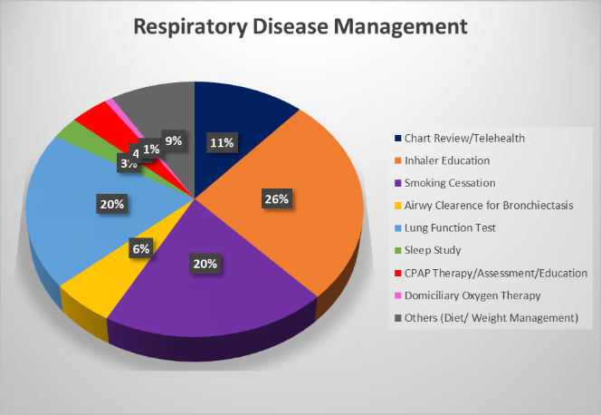
Conclusion: This audit demonstrates that specialist respiratory care via respiratory outreach service for patients residing in regional and rural Aboriginal communities is useful. However, further prospective research to assess the overall positive impact of this service model is required.
Grant Support: Nil to declare.

