International Lung Screen Trial of lung cancer screening enrolment
Kwun Fong¹ Henry Marshall¹ Annette McWilliams ^{2,3} Fraser Brims ^{4,5} Emily Stone⁶ Renee Manser ^{7,} Paul Fogarty ⁸ Linda Passmore ¹, Jacqueline Logan ², Jaccalyne Brady ¹ Sukinder Atkar-Khattra ⁹ Renelle Myers ⁹ Stephen Lam ⁹ Martin Tammemagi ¹⁰ Ian Yang ¹
¹ UQ Thoracic Research Centre, the University of Queensland; Thoracic Program, The Prince Charles Hospital (TPCH), Chermside, Queensland, Australia
² Fiona Stanley Hospital, Murdoch, Perth WA,
³ University of Western Australia, Nedlands, Perth Western Australia, Australia
⁴ Sir Charles Gairdner Hospital, Nedlands, Perth WA Australia
⁵ Curtin University, Perth Western Australia, Australia
⁶ St Vincent’s Hospital, Sydney NSW, Australia
⁷ Royal Melbourne Hospital, Victoria, Australia
⁸Epworth Eastern, Box Hill, Victoria, Australia
⁹ British Columbia Cancer Research Centre, Vancouver BC, Canada
¹⁰ Brock University, St Catharines Ontario, Canada
Introduction/Aim:
Low dose computed tomography (LDCT) screening reduces mortality from lung cancer. Refinement of the screening pathway using prediction models has been proposed. The International Lung Screen Trial (ILST) is a multicentre, prospective trial that incorporated risk prediction models for participant selection for screening. The PLCOm2012 lung cancer risk model and USPSTF2013criteria.
Methods:
Participants aged 50-74 years were recruited by advertisement. Eligibility was determined by PLCOm2012 lung cancer risk ≥1.51%/6 years or USPSTF2013 criteria (current/former smoker, quit <15 years prior, ≥30 pack years). We calculated the numbers eligible by each criteria who then went onto LDCT screening.
Results:
Interim results from ILST; 5518 Australians responded to public advertisements, news releases, General Practitioner (GP) based recruitment and Department of Health Services (DHS) mailout and were interested in being enrolled in ILST and who contacted ILST for eligibility assessment. In terms of eligible participants, 2375 (61.6%) met both the PLCOm2012 threshold of 1.5%/6 years and the USPSTF2013 criteria. 686 (12.4%) participants were eligible by the PLCOm2102 threshold only and 340 (6.2%) on the USPSTF2013 criteria only. Of the 3401 eligible participants, 2096 (61.6%) proceeded to LDCT. 485 (14.3%) were eligible on PLCOm2012 or USPSTF2013 criteria but were ineligible on other exclusion criteria and 524 (15.4%) declined to undertake a LDCT.
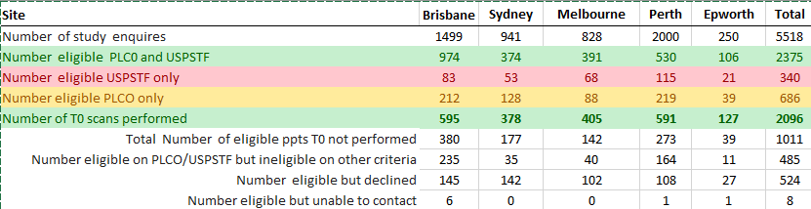
Conclusion:
Nearly 2/3rds of Australians interested in lung cancer screening were eligible for LDCT by either PLCOm2012 or USPTSF 2013 criteria. Of eligible participants 61.6% proceeded to LDCT with nearly 30% ineligible on exclusion criteria or declining to proceed to LDCT. These findings will hopefully inform the upcoming Australian lung cancer screening program.
Grant Support: ILST is part funded by the National Health and Medical Research Council (NHMRC).

