Paper
Colonial legacies on adaptive capacity to climate change: insights from relocation in New Caledonia (South Pacific)

Introduction
In the face of already observed climate impacts (marine flooding and coastal erosion) and future risks, Indigenous Kanak communities of the east coast of New Caledonia, a French overseas territory in the Pacific, are relocating or plan to relocate in safer areas. Past and current relocation cases highlight two important drivers of success: customary land availability and financial assistance from the French State. Meeting these two drivers however raises questions for future relocation projects due to a current context of land pressure and conflicts, combined with uncertainties surrounding the political and economic stability today. At a deeper level, the problem is rooted in colonial legacies and induced power relations, which constrain Kanak relocation capacities. One cannot overcome those barriers without taking account of historically-rooted power relations and interdependencies between scales and communities.

Objectives
We build on fieldwork material collected in New Caledonia between 2024 and 2025 to address two major questions:
- How do scales interplay to allow for locally-led adaptation today, and in light of past experiences? Answering this question requires to understand how to define the “community” (1) in the Kanak socio-cultural organisation, who are the key stakeholders beyond local “community”, and how solidarity across scales is mobilised.
- What are the implications on future relocation capacities for Kanak communities?

Methods
We use qualitative methods encompassing the analysis of historical, anthropological and legal documents in order to understand historical dynamics, as well as discursive elements from 35 semi-structured interviews with members of the Kanak communities of the Touho and Ponérihouen municipalities, Kanak institutions and institutional stakeholders.

Findings
The results highlight three relational dimensions of relocation in a formerly colonised territory:
- Observed relocation cases demonstrate that colonial policies have created economies of dependence tending to concentrate power and means, including finance, in the hands of external (2) and/or at the national-level stakeholders. These cases reveal that external financial assistance and the availability of customary land are both necessary for ensuring successful relocation.
- The challenges today are related to the interrelationships between people, communities and localities. Because of the specific land tenure system inherited from colonisation, the ability of local communities to relocate strongly depends on solidarity between scales and across communities. This communication will detail those interrelations and dynamics to show that today’s relocation capacity of some Indigenous communities depends on the will of neighbouring ones to cede or grant their own lands.
- Regarding challenges ahead, our analysis shows that understanding how colonial legacies affect “contextual equity” (3) is key to determine the capacity of Kanak communities to undertake new relocation projects. Based on this, this communication will propose some ways forward to overcome those barriers.

Implications for science, policy and practice
The relocation capacity is relational by nature, calling for solidarity-driven negotiation within and between local communities, and across scales, to integrate bottom-up and top-down approaches (4) and minimise conflicts. Our hypothesis is that under these conditions, climate-related relocation could help overcome inherited path-dependencies and be a vehicle for long-term climate change adaptation.

Figure 1. Displaced family in Touho.

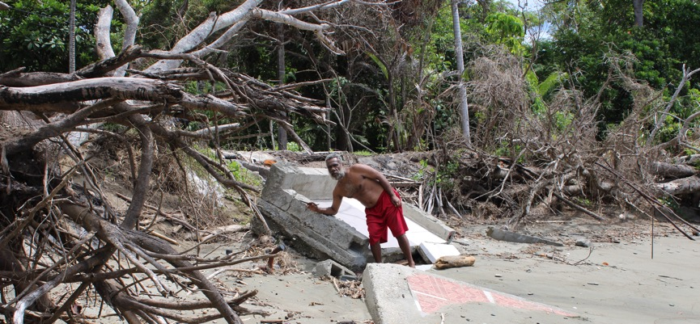

References
(1) Harrington-Abrams, Rachel, Erica Bower, et Betsy Priem. 2024. « Complicating “community” engagement: Reckoning with an elusive concept in climate-related planned relocation ». Global Environmental Change 88 (septembre). https://doi.org/10.1016/j.gloenvcha.2024.102913.

(2) Bordner, Autumn S., Caroline E. Ferguson, et Leonard Ortolano. 2020. « Colonial dynamics limit climate adaptation in Oceania: Perspectives from the Marshall Islands ». Global Environmental Change 61 (mars):102054. https://doi.org/10.1016/j.gloenvcha.2020.102054.

(3) McDermott, Melanie, Sango Mahanty, et Kate Schreckenberg. 2013. « Examining equity: A multidimensional framework for assessing equity in payments for ecosystem services ». Environmental Science & Policy 33 (novembre):41627. https://doi.org/10.1016/j.envsci.2012.10.006.

(4) Butler, J, Russell Wise, Timothy Skewes, Erin Bohensky, Nate Peterson, W Suadnya, Y Yanuartati, et al. 2015. « Integrating Top-Down and Bottom-Up Adaptation Planning to Build Adaptive Capacity: A Structured Learning Approach ». Coastal Management 43 (juillet):34664. https://doi.org/10.1080/08920753.2015.1046802.

