Automated View Positioning of Standard Apical 2D Echocardiographic Images Using Deep Learning

Background: 2D echocardiography (echo) is the clinical workhorse for assessment of cardiac mass, volumes, and ejection fraction. However, the relative spatial positions of echo views are unknown, and therefore these measurements rely on geometric assumptions. This work aims to accurately estimate the relative spatial positioning of standard apical echo views, to ultimately reduce reliance on geometric assumptions to improve mass and volume estimation.

Method: A deep learning network was trained to automatically position standard 2D echo views in 3D space. Training was performed using 3D echo from healthy subjects and patients with cardiac disease across varied demographics (17/CEN/226). End‑systolic 3D geometries were sliced to generate simulated 2D views for training input. The dataset included 152 subjects, split into 70%/15%/15% for network training/validation/testing.

Results: Preliminary results show a mean plane‑normal angular error of 11° ± 6° and a mean centre‑point error of 12 ± 8 mm on 2D echo views sampled from 3D echo. The model generalises to clinical 2D echo acquisitions and accurately aligns anatomical structures (Figure).

Conclusion: This approach demonstrates strong potential for automated view positioning of 2D echocardiographic views. Future work will investigate whether this method improves volume estimation from 2D echo with respect to gold standard MRI.

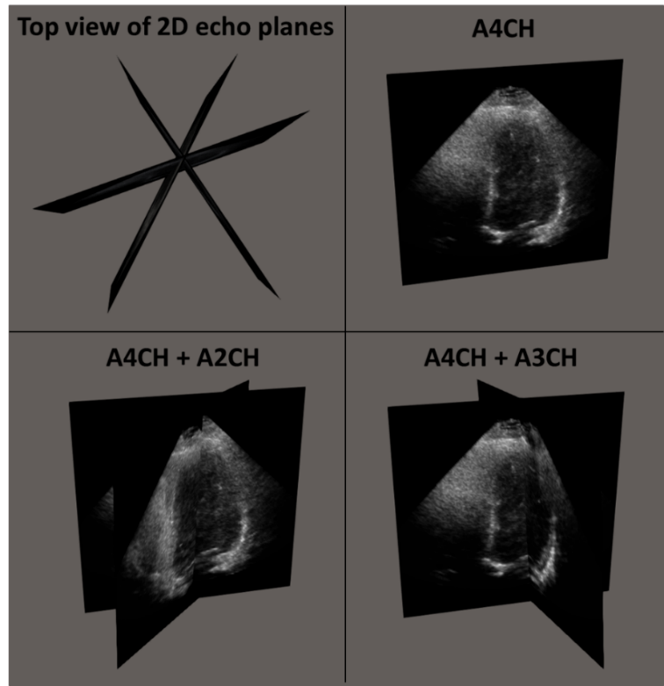
Figure. Alignment of standard apical 2D echo views using the relative spatial positions predicted by the deep learning network. Abbreviations: A4CH, apical four chamber view; A2CH, apical two chamber view; A3CH, apical three chamber view.

