Detection of ventilation inhomogeneity in children with cystic fibrosis using CT LVAS technology.
Rebecca Heyman¹, Tamara Blake¹, Nina Eikelis², Kris Nilsen², Weinheimer O³, Pandit C⁴, Paul D Robinson^{1,5}
¹Children’s Health and Environment Program, Child Health Research Centre, University of Queensland, Brisbane, QLD, Australia, ²4DMedical, Melbourne, VIC, Australia, ³University Hospital of Heidelberg, Heidelberg, Germany, ⁴Children’s Hospital at Westmead, Westmead, NSW, Australia, ⁵Queensland Children’s Hospital, Brisbane, QLD, Australia

Introduction/Aim:
Novel methods for early detection of ventilation inhomogeneity (VI) in patients with cystic fibrosis (CF) are essential for mitigating disease progression. The ability to derive ventilation distribution maps from paired inspiratory and expiratory CT images has recently been developed (CT LVAS, 4DMedical). The aim was to assess the ability of CT LVAS-derived indices to identify abnormal VI in a previously published study conducted in early CF lung disease¹ and their correlation with established pulmonary function indices.

Method:
CT LVAS was applied to CT imaging from an existing dataset of n=50 children with FEV₁≥70% (50% male, mean (SD) age 11.1 (3.8) years). CT LVAS metrics calculated were mean specific ventilation (MSV), ventilation heterogeneity (VH) and ventilation defect percentage (VDP). Correlation was examined using Spearman’s rho with indices from multiple breath washout, spirometry, oscillometry and CT imaging.

Results:
CT LVAS was successful in 38/50 (76%) children: mean (SD) age 11.3 (3.8) years, 58% male, mean (SD) FEV₁ z-score -0.31 (0.96) and median (IQR) lung clearance index (LCI) 7.45 (6.91-8.71). CT LVAS results are summarised in the table: MSV was significantly lower in those with abnormal, vs normal, AT (p < 0.001) and LCI (p = 0.038). Differences in VH and VDP were not as pronounced. Moderate to strong correlation was observed between MSV and air trapping on CT (rho = -0.6, p < 0.0001). Oscillometry reactance at end-inspiration showed a moderate correlation with LCI (rho = -0.48, p = 0.007) but not with any CT LVAS indices.

Conclusion:
CT LVAS technology was a feasible assessment of VI in children with early CF lung disease. MSV showed the strongest utility of the indices examined. Further studies are warranted to optimise CT LVAS indices and define clinical utility in CF.
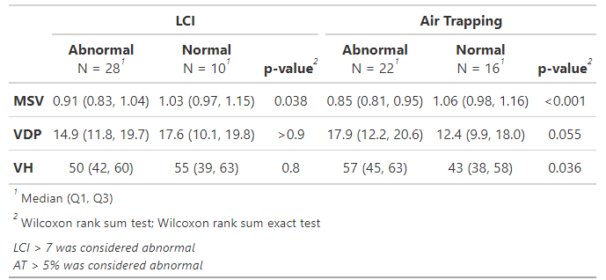

Grant Support: Australian CF Research Trust Innovation Grant

Declaration of Interest Statement: No conflicts of interest to declare.

Key Words: Cystic fibrosis (CF), CT LVAS, ventilation inhomogeneity (VI), lung clearance index (LCI), air trapping.

Acknowledgements: We wish to acknowledge the families and investigators involved in the original study¹

References:
¹Bayfield et al., Journal of Cystic Fibrosis, 2024, 23, 918-925

