**Culturally Grounded Diabetes Education: A Framework Utilising Indigenous Knowledge**

**Aims/objectives**: Type 2 diabetes (T2D) inequitably impacts Māori in Aotearoa New Zealand, highlighting the need for culturally responsive educational resources. Like other indigenous populations globally, the enduring impacts of colonisation, land alienation, cultural suppression, racism, and socioeconomic inequities have created barriers to equitable access to healthcare. This study explores the T2D education preferences of Māori communities in the Waikato, to develop a culturally responsive educational framework.

**Methods**: Qualitative methodologies were employed, involving two focus groups (n=7; 2 males, 5 females, aged 35-44 years; 6 Māori, 1 Cook Island Māori) recruited via snowball sampling from a diabetes community group. Discussions critically analysed existing resources (print, video, websites) in Aotearoa, eliciting participant suggestions for improvement. Data was analysed using a strength-based Kaupapa Māori inductive thematic analysis.

**Results:** Overarching key themes were found including Mātauranga (knowledge) and whānau aspirations. Mātauranga included the pursuit of knowledge, pono (honesty) and intergenerational knowledge transfer. Whānau aspirations comprised cultural identity, and a whānau-centred approach. From here, the innovative ‘Ko Tuna Anahe’ framework (figure 1) was developed by weaving together emergent themes, mātauranga, and whānau aspirations using the symbol of a traditional Māori food source (Tuna/eel). The Tuna symbolises a return to more traditional food sources compared to the energy dense, nutrient deficit food present in modern diets, contributing to T2D. The framework is accompanied by the associated whakataukī (proverb), *Ko Tuna anahe ki taku hīnaki',* (*Tuna is the only one I would want in my eel-pot)'*.

**Conclusion**: The development of the ‘Ko Tuna Anehe’ framework offers a novel pathway to create culturally responsive T2D education. The framework, combined with the whakataukī (proverb), symbolises the autonomy of Māori communities to exercise agency in healthcare decisions, informed by traditional knowledge and inherent strengths. The framework's significance is its potential to decolonise T2D education, centering Māori knowledge and whānau involvement.

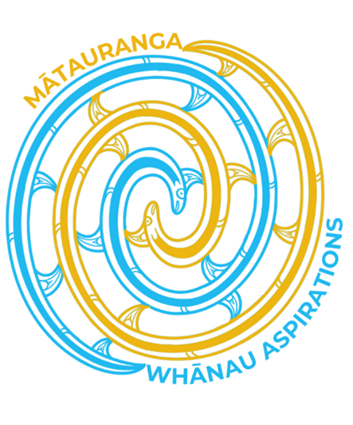

**Cultural identity**

**Pursuit of knowledge**

**Whānau centred care**

**Pono**

**Intergenerational knowledge transfer**

Figure 1: Ko Tuna Anahe Framework for developing culturally responsive T2D rauemi for Māori communities. (designed by Georgia Latu)