**Title** The Te Kūiti Access to Cardiology Pilot Study (TKACPS) – Comparison of participant and normal care control group’s acute hospitalisation rates due to cardiac events.

**Background:**

TKACPS was designed to assess in a high proportion Māori GP population (Te Kūiti), with increased cardiovascular risk (CVR), whether a simple local screening protocol, followed by more definitive cardiology tests performed locally, would identify people with undiagnosed heart disease for treatment or tertiary referral, more effectively, when compared with a normal care control group. We evaluated the amount of hospitalisations due to cardiac events between each group from first patient contact of study (May 2022) to January 2025.

**Method:**

Te Kūiti GP patients aged 35-74, with a 5 year CVR of ≥10% (PREDICT CVD) were eligible for inclusion in participant group. Current cardiology patients (or those seen within two years), were excluded. Screening protocol (Phase 1: symptom questionnaire, electrocardiogram and plasma Troponin T, NTproBNP and ST-2) was followed by, if cardiologist and GP felt indicated, Phase 2 locally performed investigations (screening echo, Holter Monitor or exercise tolerance test (ETT)). Patients were referred to cardiology / tertiary services, for review or further investigations, as indicated.

We investigated the amount of hospitalisations due to cardiac events, separated into normal care control and participant groups.

**Results:**

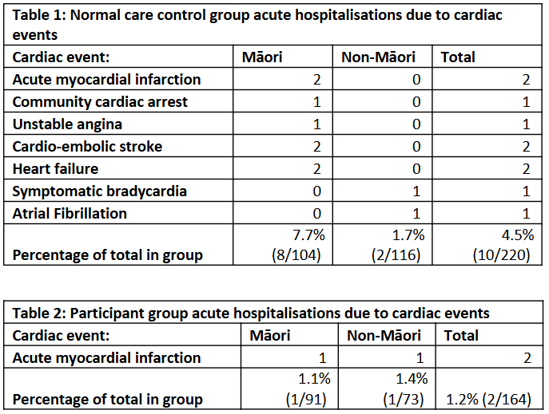

**Conclusion:**

There is a larger percentage of patients that were hospitalised due to cardiac event in the non-participant group (4.5%) when compared to the participant group (1.2%). This suggests that TKACPS screening protocol may be effective in reducing numbers of hospitalisations due to cardiac events in this population.