**Case study: Improving safety in Type 1 diabetes with hypoglycaemia unawareness using 24 hours continuous glucose monitoring**

**Background & Aim**

Hypoglycaemia unawareness affects up to 40% of individuals with Type 1 Diabetes and significantly increases the risk of severe hypoglycaemia, which can lead to seizures, arrhythmias, and sudden death. Traditional measures such as HbA1c often unable to capture glycaemic variability and frequency of hypoglycaemia events. This case study aimed to elevate the effectiveness of the CGM in identifying and managing hypoglycaemia in a patient with longstanding Type 1 diabetes and hypoglycaemia unawareness.

**Methods**

This case involved a 40-year-old male with a 20-year history of poorly controlled Type 1 diabetes, multiple microvascular complications, and recurrent severe hypoglycaemia (Figure 1). Despite HbA1c of 7.1%, CGM data revealed profound glycaemic instability, including 22% time in low and 55 hypoglycaemia episodes and 164 minutes in hypoglycaemia ranges over 30 days (Figure 2). A multidisciplinary intervention was implemented, involving adjustment of CGM alarm thresholds, insulin regimen review, simplified education tailored to the patient’s low literacy, and caregiver training with remote monitoring via data sharing platform.

**Results**

Following CGM initiation and tailored interventions, patient’s time in hypoglycaemia dropped from 14% to 3% within one week (Figure 3). The frequency and duration of nocturnal hypoglycaemia reduced significantly. Patient and family demonstrated increased confidence in diabetes management with regular contact diabetes team for insulin stabilization, and no further severe hypoglycaemia episodes were reported following discharge.

**Discussion/Conclusion**

This case highlights the limitations of relying solely on HbA1c and the critical role of CGM in identifying and addressing hidden glycaemic risks in patients with hypoglycaemia unawareness. CGM provided critical insights into real time glucose trends. Personalising CGM alerts and involving family in monitoring and response strategies proved essential in reducing hypoglycaemia episodes, enhancing patient safety and empowering both patients and caregivers.

**Figure 1**

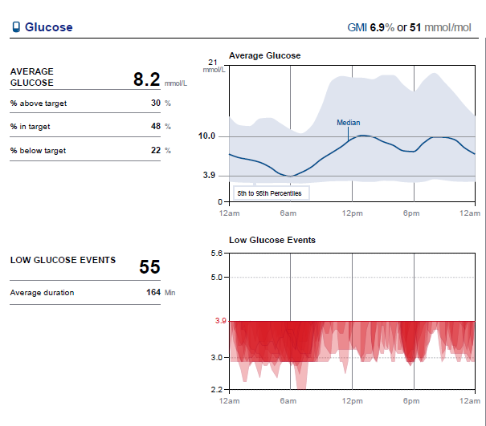

**Figure 2**

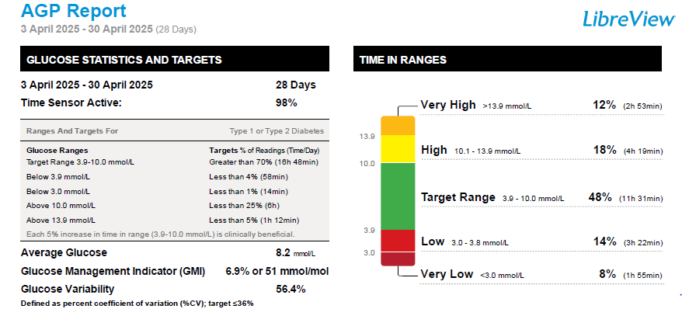

**Figure 3**

