Towards culturally responsive Diabetes care for Māori communities: A Framework informed by healthcare provider perspectives

Aim/s
Type 2 diabetes (T2D) disproportionately affects Indigenous populations worldwide. In Aotearoa New Zealand (NZ), Māori face a three-fold higher rate of T2D compared to non-Māori. Similar disparities are present in many Indigenous communities, including First Nations Peoples of Australia. These disparities are due to many factors, particularly barriers in accessing and achieving best outcomes in a Western Health System. The aim of this study was to explore strategies that community care-based health professionals in the Waikato have found successful in reducing these barriers for Māori with T2D.

Methods
Nine participants (6 Māori, 3 NZ European) comprising a general practitioner, podiatrist, exercise physiologist, three kaiāwhina (holistic support workers), dietitian, and two pharmacists, were recruited using purposive sampling to ensure representation across disciplines involved in managing T2D. Participants were interviewed and analysed using Kaupapa Māori inductive thematic analysis, using a strength-based approach.

Results
Successful clinician-employed strategies included empowering language, ensuring whānau (immediate and extended family) and community involvement, interprofessional collaboration, and culturally appropriate analogies with metaphors and storytelling. A theoretical Poutama framework, a significant Māori symbol which embodies learning, growth and the continuous pursuit of knowledge was developed to convey these results (Figure 1 below). and The Poutama provides a powerful guide for enabling culturally responsive T2D care through step-wise methodology.

Conclusion
Culturally grounded clinical approaches are imperative in reducing inequities in indigenous peoples. The findings underscore the necessity of a sustained commitment to culturally grounded clinical approaches, moving beyond standard healthcare models. The Poutama was selected for healthcare providers to symbolise their continuous journey of learning and professional development in providing culturally responsive care for Māori. Each step represents the continuous development of cultural competency and effective whānau partnerships, with the ascent symbolising ongoing aspirations and sequential advancement in addressing inequities in health outcomes for Māori whānau with T2D.

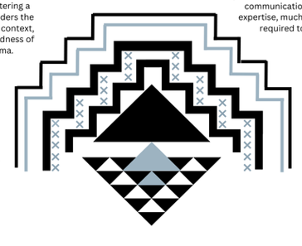
Interprofessional Collaboration
Whānau involvement

Culturally Appropriate Analogies
Empowering language

Figure 1: Ascending the Poutama: Framework for culturally responsive care (designed and created by Associate Professor Anna Tiatia Fa’atoese Latu)

