Forest Stand-Scale AGB Mapping over the farm Using Timber Cruising and Airborne LiDAR Data
Introduction/Aim:
Airborne LiDAR data are one of the primary methods for large-scale forest biomass mapping. The commonly used area-based approach (ABA) typically relies on the statistical relationship between LiDAR point cloud feature parameters and plot-level forest biomass, with a spatial resolution usually between 20 to 30 meters (Tompalskia et al., 2019). Field data collection is a laborious task in biomass mapping using ABA predictive models developed from stratified inventory data from field plots (Du et al., 2023 ).

In plantations with logging plans, timber cruising is conducted to calculate the volume and biomass before and after harvesting for a certain number of forest stands. Forest stands, due to their homogeneous internal characteristics, hold potential as units for AGB estimation. Consequently, we propose a novel approach that utilizes timber cruising data as reference data and predictor variables derived from airborne laser scanner (ALS) data to establish a biomass estimation model at forest stand scale. Subsequently, this model is used in conjunction with automatically delineated sub-compartment ploygons to create AGB distribution maps at the forest farms scale.

Methods:
In this paper, we compile timber cruising data from 2017 to 2020 in the Mengjiagang Forest Farm(MFF),Heilongjiang Province, China, and align it with two sets of ALS data (2017 and 2020). Subsequently, we computed ALS-derived variables for each forest stand, including height, canopy density, and vertical structure variables. Across different forest types, we evaluated four variable selection and regression approaches: linear models based on Recursive Feature Elimination (RFE), linear models based on Stepwise regression (ST), linear models with ridge regularization (LMR), and Random Forest models (RF). Finally, by integrating the forest stands automatically delineated based on remote sensing data across the entire forest farm. (Xiong et al., 2024), we utilize the optimal model to conduct biomass mapping for the MFF.
Results:
The accuracy of the biomass estimation model at the sub-compartment scale is shown in Figure 1 to 2. For Larix and Pinus sylvestris, the optimal model, determined through 1000 iterations of tenfold cross-validation, achieved an average accuracy of R²=0.87, rRMSE=0.16 for Larix, and R²=0.76, rRMSE=0.14 for Pinus sylvestris. For Picea, due to fewer sample plots, leave-one-out cross-validation was used, resulting in an accuracy of R²=0.98, rRMSE=0.12.
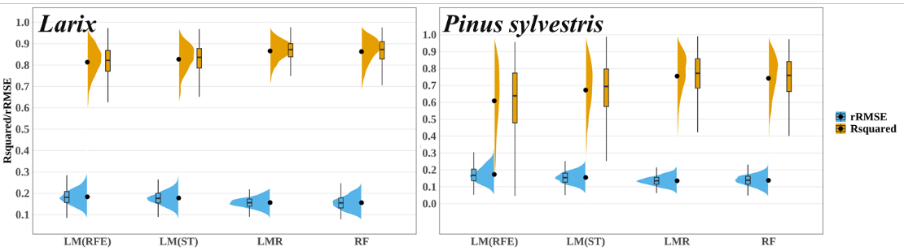
Figure 1: Precision of biomass estimation for Larix and Pinus sylvestris in forest stand.

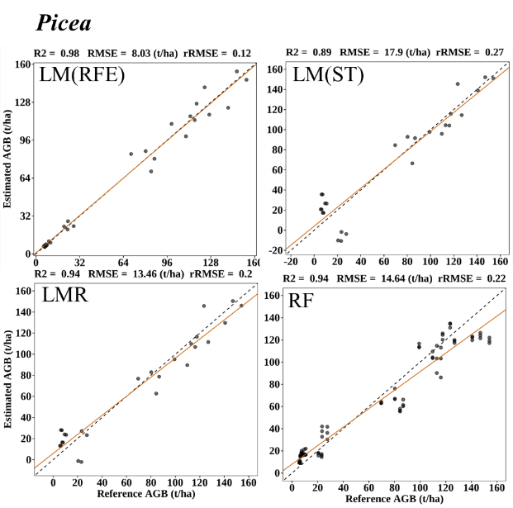
Figure 2: Precision of Picea biomass estimation in forest stand.
Conclusion:
This study validates the feasibility of forest Stand-Scale Biomass estimation using Timber Cruising and ALS Data, the accuracy is consistent with the widely used plot-scale ABA method. The dependency on actual measured sample plots is greatly reduced for mapping biomass at the farm level.

Du, Liming., Pang, Yong., Wang, Qiang., et al. 2023. “A LiDAR Biomass Index-Based Approach for Tree- and Plot-Level Biomass Mapping over Forest Farms Using 3D Point Clouds.” Remote Sensing of Environment 290 (5): 113543. doi:10.1016/j.rse.2023.113543.
Xiong, Hao., Pang, Yong., Jia, Wen., et al. 2024. “Forest Stand Delineation Using Airborne LiDAR and Hyperspectral Data.” Silva Fennica 58 (2). doi:10.14214/sf.23014.
Tompalski, Piotr., Joanne C. White., Nicholas C. Coops., et al. 2019. “Demonstrating the Transferability of Forest Inventory Attribute Models Derived Using Airborne Laser Scanning Data.” Remote Sensing of Environment 227 (6): 110-124. doi:10.1016/j.rse.2019.04.006.

Please note the headings provided are optional, please remove or change to best suit your content.

