Insulin aspart compared with faster aspart in fully closed loop insulin pump systems: Insights from the CLOSE IT Trial

Aims
Hybrid closed-loop (HCL) automated insulin delivery (AID) systems require users to manually announce meals, adding burden for people with type 1 diabetes (T1D). The CLOSE IT ((Closed Loop Open SourcE In Type 1 diabetes) study evaluated a fully closed-loop (FCL) system using the open-source oref1 algorithm, which eliminates the need for meal announcements and found non-inferiority with the system used as HCL. This extension study compared Novorapid® (insulin aspart) with Fiasp® insulin within this FCL system.

Methods
In this open-label, parallel, non-inferiority trial, 20 adults with T1D) from the FCL arm switched from insulin aspart to faster aspart for 4-weeks, continuing use of the oref1-based FCL system. The primary outcome was time in range (TIR, 3.9–10.0 mmol/L or 70–180 mg/dL) during the final 2-weeks, adjusted for 2-week run-in values. Secondary outcomes included postprandial glucose, variability, and time below (TBR) and above range (TAR).

Results
Among 20 participants (60% male, age 36 [29–51] years, diabetes duration 20 [11–25] years), mean TIR was similar with insulin aspart and faster aspart (65±10% vs 68±10%; mean difference 3.0% [-0.04, 6.0], p=0.053). Mean glucose (9.0±0.9 vs 8.8±1.0 mmol/L), TBR (<3.0 mmol/L: 0.25% vs 0.27%), TAR (>10.0 mmol/L: 33% vs 30%), GMI (7.2% vs 7.1%), and glucose variability were comparable (all p>0.05), figure 1. No severe hypoglycaemia or DKA events occurred.

Conclusion
Insulin aspart was compared with faster aspart in an oref1-based FCL system showing no significant difference in glycaemic metrics.

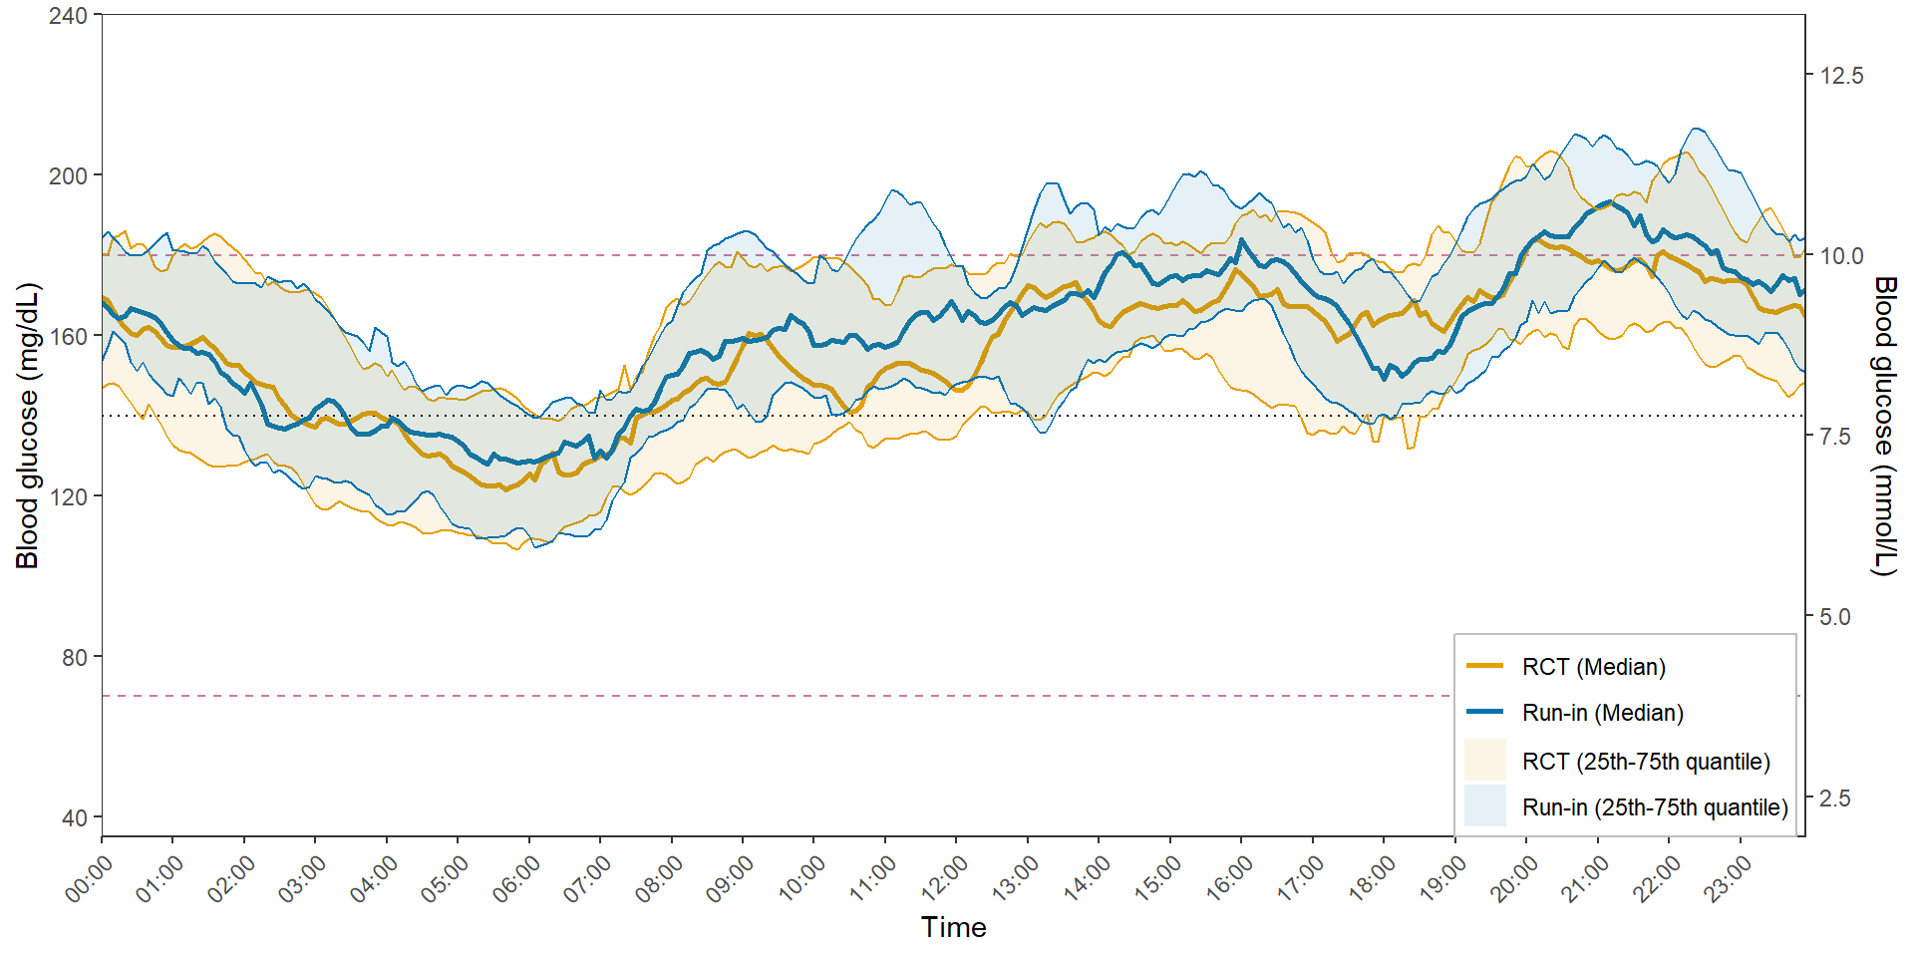

Figure 1: Interstitial glucose levels in an FCL system during the RCT (using rapid insulin) and extension (using ultra-rapid insulin) phases of the CLOSE IT study

