Multi-temporal 3D virtual forest reconstruction using terrestrial laser scanning in a temperate forest
Introduction:
European forests are currently undergoing large-scale changes in both structure and species composition, primarily driven by climate change, and various disturbances affecting the forest canopy. The canopies of forests across Europe are currently opening up due to tree mortality caused by factors such as drought, pests, storms, and fire. Understanding the implications of these changes for forest functionality is crucial for effective forest management. Therefore, it is essential to accurately quantify the spatial and temporal relationships among forest structure, light availability, and microclimate.

Methods:
To address this need, we have established a novel edge-to-core transect within a temperate deciduous forest near Ghent (Aelmoeseneiebos, Gontrode, Belgium). This 30m-wide transect spans from the forest edge to 135 meters deep into the forest interior, encompassing both an oak-beech-dominated zone and an ash-dominated zone characterized by ash dieback. Along the transect, we have deployed a densely spaced network of light and microclimate sensors at 15-meter intervals. Additionally, a fiber optic sensing cable for distributed temperature sensing (both in air and soil) runs along the entire transect. A 35-meter-high measuring tower is part of the setup, allowing for measurements of light and microclimate along a vertical transect from the ground till above the canopy. To quantify the temporal and spatial variations in forest structure, we have collected terrestrial laser scanning (TLS) data on a monthly basis, since March 2023. This data is acquired using a RIEGL VZ400i laser scanner at a pulse repetition rate of 600 kHz using a 15 by 15 m grid. Using this multi-temporal TLS data we will reconstruct a 3D virtual forest transect throughout time.
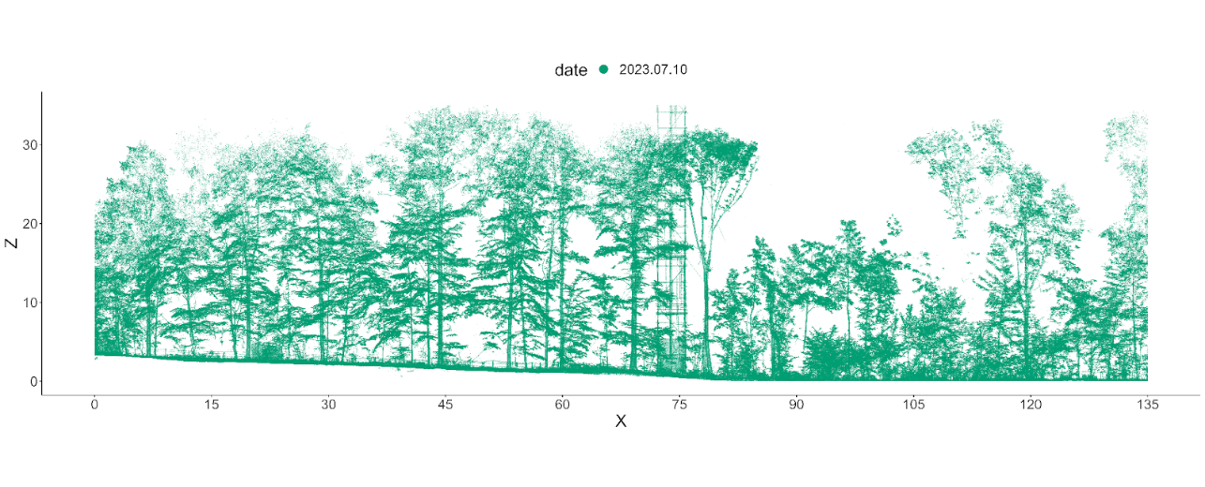
To construct this 3D virtual forest transect, the transect point cloud is first fully segmented to individual tree point clouds in RIEGL’s RiSCAN PRO software using a combination of the software’s tree segmentation plug-in and manual corrections. Next, the tree point clouds undergo a leaf-wood separation using the GBSeparation algorithm of Tian et al. (2022). This is followed by reconstructing the woody points to the finest detail using cylinders (so called QSMs, quantitative structure models) for each individual tree applying the treeQSM version 2.0 workflow of Calders et al. (2015) which builds upon Raumonen et al. (2013). Leaves are added to the tree QSM structures using the Foliage and Needles Naïve Insertion (FaNNI) algorithm (Åkerblom et al., 218).
Outlook:
This virtual forest transect will serve as input for radiative transfer modeling (RTM), a simulation method that simulates the interaction between light and forest structure. Utilizing highly detailed forest structure obtained from TLS data, 3D RTMs provide an effective means to accurately model light transmission within forests at a high resolution. Using this approach we aim to (i) validate 3D light measurements conducted along the transect and (ii) implement virtual light sensors. The former enables the assessment of uncertainty in the collected time series data, while the latter offers a comprehensive understanding of the light conditions in the canopy. This information is crucial for evaluating the impact of canopy structure on light penetration and its subsequent effects on the microclimate.

References:
Åkerblom, M., Raumonen, P., Casella, E., Disney, M. I., Danson, F. M., Gaulton, R., ... & Kaasalainen, M. (2018). Non-intersecting leaf insertion algorithm for tree structure models. Interface Focus, 8(2), 20170045.

Calders, K., Newnham, G., Burt, A., Murphy, S., Raumonen, P., Herold, M., ... & Kaasalainen, M. (2015). Nondestructive estimates of above‐ground biomass using terrestrial laser scanning. Methods in Ecology and Evolution, 6(2), 198-208.

Raumonen, P., Kaasalainen, M., Åkerblom, M., Kaasalainen, S., Kaartinen, H., Vastaranta, M., ... & Lewis, P. (2013). Fast automatic precision tree models from terrestrial laser scanner data. Remote Sensing, 5(2), 491-520.
Tian, Z., & Li, S. (2022). Graph-Based Leaf–Wood Separation Method for Individual Trees Using Terrestrial Lidar Point Clouds. IEEE Transactions on Geoscience and Remote Sensing, 60, 1-11.

Please note the headings provided are optional, please remove or change to best suit your content.

