**Incidence of Major Types of Anaemia in Relation to Diabetes: Associations and Mechanisms**

**Aims:** Anaemia is an emerging complication of diabetes, possibly caused by chronic inflammation, use of glucose-lowering medication, or diabetic nephropathy. However, neither the strength of the association between diabetes and incident anaemia, nor the extent to which the association can be explained by the aforementioned mechanisms have been well characterized. We aim to address these two questions.

**Method:** We analysed 394,536 participants without anaemia at the UK Biobank baseline. Cox proportional hazards regression was performed to estimate hazard ratios (HRs) and 95% CIs of incident anaemia in relation to diabetes. Age, sex, ethnicity, deprivation index, smoking status and BMI were adjusted as confounders.

**Results:** During a median of 13.5 years of follow-up, 48,158 participants developed anaemia, among whom 1,502, 17,528, 1,085, 1,017, and 32,328 developed B12-deficiency anaemia, iron-deficiency anaemia, anaemia of chronic disease, aplastic anaemia and unspecified anaemia, respectively. The adjusted HRs for incident anaemia comparing diagnosed diabetes with normal glycaemia were 5.25 (95% CI: 4.60─5.99) for B12-deficiency anaemia, 3.10 (95% CI: 2.96─3.25) for iron-deficiency anaemia, 3.13 (95% CI: 2.63─3.73) for anaemia of chronic disease, 1.99 (95% CI: 1.63─2.42) for aplastic anaemia, and 2.41 (95% CI: 2.33─2.50) for unspecified anaemia. After further adjustment for inflammation, relevant medication use, renal and gastrointestinal diseases, the associations remained strong and significant **(Figure 1)**.

**Conclusions:** Diabetes was associated with two to three times increased risk of several major types of anaemia, particularly B12-deficiency anaemia. Further studies are warranted to identify the mechanisms. *(Word count:238)*

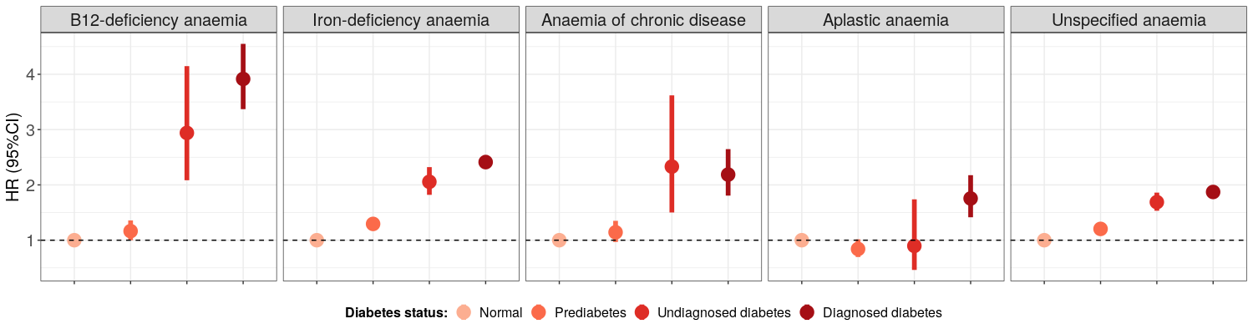**Figure 1. Association between diabetes and anaemia in fully-adjusted models**