**Development of a Novel Neuromodulation Device for Diabetic Peripheral Neuropathy**

**Aim:** Recent research, including our own, indicates that electrical neuromodulation can improve sensory perception and reduce neuropathic pain in individuals with diabetic peripheral neuropathy (DPN). However, no current device enables translation of these findings to long-term, real-world outcomes. This project aimed to develop the first wearable system tailored to this need.

**Methods:** We established user and technical requirements, evaluating multiple circuit and system design options. In parallel, we engaged clinicians and individuals living with DPN to identify design preferences and usability needs. A final prototype was developed based on these insights and within defined cost and timeline constraints.

Results: The resulting device is fully functional and suitable for initial usability and safety testing (Figure 1). Its modular design supports future integration of additional neuromodulation paradigms. The current prototype offers appropriate functionality and form for preliminary trials and lays the foundation for a more comprehensive, personalized solution with further development and funding.

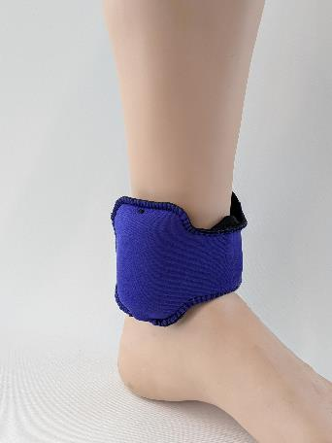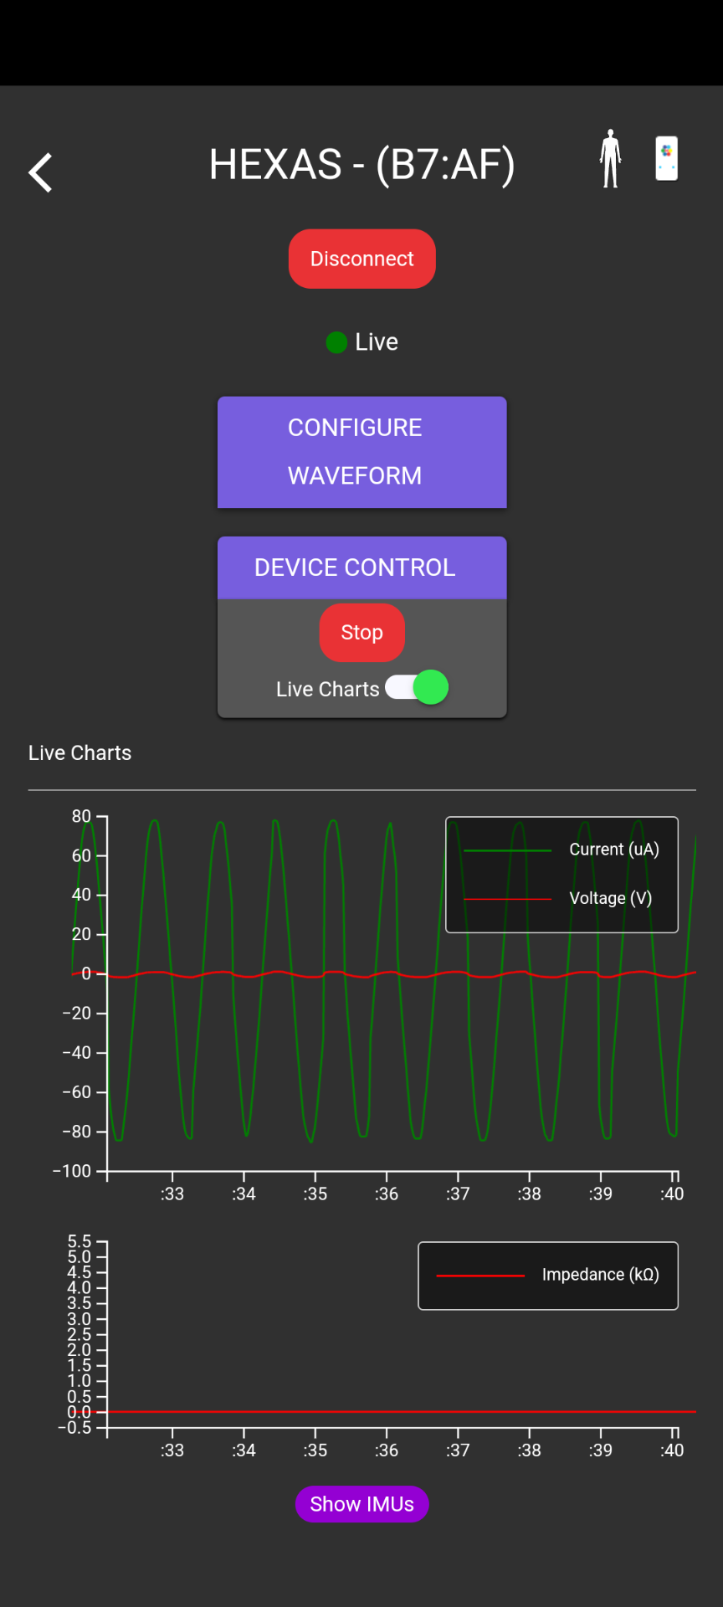

Figure 1. Developed device as worn and associated App.

**Conclusion:** We present the world’s first fully wearable neuromodulation device developed specifically for individuals with diabetic peripheral neuropathy. Initial usability trials will inform future refinements in both electronics and physical design, with the goal of enhancing long-term treatment outcomes.