Performance of exercise during HCT affects in-flight oxygen recommendations
Christopher Lawrence¹, Alanna Bodger¹, Iain Smith¹, Annette Dent^{1,2}, Emma Smith^{3,4}
¹Department of Thoracic Medicine, The Prince Charles Hospital, QLD
²University of Queensland Thoracic Research Centre, QLD
³Department of Respiratory and Sleep Medicine, Austin Hospital, Heidelberg, VIC
⁴Institue for Breathing and Sleep, Austin Hospital, Heidelberg, VIC
Introduction/Aim: Normobaric hypoxic challenge tests (HCTs) can be used to predict whether passengers with respiratory disease require in-flight oxygen. While in-flight oxygen is recommended if SpO₂ falls below 85% during an HCT, there currently exist no national or international standards on the performance of an HCT, and whether the nadir SpO₂ should be obtained from a subject seated quietly at rest, or after performing light exercise. Given the length of flights within and to and from Australia and the resultant possibility that passengers may be unable to remain seated for the entire flight, laboratory practice is to perform two periods of exercise during an HCT: one minute of 8-12 sit-to-stand manoeuvres and one minute of 8-12 stepping manoeuvres to emulate movement around the aircraft cabin.

Method: The results of 409 HCTs performed between 2004 – 2022 were analysed. The nadir SpO₂ on an FiO₂ of 0.15 at rest was compared to that after light exercise, and the recommendation to travel with or without in-flight oxygen compared.

Results: 32 HCTs did not include exercise. Of the remaining 377 tests (median age 64, 49% male), 40 reached their nadir SpO₂ during the seated period of the test (88 ± 5% (mean ± SD)), 205 during the sit-to-stand exercise (81 ± 7%) and 164 during the stepping exercise (82 ± 6%). 201 (53%) of tests may have moved from a recommendation to travel with no oxygen (nadir SpO₂ ≥85%) to travelling with in-flight oxygen (nadir SpO₂ <85%). Agreement between the results of performing the test with and without exercise was poor (raw agreement 46%, Cohen’s Kappa 0.16).
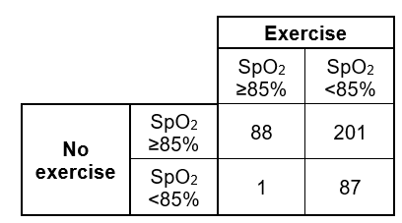

Conclusion: Not incorporating light exercise into an HCT may over-estimate the nadir SpO₂ and may under-estimate the requirement for in-flight oxygen in passengers with respiratory disease.

Key Words: high altitude simulation test, hypoxic challenge test.
Nomination for New Investigator Award: N/A
Grant Support: N/A

