Wānanga/Talanoa/Dialogue or Workshop
Empowering Pacific Children to Adapt to Climate Change Through Traditional Dance and Knowledge

This interactive session explores how traditional Pacific dance and storytelling can empower children to understand and engage with climate adaptation. The Pacific region is highly vulnerable to climate change, and children are often disproportionately affected. Dominant narratives of “sinking islands” can create anxiety while ignoring the deep histories of Pacific peoples’ resilience and adaptive strategies (Nalau et al., 2018). This session demonstrates how Indigenous knowledge, expressed through dance and talanoa (open dialogue), can make climate adaptation more relatable, culturally relevant, and actionable for young learners.

Participants will actively engage in learning a traditional dance that illustrates environmental change and adaptation practices. Through movement, participants will experience how Pacific knowledge systems embed climate resilience within cultural expressions. Following the dance, a storytelling segment will highlight Indigenous narratives of environmental stewardship and adaptation. The session will conclude with a collective talanoa, inviting reflections on how arts-based approaches can foster climate empowerment and intergenerational knowledge sharing.

By integrating performance, narrative, and discussion, this session offers a unique, embodied approach to climate adaptation education. It provides insights into how educators, researchers, and policymakers can incorporate arts-based learning into climate adaptation strategies, particularly for young and vulnerable populations. Experience how dance and storytelling can transform climate communication and inspire agency among Pacific children and youth.

References
Nalau, J., Becken, S., Schliephack, J., Parsons, M., Brown, C., & Mackey, B. (2018). The role of indigenous and traditional knowledge in ecosystem-based adaptation: A review of the literature and case studies from the Pacific Islands. Weather, Climate, and Society, 10(4), 851-865.

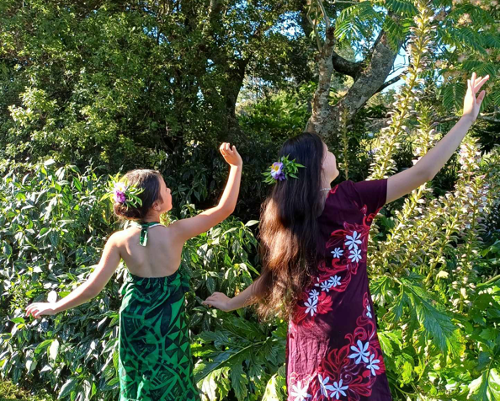

PARTICIPANTS

Participant 1
Full Name: Cilla Brown
Bio:
Cilla is of Samoan, Asian, European descent, and resides in Auckland. She is an Arts Manager, Choreographer, Environmental Educator and Researcher focusing on climate change adaptation and community engagement. Cilla leads initiatives at Pacific Dance NZ, teaches Samoan Siva to young girls, and integrates cultural education with environmental awareness.

Participant 1 Contribution: Presenter and Facilitator

The session will begin with a PowerPoint presentation, followed by a movement and dance workshop. There will be a brief break, followed by a talanoa (open dialogue).
The movement and dance workshop can accommodate up to 30 participants of all physical abilities. Comfortable clothing is recommended, and participants should bring a water bottle, lavalava (sarong) is optional.
Note: People are welcome to attend just the PowerPoint presentation.

