Paper
Envisioning the future of the adaptation solution space: insights from atoll islands

Introduction
Science warms against the potential shrinking, with intensifying global warming, of the range of available options for climate adaptation (1). But to what extent is such a conclusion evidence-based? And what influence do local context-specificities have on such a gloomy assertion? Such questions deserve to be asked in any human settlement on Earth, starting with those being acknowledged at the frontline of climate risks. Atoll islands are among them.

Objectives
This communication presents the conclusions of a Structured Expert Judgment (SEJ) approach that we designed to understand the future of the solution space for climate adaptation in atoll islands (Fig. 1). A group of 15 international scientists with decades of experience in atolls of the Pacific and Indian oceans assessed the potential effectiveness of twenty types of measures to minimise future climate risks, and ranging from engineered and nature-based coastal protection and accommodation, to internal and international relocation. Such a SEJ approach allows to differentiate between long-term transformational processes and only short-sighted fixes, therefore laying foundations for the elaboration of solution-based adaptation pathways.

Methods
SEJ methods are especially useful to bring together multiple types of information (quantitative and qualitative, published and non-published, the human experience) and integrate a diversity of context specificities and worldviews (2,3,4). The SEJ method that we designed has been driven by a series of simple questions: are all measures “solutions”, until when, for how long and under which conditions?
The method relies on a scoring system (1-5) to assess four criteria for each of the potentially relevant adaptation measures in atoll contexts (see Fig. 1 for details): potential to reduce climate risks, readiness to implementation, lead time to achieve full benefits, and duration of these benefits. The scoring exercise considers three contrasting types of atoll islands reflecting various geomorphological features and a urban-rural gradient. It also contrasts various warming scenarios, time periods, and adaptation scenarios.

Findings
Preliminary results —final analysis in progress at the time of writing this abstract— show that the future of the solution space is intrinsically dependent of the island types), future global greenhouse gas emissions and adaptation efforts. For all island types, the combination of ambitious mitigation and adaptation scenarios clearly allow for the solution space to remain relatively open, hence able to support the long-term habitability of atoll island communities. The study shows, however, that differentiated combinations of measures are to be considered according to different island types, and so that there is no one-size-fits-all adaptation pathway for atoll islands.

Implications for science, policy and practice
Both the SEJ approach and conclusions highlight a practical way to develop sound (because connecting present and future challenges), flexible (pathway) and localised adaptation strategies, at the community scale. The next step, which we are currently deploying in some atoll case studies, consists of running the SEJ with another poll of experts, namely local/Indigenous people and practitioners. The aim is to both contrast and bring together scientific and local perspectives to support the co-design of adaptation pathways.

Figure 1. Overview of the approach.

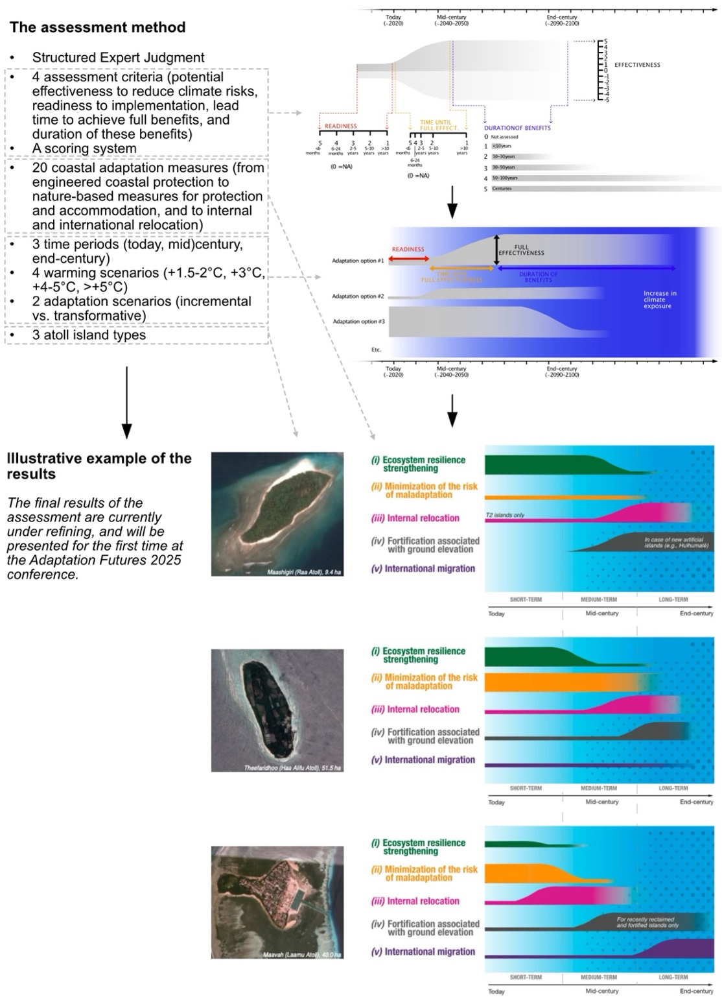

References
- Haasnoot M., et al. (2021). https://www.science.org/doi/10.1126/science.abi6594
- Mach K., et al. (2017). https://doi.org/10.1016/j.gloenvcha.2017.02.005
- Majszak M., Jebeile J. (2023). https://doi.org/10.1016/j.shpsa.2023.05.005
Magnan A.K., et al. (2025). https://doi.org/10.1016/j.crm.2025.100692

