Small is better... when reversing peripheral airway dysfunction in asthma
C.F. O’Sullivan^{1,2,3}, K. Nilsen¹, G.K. Prisk⁴, B.R. Thompson^{1,5}
¹Respiratory Physiology, The Alfred Hospital, VIC, Australia
²Monash University, VIC, Australia
³Newcastle University, Newcastle Upon Tyne, UK
⁴Department of Medicine, University of California, San Diego, USA
⁵University of Melbourne, School of Sciences, VIC, Australia
Introduction/Aim:
Peripheral airway dysfunction function is associated with airway hyperreactivity and symptom burden in asthma, however the efficacy of inhaled medication targeting peripheral airway regions has not been assessed with sensitive measures. This study measured response to small and large particle aerosol bronchodilator with assessment of conductive and peripheral airway function via MBW and spatial ventilation via MR scans.
Method:
10 subjects with asthma completed spirometry, multi-breath nitrogen washout to measure conductive (S_{cond}) and acinar (S_{acin}) ventilation heterogeneity, forced oscillation technique, and specific ventilation imaging (SVI) to measure the spatial heterogeneity of ventilation. Tests were performed at baseline following a 24-hour drug withhold and post 30µg SABA delivered via vibrating mesh nebuliser on two visits; a large (6.2μm) and small (2.6μm) particle visit.
Results:
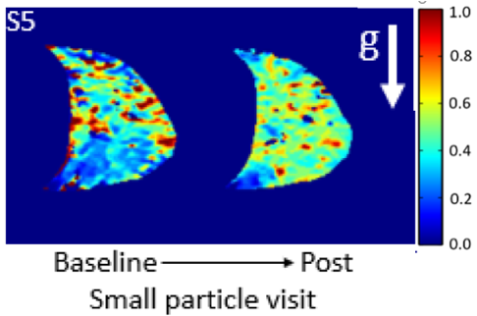
Small particle SABA achieved a statistically significant improvement from baseline for more parameters compared to large particle (12 vs 2). A greater number of subjects achieved a clinically significant spirometric response with small particle SABA compared to large (5 subjects vs 1). Of those ‘responders’ a greater reversal of airway dysfunction was seen post small particle bronchodilator for: ΔFEV₁mL 510±170 (small) vs 226±151 (large), p=0.01, ventilation heterogeneity ΔS_{acin} (L⁻¹) -0.041±0.0007 (small) vs 0.013±0.027 (large), p=0.02, and airway closure ΔDR2vol (% of TLC) -7.7±3.2 (small) vs 1.0±5.3 (large), p=0.01. Reversal of abnormal distribution of specific ventilation was seen in some subjects (figure) however there was no difference between response to small and large BD.

Figure: Asthma subject specific ventilation maps at baseline (left) demonstrated abnormal distribution of SV, which is greatest in non-dependent lung, post-small particle bronchodilator (right) specific ventilation was more homogenous.
Conclusion:
Small particle aerosol bronchodilator is superior to large particle in reversing peripheral airway dysfunction for some patients, highlighting the importance of patient phenotyping for personalised medicine in airway therapy.

Key Words: Peripheral airway function, aerosol, asthma, ventilation heterogeneity

