Referrals to a home-based multidisciplinary intervention for breathless COPD patients
Akhunji M^{1,2}, Smith T³, Smith S^{4,5}, Cochrane B^{1,6}
¹Department of Respiratory and Sleep Medicine, Campbelltown and Camden Hospitals, South Western Sydney Local Health District, Sydney, NSW, Australia
²South Western Sydney Clinical School, University of New South Wales, Sydney, NSW, Australia
³Department of Respiratory and Sleep Medicine, Westmead Hospital, Western Sydney Local Health District, Sydney, NSW, Australia
⁴School of Nursing and Midwifery, Western Sydney University, Sydney, NSW, Australia
⁵Greater Brisbane Clinical School, Faculty of Medicine, University of Queensland, Brisbane, QLD, Australia
⁶Western Sydney University, School of Medicine
Introduction/Aim: Refractory dyspnoea in COPD is associated with poor prognosis, worse quality of life and healthcare utilisation. Previous studies found integrative clinics effective at improving breathlessness, however COPD patients were largely unrepresented. We developed a primarily home-based multidisciplinary clinic to help address breathlessness in COPD patients. We aimed to characterise referrals to the programme to inform its systematic implementation.
Methods: Here we describe the population enrolled into a nine-week, open label, single arm, intervention targeting patients with clinical and spirometric diagnosis of COPD. Eligibility included disabling shortness of breath determined by a Modified Medical Research Council scale score ≥2, age ≥40 years and subjectively sufficient English proficiency and cognition. Clinic protocols involved physician assessment for causes of dyspnoea and optimised medical management according to appropriate guidelines. Non-pharmacological strategies to enhance self-management of breathlessness were employed by a multidisciplinary team comprised of an occupational therapist, specialist nurse and physiotherapist.
Results: Of 92 participants, 57 were female and 12 current smokers. By Montreal Cognitive Assessment, 46/86 subjects had mild, three moderate and one severe cognitive impairment. Mini Nutritional Assessment indicated 22% of participants were malnourished. Furthermore, 69% of participants scored abnormally on the anxiety subscale of the Depression Anxiety and Stress Scale 21 (DASS-21), with 26/90 extremely severe, while 61% of subjects had abnormal scores on the depression subscale (13/90 extremely severe).
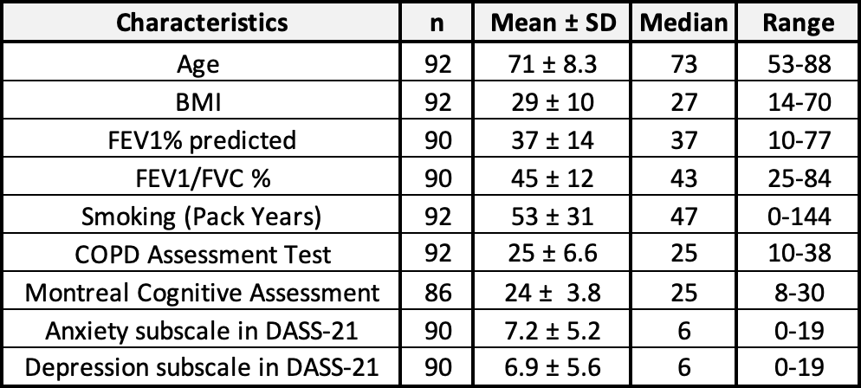
Conclusion: Breathlessness in COPD patients is multifactorial, supporting the use of an interdisciplinary intervention. Given the high frequency of cognitive impairment, cognition assessment prior to enrolment is essential. Levels of malnutrition and psychological symptoms suggest the importance of dietitian and clinical psychologist involvement. Future analyses will focus on the intervention’s impact on dyspnoea severity, quality of life and healthcare outcomes.
Key Words: COPD, dyspnoea, home-based, multidisciplinary.
Grant Support: Research funding from GlaxoSmithKline without contribution to study design, protocol or reporting of results.
Declaration of interest: Nil to declare.

