Paper
Security in a changing climate: adaptation to climate change and peacebuilding in coastal communities affected by violent conflict

Graphical/Visual Abstract and Caption
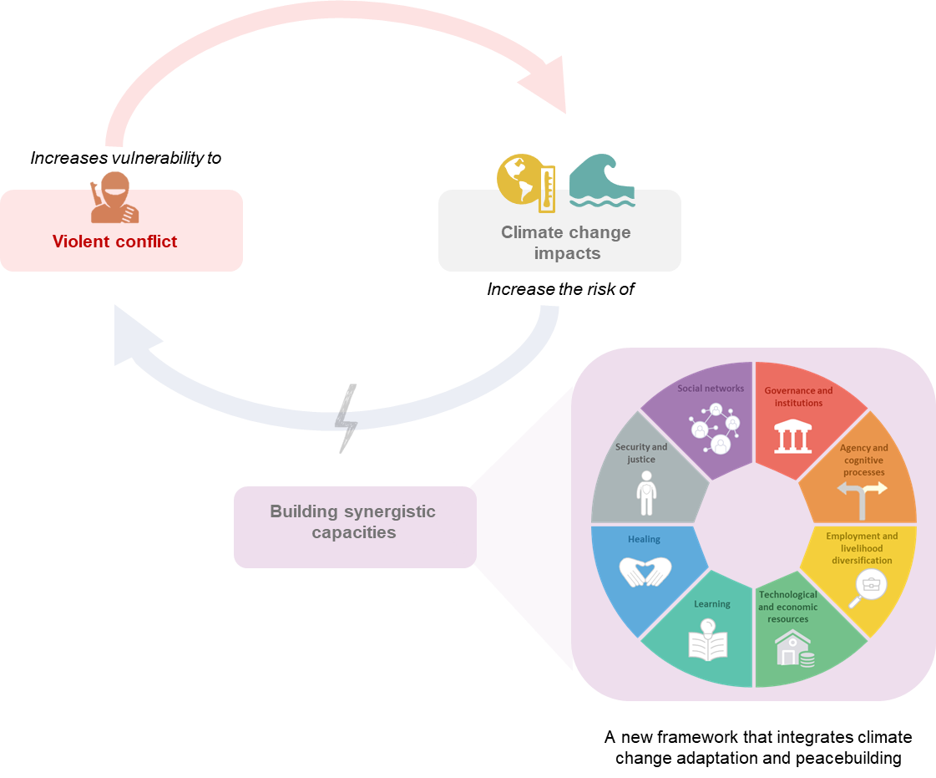

Caption: The climate change–violent conflict interaction creates a negatively reinforcing cycle where conflict increases vulnerability to climate change, and climate change impacts increase the risk of violent conflict. To break the cycle, we developed a new framework that integrates climate change adaptation and peacebuilding concepts and builds synergistic capacities in conflict-affected communities.

Introduction
Climate change and violent conflict have intense and combined effects on coastal communities. Coastal communities affected by conflict and climate change experience displacement and movement restrictions that limit the capacity to recover from these impacts. Climate adaptation and peacebuilding organisations implement projects to be prepared for and minimise these impacts (Fernández Arribas, 2023; Ide, 2021; Pérez Marulanda & Castro, 2022). But these projects are implemented in separate policy sectors and hardly interact across sectoral silos (Buhaug & von Uexkull, 2021; Ide et al., 2023; Vivekananda et al., 2014). Existing research on climate change and conflict has long-analysed the relationship between changing temperature and rainfall patterns and conflict-related variables (Buhaug, 2010; Busby et al., 2018; Hendrix et al., 2022; Ide, 2023; Mach, 2019; Raleigh & Urdal, 2007; Salehyan & Hendrix, 2014; Slettebak, 2012; Theisen, 2008; von Uexkull et al., 2020). However, there is a limited understanding of climate impacts in conflict-affected communities and how climate change adaptation and peacebuilding can be integrated to respond to these impacts.

Objectives
In this research, we draw on climate change adaptation and peacebuilding theories to empirically analyse the capacities that climate change adaptation and peacebuilding projects are building, how they interact and identify potential ways to integrate climate adaptation and peacebuilding.

Methodology
We used a case study and two data collection methods (a) semi-structured interviews with key informants and (b) document analysis. The study site was Cispatá Bay, located in the Caribbean Sea, Colombia; a 27,000-acre mangrove forest that provides food and protection from storm surges to Indigenous and Afro-descendant coastal communities. We conducted confidential, semi-structured interviews with 16 participants who were asked to represent their organisation or group, classified as either a ‘climate change adaptation organisation’ or a ‘peacebuilding organisation’. To identify the capacities that climate change adaptation and peacebuilding projects were building, we asked the participants about the goals, projects, and actions involved. We also asked them to describe the difficulties they have faced and their recommendations for overcoming these difficulties. To supplement the qualitative analysis secondary demographic, economic, and employment data was also extracted from relevant institutional reports, and organisational documents (qualitative and quantitative) (n=45) in Spanish and English published between 2010 and 2023.

Findings
Our results show that climate change adaptation and peacebuilding organisations were building capacities through separate, siloed projects. Climate adaptation organisations focused on developing capacities for these domains: assets, flexibility, organisation, learning, socio-cognitive constructs and agency. Peacebuilding organisations were building capacities in projects categorised into these components: social, economic, and environmental, governance and political, security, and truth and reconciliation. However, these capacities often overlap. We found six major overlaps for climate adaptation and peacebuilding: access to information, education, social networks, employment, environmental management, and healing. There were also two glaring gaps: protection and/or safety and socio-cognitive constructs. Drawing on the overlaps and gaps, we developed a new framework centred on building synergistic capacities in climate and conflict-affected communities. We identified eight major elements that can help build climate resilience and peace: Governance and institutions; Agency and cognitive processes; Employment and livelihoods diversification; Technological and economic resources; Learning; Healing; Security and justice; and Social networks.

Significance of the work for policy and practice
Our research has important implications for translating conceptualisations of the climate-conflict relationship into policy and planning. Using the new framework in policy design, governments and organisations can create comprehensive interventions that address the combined challenges of climate change and conflict; including strengthening governance structures, enhancing equitable access to resources, developing economic opportunities, and building trust and social cohesion to create conflict-sensitive climate adaptation and development solutions.

References
Buhaug, H. (2010). Climate not to blame for African civil wars. Proceedings of the National Academy of Sciences - PNAS, 107(38), 16477-16482. https://doi.org/10.1073/pnas.1005739107
Buhaug, H., & von Uexkull, N. (2021). Vicious Circles: Violence, Vulnerability, and Climate Change. Annual review of environment and resources, 46(1), 545-568. https://doi.org/10.1146/annurev-environ-012220-014708
Busby, J., Smith, T. G., Krishnan, N., Wight, C., & Vallejo-Gutierrez, S. (2018). In harm's way: Climate security vulnerability in Asia [Article]. World Development, 112, 88-118. https://doi.org/10.1016/j.worlddev.2018.07.007
Fernández Arribas, G. (2023). Cambio climático, inestabilidad y desplazamientos en el Sahel. Desafíos y respuesta por parte de la Unión Europea [Climate change, instability and displacement in the Sahel. Challenges and the EU response.]. Revista Española de Derecho Internacional, 75(1). https://www.revista-redi.es/redi/article/view/63
Hendrix, C. S., Glaser, S. M., Lambert, J. E., & Roberts, P. M. (2022). Global climate, El Niño, and militarized fisheries disputes in the East and South China Seas [Article; Early Access]. Marine Policy, 143, 6, Article 105137. https://doi.org/10.1016/j.marpol.2022.105137
Ide, T. (2021). La construccion de la paz ambiental. https://www.instituto-capaz.org/wp-content/uploads/2021/03/DT-1-2021espanol-v6.pdf
Ide, T. (2023). Climate, Women, and Conflict: Rebel Groups' Armed Activities after Major Disasters [Article]. Global Studies Quarterly, 3(3), Article ksad039. https://doi.org/10.1093/isagsq/ksad039
Ide, T., Johnson, M. F., Barnett, J., Krampe, F., Le Billon, P., Maertens, L., von Uexkull, N., & Vélez-Torres, I. (2023). The Future of Environmental Peace and Conflict Research. Environmental Politics, 32(6), 1077-1103. https://doi.org/10.1080/09644016.2022.2156174
Mach, K. J. K., Caroline M.; Adger, W. Neil; Buhaug, Halvard; Burke, Marshall; Fearon, James D.; Field, Christopher B.; Hendrix, Cullen S.; Maystadt, Jean-Francois; O'Loughlin, John; Roessler, Philip; Scheffran, Jürgen; Schultz, Kenneth A.; von Uexkull, Nina. (2019). Climate as a risk factor for armed conflict. Nature (London), 571(7764), 193-197. https://doi.org/10.1038/s41586-019-1300-6
Pérez Marulanda, L., & Castro, A. (2022). Marco conceptual para medir las contribuciones de las intervenciones en agricultura para mitigar el cambio climático y construir paz. https://cgspace.cgiar.org/items/7f37de9e-2323-4e6c-944a-7c29517189fd
Raleigh, C., & Urdal, H. (2007). Climate change, environmental degradation and armed conflict [Article]. Political Geography, 26(6), 674-694. https://doi.org/10.1016/j.polgeo.2007.06.005
Salehyan, I., & Hendrix, C. S. (2014). Climate shocks and political violence [Article]. Global Environmental Change, 28(1), 239-250. https://doi.org/10.1016/j.gloenvcha.2014.07.007
Shimada, G. (2022). The impact of climate-change-related disasters on africa’s economic growth, agriculture, and conflicts: Can humanitarian aid and food assistance offset the damage? [Article]. International Journal of Environmental Research and Public Health, 19(1), Article 467. https://doi.org/10.3390/ijerph19010467
Slettebak, R. T. (2012). Don't blame the weather! climate-related natural disasters and civil conflict [Article]. Journal of Peace Research, 49(1), 163-176. https://doi.org/10.1177/0022343311425693
Theisen, O. M. (2008). Blood and soil? Resource scarcity and internal armed conflict revisited [Review]. Journal of Peace Research, 45(6), 801-818. https://doi.org/10.1177/0022343308096157
Vivekananda, J., Schilling, J., & Smith, D. (2014). Climate resilience in fragile and conflict-affected societies: Concepts and approaches [Article]. Development in Practice, 24(4), 487-501. https://doi.org/10.1080/09614524.2014.909384
von Uexkull, N., d’Errico, M., & Jackson, J. (2020). Drought, Resilience, and Support for Violence: Household Survey Evidence from DR Congo [Article]. Journal of Conflict Resolution, 64(10), 1994-2021. https://doi.org/10.1177/0022002720923400

