Accelerometry daily steps count predicts overall survival in malignant pleural effusion patients
Pedro Lopez^{1,2}, Emily Jeffery³, Sanjeevan Murugananda⁴, Ken K. P. Chan⁵, David C. L. Lam⁶, Joanne A. McVeigh^{7,8}, Robert U. Newton⁹, Deidre Fitzgerald^{1,2}, Yun Chor Gary Lee^{1,2}, Carolyn J. Peddle-McIntyre^{1,9}
¹Pleural Medicine Unit, Institute for Respiratory Health, Perth, WA, Australia;
²Medical School, Faculty of Health & Medical Sciences, University of Western Australia, Perth, WA, Australia;
³School of Population Health, Curtin University, Bentley, WA, Australia;
⁴Respiratory Medicine, Northern Health, Epping, VIC, Australia;
⁵Department of Medicine and Therapeutics, Prince of Wales Hospital, The Chinese University of Hong Kong, Shatin, Hong Kong;
⁶Department of Medicine, Queen Mary Hospital, The University of Hong Kong, Hong Kong;
⁷Curtin School of Allied Health, Curtin University, Perth, WA, Australia;
⁸enAble Institute, Faculty of Health Sciences, Curtin University, Perth, WA, Australia;
⁹Exercise Medicine Research Institute, Edith Cowan University, Joondalup, WA, Australia.
Introduction/Aim: To investigate the association of accelerometry-derived daily step count with 3-year overall survival (OS) in patients with malignant pleural effusion (MPE).
Methods: This is a pooled analysis of 5 studies in patients with MPE. Activity behaviour was captured using 7-day accelerometry (Actigraph GT3X+) and survival information was collected from medical records. Participants were divided into two groups based on median number of steps: high (n=81, median of 7509 [interquartile range (IQR):5699;9844] steps/day) and low steps (n=82, 2940 [IQR:1676;3947] steps/day). Data were analysed with Cox regression analyses (hazard ratio [HR] and 95% confidence intervals [95%CI]) and Kaplan–Meier method to explore the association of daily step count with 3-year OS.
Results: A total of 163/222 MPE patients had complete accelerometry and survival information. The high steps group exhibited greater light (+1.3 hours), moderate-to-vigorous activity (+9.7 minutes) and waking wear time (+1.1 hours) and less time sedentary (-0.6 hour) per day than the low steps group (p<0.001). With 57 and 72 deaths in the high and low steps group, respectively, an unadjusted HR of 0.50 (95%CI, 0.35-0.71) was observed for those in the high steps group. The high steps group presented a median 3-year OS of 18.9 (95%CI, 13.4-24.3) months vs. 9.3 (95%CI, 6.2-12.4) months in low steps (Figure 1; Kaplan-Meier Log-Rank, χ2=16.0, p<0.001). An adjusted HR of 0.51 (95%CI, 0.27-0.97) was observed for patients presenting with high number of steps after controlling for Eastern Cooperative Oncology Group status (0, 1, 2, and 3), age, sex, cancer type (non-mesothelioma, non-epithelioid mesothelioma, epithelioid mesothelioma), serum albumin, enrolled trial, accelerometry waking wear time, sedentary time and light physical activity time.
Conclusion: Accelerometry-based step count measurement is a meaningful prognostic marker in patients with MPE, even after controlling for established prognostic factors. Accelerometry may add value to existing prognostic models.
Grant Support: N/A; Declaration of Interest Statement: Nothing to disclose.
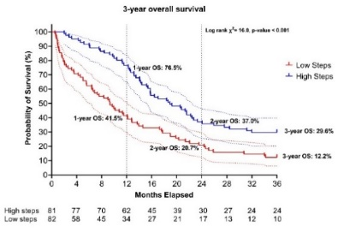
Figure 1. Kaplan-Meier 3-year overall survival (OS) curve stratified by low and high number of steps. Dotted lines represent 95% confidence intervals.

