TSANZ Abstract 2026

Abstract Title: Assessing Collateral Ventilation via Advanced Imaging for Pre-Procedure Planning in Bronchoscopic Lung Volume Reduction

Nilsen K¹, Eikelis N¹, Wilmhurst M¹, Marchetti N², Rashid M², Walia P², Criner H², Hatt C¹, Criner GJ²
¹4DMedical Limited, Melbourne, Australia
²Temple University Hospital, PA, USA

Introduction/Aim: Bronchoscopic lung volume reduction (BLVR) is an approved treatment for advanced emphysema, using endobronchial one-way valves (EBVs) to collapse a target lobe. BLVR has been shown to improve lung function, reduce hyperinflation, and alleviate dyspnea. However, successful lobe collapse can be hindered by collateral ventilation (CV), airflow between lobes due to incomplete fissures. This study aims to determine whether advanced CT imaging can more accurately assess CV, potentially improving BLVR outcomes.
Method: In this prospective study, 30 participants aged 40 years and older were recruited at Temple University Hospital, USA. Collateral ventilation (CV) was determined using Chartis assessment as the reference standard. Paired inspiratory–expiratory CT scans were used to generate advanced ventilation images (CT LVAS, 4DMedical) and density/emphysema maps (LDAf, IMBIO). These images were analyzed to evaluate ventilation and emphysema distribution within the fissure region as predictors of CV. A weighted factor model was applied, and results were validated using k-fold cross-validation to ensure robustness.
Results: Our weighted model, incorporating LDAf density scoring and ventilation assessment in the fissure region, predicted CV with an accuracy of 0.97, an area under the curve (AUC) of 0.94, sensitivity of 0.9, and specificity of 1. The use of repeated stratified k-folds cross-validation further reinforced the consistency of our findings, yielding a mean accuracy of 94%.
Conclusion: This study demonstrates that employing advanced imaging techniques for CV detection in BLVR pre-planning is highly effective. The novel approach offers a more efficient and less invasive diagnostic alternative, holding significant promise for enhancing the accuracy of BLVR procedures and ultimately improving patient outcomes.

Figure 1: The predicted probability of each subject being CV-positive(+) from the weighted model. The blue crosses indicate CV-positive subjects, while red dashes indicate CV-negative(-) subjects according to Chartis.

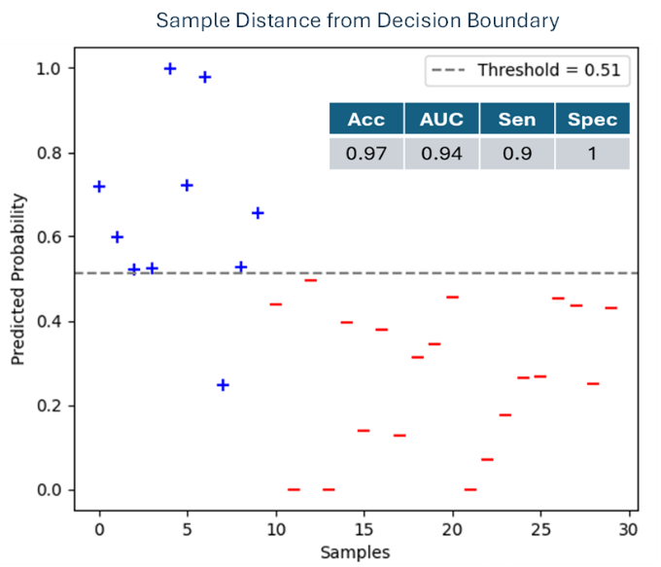

Key Words: Emphysema, lung volume reduction, COPD, collateral ventilation, BLVR

