Abstract Title: Novel Contrast-Free CT VQ matching predicts poor gas exchange in subjects with COPD (COPDgene database)

Nilsen K¹, Eikelis N¹, Power. S, Fouras A¹, Hatt C¹
¹4DMedical, Melbourne, VIC, Australia

Introduction: Both adequate ventilation and perfusion are essential for effective gas exchange in the lungs. In Chronic Obstructive Pulmonary Disease (COPD), airway obstruction, uneven ventilation distribution, and emphysematous loss of perfusion disrupt the V/Q ratio. Conventional assessment of ventilation–perfusion mismatch typically relies on nuclear medicine scans, which are costly and not widely accessible. Here, we present a novel imaging approach (4DMedical™) that utilizes non-contrast, paired inspiratory–expiratory breath-hold CT to evaluate regional ventilation and perfusion matching in COPD.

Method: Permission to access the COPDGene database was obtained. A total of 3,162 subjects were randomly selected, and their imaging and physiological data were accessed for analysis. For each subject, a non-contrast, paired inspiratory–expiratory CT was used to generate three-dimensional regional ventilation–perfusion (V/Q) maps. Defect regions of low ventilation with normal perfusion and low perfusion with normal ventilation were identified and quantified. Standard pulmonary function results, including spirometry and diffusing capacity for carbon monoxide (DLCO), were compared with imaging-derived measures of lung function.

Results: The proportion of lung exhibiting V/Q mismatch increased significantly with higher COPD GOLD stages (p < 0.001; Figure 1B) and correlated with DLCO % predicted (R² = 0.48). Subjects were further categorized by COPD phenotype. V/Q mismatch proportion correlated with DLCO in both emphysema (R² = 0.45) and chronic bronchitis (R² = 0.46), whereas in asthma (R² = 0.60), the correlation was observed with FEV₁/FVC ratio.

Conclusion: This study demonstrates that the proportion of V/Q mismatch directly affects the efficiency of gas exchange. The imaging approach enables visualization of where mismatches occur within the lung. Beyond providing structural information, CT scans can now generate functional ventilation and perfusion data, potentially supporting personalized medicine and tailored management of respiratory disease.
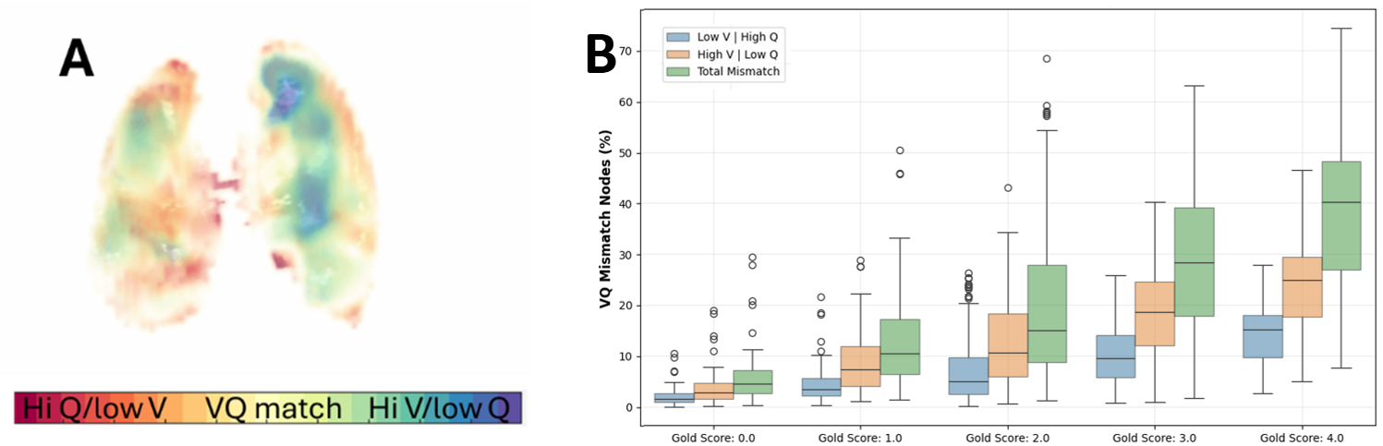
Figure 1: A) 3D visualization of VQ matching. B) VQ matching defect proportion by GOLD score

Key Words: COPD, VQ matching, DLCO, imaging

