PSGN induced diffuse alveolar haemorrhage in the context of vaping
Geraud Freer¹, Nagaraj Pandharikar², Geshani Jayasuriya³
¹ John Hunter Hospital Australia, Department of Paediatric Intensive Care
² John Hunter Hospital Australia, Department of Paediatric Intensive Care
³ John Hunter Hospital Australia, Department of Paediatric and Respiratory Medicine
Introduction/Aim: Diffuse alveolar haemorrhage (DAH) is a life-threatening complication which is associated with many clinical entities but its association with post streptococcal glomerulonephritis (PSGN) is rare and more so in children. It is also increasingly reported with use of vaping. We present a case of DAH in the context of PSGN and vaping exposure in an adolescent.

Case report: A 14-year-old boy presented with 2 days of dyspnoea, haemoptysis and haematuria. Two weeks prior he received a course of oral penicillin by his primary care provider for tonsillitis. He had a history of vaping for eight months, approximately 300 inhalations per day and was smoking 3 cigarettes per week. He had no other significant past medical and travel history. His chest X-ray demonstrated bilateral airspace opacification with varying degrees of confluence, more prominent on the right (Figure A). CT chest demonstrated bilateral patchy airspace infiltrates consistent with DAH (Figure B). The patient received intravenous hydrocortisone because of his history of vaping and possible diagnosis of E-cigarette or vaping product associated lung injury (EVALI). Upon admission to PICU at our hospital he was commenced on non-invasive ventilation for respiratory distress. He had acute kidney injury (AKI), fluid overload and hyperkalaemia which were managed medically. Further investigations revealed elevated antistreptolysin O antibodies (802IU/ml), low C3 (0.13G/l) and normal C4 (0.18) consistent with diagnosis of PSGN. High dose methylprednisolone therapy (30 mg/kg/day) was given for 5 days for provisional diagnosis of DAH secondary to PSGN/EVALI and proven benefit in previous cases. He was successfully weaned off respiratory support and had no further episodes of haemoptysis.

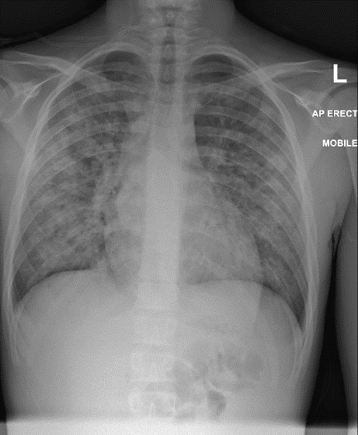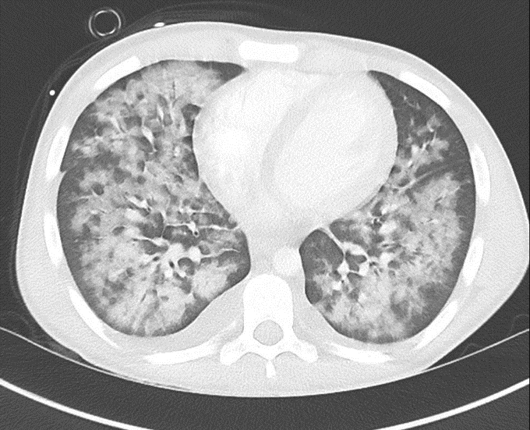
Figure A Figure B

Conclusion:
We present a paediatric case of diffuse alveolar haemorrhage in a patient with post streptococcal glomerulonephritis with a significant history of vaping. This presentation is very rare in children and adolescents and is described only in 2 other paediatric case reports. We think it is possible that the history of smoking and vaping may have increased the risk of pulmonary haemorrhage in our patient. We think early steroid therapy may have been beneficial and should be considered in such patients.

Grant Support: Nil

