Title | Paper  Research by Design as a novel approach to climate adaptation in coastal cities: a South-East Queensland case study
Introduction | Sea-level rise due to climate change necessitates adaptation in coastal cities to prevent failure of coastal infrastructure and assets, including open space, stormwater and roads. Coastal cities will face permanent and temporary inundation due to combined sea level rise and riverine and local catchment flooding. Local authorities are faced with retreating and abandoning assets, defending (keeping the water out), or raising or adapting existing land-use to accommodate inundation.  The “wicked problems” associated with adaptation encourages testing novel approaches to resolve the engineering and urban design challenges to ensure holistic, integrated adaptation responses.
Objective | In Australia, responsibility for adaptation primarily lies with local governments, yet there is little guidance on how to implement physical adaptation in a way that is well-integrated with urban design. This leads to reactive, business as usual (BAU) adaptation through heavily engineered solutions, which are disconnected from place and community. The primary driver for an alternative project approach was that drainage modelling already identified that upgrading existing stormwater capacity alone was not adequate to mitigate expected drainage issues in low-lying areas.
Methodology | Using two existing, urban case-study areas in South-East Queensland, the project investigated options for adapting public realm to >1m sea level rise by 2100, including resolving urban design and engineering issues such as stormwater drainage and interfaces to private realm.  Three adaptation strategies were investigated:  - Do nothing (managed retreat)  - Edge raising with linear barriers and significant stormwater infrastructure, including backflow prevention, pump stations, lock and weirs systems.  - Raising roads and public space, including resolving transitions to private property, and stormwater drainage augmentation, services and street trees within road corridors and public space.  Through a multi-disciplinary, collaborative process, involving community engagement, engineering, urban design and economic analyses, a “treatment toolkit” was proposed. Shortlisted treatments for road raising and defensive scenarios were then investigated in plan, section and three-dimensions to test integration with existing urban form, potential staging and resolving transitions to private infrastructure (which is assumed to gradually transition to higher levels through traditional planning mechanisms).
Findings | There is a lack of guidance on adaption in an Australian context, particularly adaptation that is strongly integrated in urban design. Combining stormwater engineering with urban design and placemaking is crucial for effective adaptation.  The approach undertaken allowed testing of options and resolving urban design and engineering challenges. The process undertaken invites further community and stakeholder engagement in the final solutions by presenting a series of possibilities and appreciation of constraints which community stakeholders can interact with, rather than presenting a “locked in” design.  The toolkit forms the basis of possible future engagement and co-design strategies by improving community understanding of the range of adaptation options available (particularly elements which have not been previously extensively applied in Australian urban design or stormwater planning) and the various values and practical planning and engineering constraints of integrating these options.  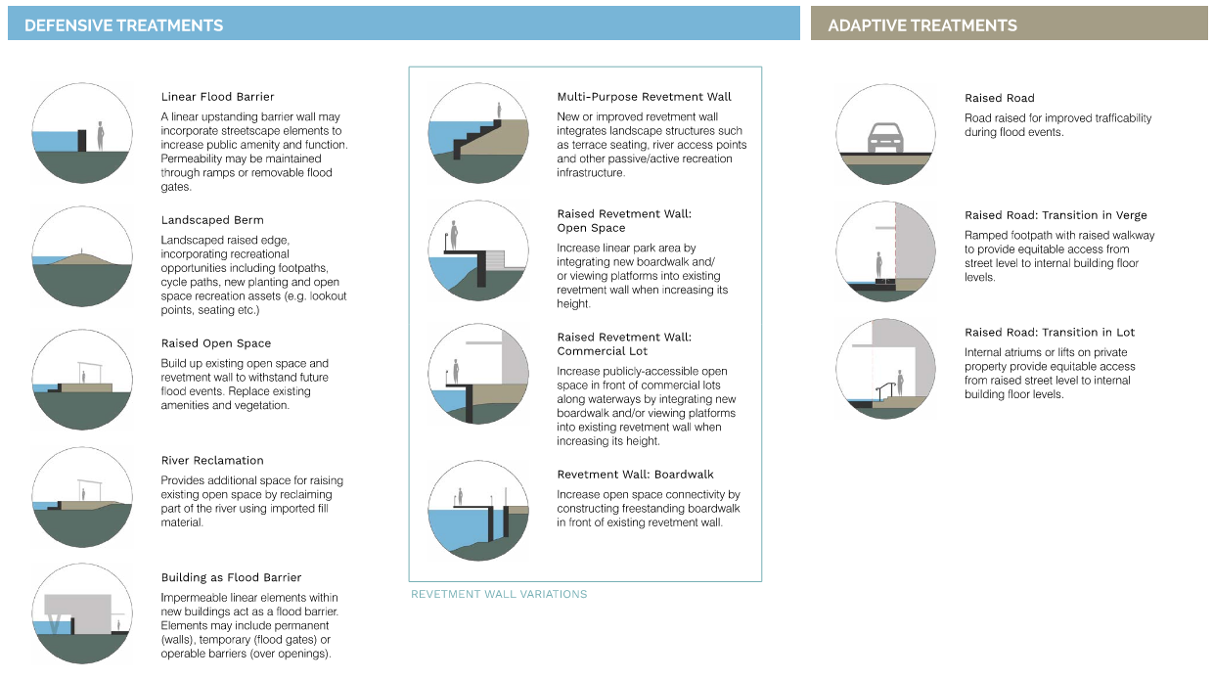  Figure 1: Excerpt from Adaptation Treatment Toolbox (Bligh Tanner and Place Design Group)
Significance of the work for policy and practice | This project represents one of the first large-scale local coastal adaptation initiatives in Australia. “Research by Design” study, is a relatively novel but powerful approach to coastal adaptation. Rather than prescribing a rigid master plan, the study investigates how adaptation strategies could be implemented in specific locations. Integrating stormwater engineering with urban design prevents the typical decoupling that results in business-as-usual solutions. Lessons from this approach offer a valuable reference for other Australian coastal authorities as they respond to climate adaptation challenges.

