Managing screen-detected lung cancers and the effect of age
Kirsten Bennett^{1,2}, Kim Betts³, Conor Murray⁴, Peter Franklin⁵, Nola Olsen⁵, Nick de Klerk⁵, Fraser Brims^{1,2,6}
¹Curtin Medical School, Curtin University, WA, Australia
² Department of Respiratory Medicine, Sir Charles Gairdner Hospital, WA, Australia
³School of Population Health, Curtin University, WA, Australia
⁴ChestRad, Nedlands, WA, Australia
⁵School of Global and Population Health, University of Western Australia, WA, Australia
⁶Institute for Respiratory Health, Curtin University, WA, Australia
Introduction: The optimal cut-off age for lung cancer screening is not known. The U.S. screen until 80 years-old, U.K. until 74yrs and Australia’s nationwide program will screen until 70yrs. The aim of this study is to analyse outcomes of lung cancer screening in older adults with asbestos exposure.
Method: The Western Australian Asbestos Review Program has used low dose CT for lung cancer screening since 2012. Inclusion requires minimum 3 months asbestos exposure, regardless of smoking status with no age cut-off. We analysed the treatment and survival of participants diagnosed with lung cancer during the first 10 years of screening. Date of censor 19 Sep 2023.
Results: From 2,131 individuals, 55 lung cancers were diagnosed in 52 participants (2.4%). 88% were male, 8% never smokers, and 75% former smokers with median 25 pack years exposure (IQR 8-50). Median age at diagnosis was 79yrs (72-82). 41/55 (75%) cancers were stage 1, with 71% treated with curative intent (surgery or SABR). Adenocarcinomas were most common (55%) and where mutation analysis was undertaken in 20/55 (36%), PDL1 (50%) and KRAS (43%) were most frequent. At censor, 32/52 (62%) were alive with a median survival of 908 days (345-1695).
33/52 (64%) participants with lung cancer were over 75yrs and 20/52 (39%) were over 80yrs. There was no significant difference in survival in those receiving curative treatment >75yrs vs. <75yrs (p=0.3) or >80yrs vs. <80yrs (p=0.06), although a trend is apparent in figure 1. The 5-year survival in over 75yrs with treatment was 60% (95% C.I. 40-89%), and 42% (16-100%) in over 80yrs.
Conclusion: It may be appropriate in some individuals >80yrs to offer treatment for screen detected lung cancer, thus, fitness for treatment may be an important metric for inclusion in screening eligibility. Overdiagnosis and low numbers should be considered when interpreting these data.
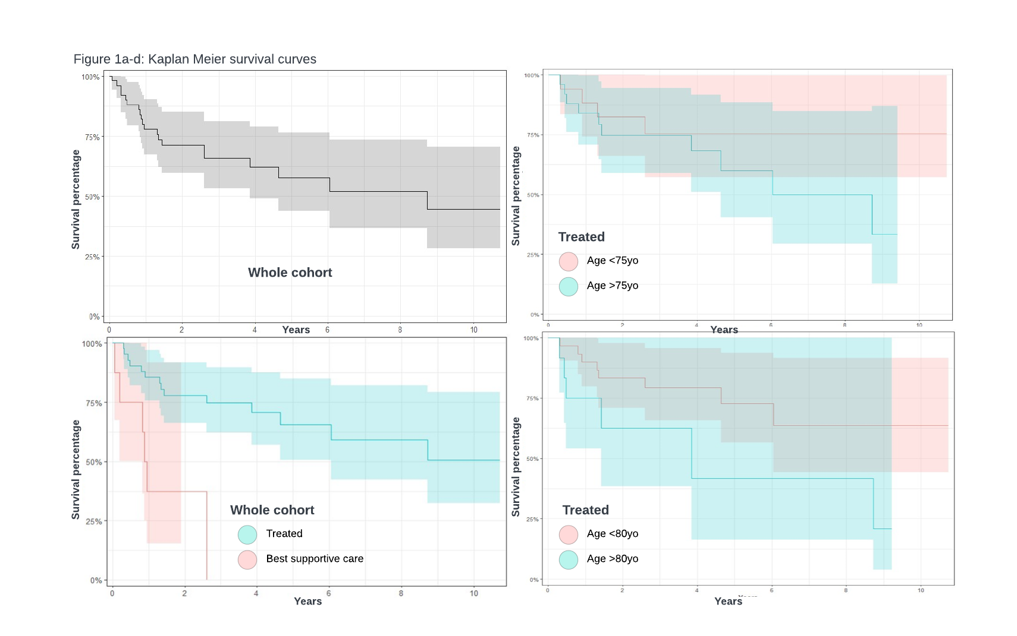
Grant support: Australian Government Research Training Program Scholarship, Charlies Foundation, NHMRC.
Key words: lung cancer, screening, asbestos

