Paper
Identifying priority actions for climate change adaptation and mitigation across the built environment life stages: practitioner perspectives

Introduction
Built environments are key contributors to climate change - the greenhouse gas emissions (emissions) attributed to urban areas estimated to be 67-72% of the global total and growing [1]. Given cities are home to a majority of the world’s population, it is important that they are able to adapt to the increasing impacts of climate change. However, there is evidence that action taken to address climate change in cities is inadequate to address the scale of the problem and meet international goals [2] such as the Paris Agreement that aims to limit warming to 1.5ºC above pre-industrial levels [3]. Additionally, adaptation action has been found to be significantly inadequate [4]. It is critical that actions to address the mitigation of emissions and adapt to climate change are integrated – without adequate mitigation the adaptation burden will continue to grow [5]. Additionally, it is important that we do “everything, everywhere, all at once” [6]. For the built environment, this includes actions across all life stages, and across all sectors that influence the built environment [7]. While there is an increasing body of research addressing barriers to climate change action, and how to facilitate progress in cities, there has been limited research to understand the barriers and facilitators that practitioners face and how these differ across sectors and across different built environment life stages. Further information is needed to progress the integration of climate change adaptation and mitigation across the built environment.

Objectives
The objectives of this research are to: 1) Identify practitioners’ perspectives of the barriers to and facilitators of climate action across built environment life stages, and 2) identify priority actions for climate action for practitioners in the built environment.

Methodology
Over 150 in-depth interviews were undertaken with Australian built environment professionals from construction (2018), property (2019), urban planning, architecture, landscape architecture, urban design (2021), and sustainability (2022) fields. Interviews were content analysed using NVIVO [8]. The findings are informed by the larger research project that this work formed part of [9] which included key actor interviews, policy analysis, process mapping, and consultation with an expert reference group.

Findings
A range of barriers to and facilitators of climate action were identified. These differed across built environment life stages, and between practitioners from different sectors [8, 10-14]. From all the research outcomes, priorities for climate action were identified across each built environment life stage, with key practitioners in their sector to implement each action identified [8, 9] visually presented in Figure 1 below [8, 15].

Significance of the work for policy and practice
The results of this research can assist built environment policy makers and practitioners identify actions that will progress climate change mitigation and adaptation in cities.

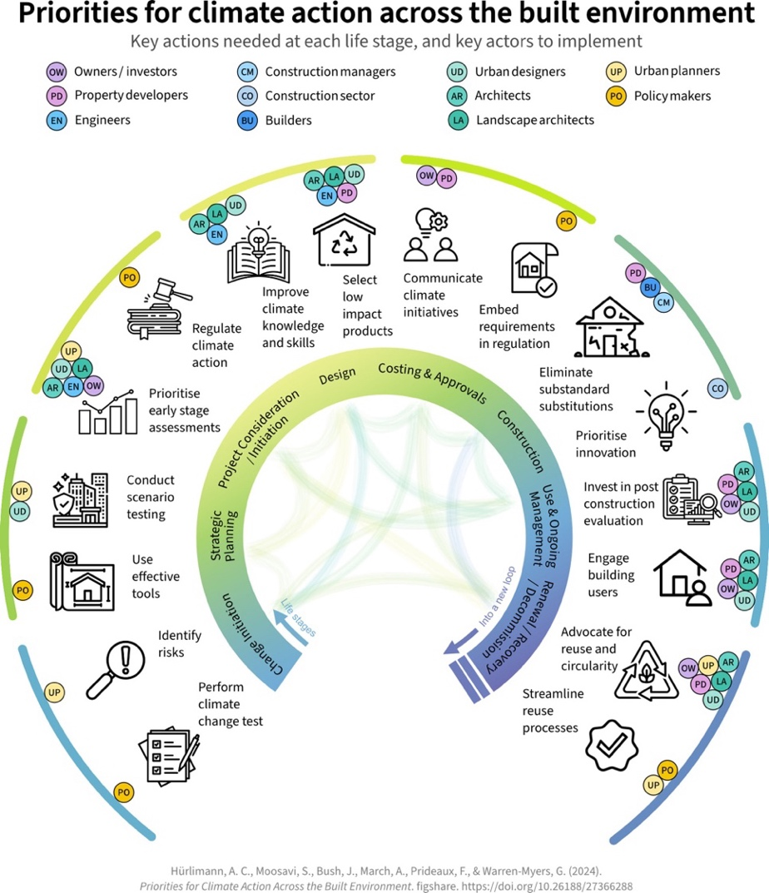
Figure 1: Priorities for climate action across the built environment [15]
References
- IPCC, Summary for Policymakers, in Climate Change 2022: Mitigation of Climate Change. Contribution of Working Group III to the Sixth Assessment Report of the IPCC P.R. Shukla, et al., Editors. 2022, Cambridge University Press, Cambridge, UK.
- United Nations Environment Program, Emissions Gap Report 2024: No more hot air … please! 2024, UN: Nairobi.
- United Nations, Paris Agreement. 2015
- United Nations Environment Program, Adaptation Gap Report 2024: Come hell and high water. 2024, UNEP Nairobi.
- Hurlimann, A., S. Moosavi, and G. Browne, Climate change transformation: A definition and typology to guide decision making in urban environments. Sustainable Cities and Society, 2021. 70: https://doi.org/10.1016/j.scs.2021.102890.
- UN Secretary General, Video message for press conference to launch the Synthesis Report of the IPCC. 2023, UN.
- Hürlimann, A. et al., Towards the transformation of cities: A built environment process map to identify the role of key sectors and actors in producing the built environment across life stages. Cities, 2022. https://doi.org/10.1016/j.cities.2021.103454
- Hurlimann, A., et al., Facilitating climate change action across built environment life stages – perspectives from built environment professionals. Cities, Under Review.
- Hurlimann, A., Moosavi, S., Bush, J. March, A., Warren-Myers, G., Prideaux, F., Integrating Climate Change Action Across the Built Environment: A Guide for Transformative Action. 2024, University of Melbourne.Figshare 10.26188/27366297
- Warren-Myers, G., et al., Barriers to and facilitators of climate change action in architecture practice. Journal of Cleaner Production, 2024. doi.org/10.1016/j.jclepro.2024.143149
- March, A., et al., Australian Urban Designers’ Experience of Barriers and Enablers to Climate Change Action. Journal of Urban Design, 2024. doi.org/10.1080/13574809.2024.2376674
- Moosavi, S. et al Transforming the agency and influence of landscape architects in climate change actions: An empirical analysis of barriers and facilitators. Landscape & Urban Planning, 2023. https://doi.org/10.1016/j.landurbplan.2023.104735.
- Hurlimann, A.C., et al., Barriers to climate change adaptation in the Australian construction industry – Impetus for regulatory reform. Building and Environment, 2018. 137: p. 235-245.
- Warren-Myers, G., A. Hurlimann, and J. Bush, Barriers to climate change adaption in the Australian Property industry. Journal of Property Investment & Finance, 2020.
- Hurlimann, A., et al., Priorities for climate action across the built environment. 2024: The University of Melbourne https://doi.org/10.26188/27366288.v1

