Fibrosis reduces ventilation and increases ventilation heterogeneity in ILD
G. Snell¹, B.Levvey¹, G.Westall¹, D.Bushell¹, A. Fouras², J.P. Kirkness², P. Pirakalathanan², N.M. Punjabi³, T. Siddharthan³ N. Eikelis², K. Nilsen²
¹Alfred Health, Melbourne, Victoria, Australia
²4DMedical Limited, Carlton, Victoria, Australia
³University of Miami, Miller School of Medicine, Miami, Florida, United States of America
Introduction/Aim: Interstitial lung diseases (ILD) are chronic progressive fibrotic lung diseases characterised by a restrictive ventilatory defect. The current standard clinical pulmonary function test (PFT) markers of disease severity in ILD, FVC and TLCO, lack spatial and regional information. This study aims to quantify the effects of fibrosis on regional ventilation in patients with ILD using X-ray Velocimetry (XV). We hypothesise that regional ventilation measurements will relate to clinical markers of disease severity and further our understanding of pulmonary function in ILD.
Methods: A prospective cross-sectional examination was performed on patients with advanced ILD who were being assessed for lung transplantation. To evaluate regional ventilation measures, XV (4DMedical Limited, Australia) was employed, which utilises fluoroscopic lung images of tidal breathing co-registered to each subject’s CT chest scan, measuring voxel-wise ventilation and ventilation defects. Regional ventilation measurements were compared to PFT measurements.
Results: A total of 9 male ILD (aged 44-71 years) and 4 control (aged 26-55 years, 25% female) subjects underwent PFTs and XV imaging. ILD subjects displayed a restrictive defect with lower FVC than controls (47.67±15.84 vs 101.25±14.75 %pred, p<0.01) and reduced gas transfer (TLCO=31±8.5 %pred). Regions of low specific ventilation, as identified from XV, correlated with FVC (L) (r²=0.65). Furthermore, for subjects with ILD, a gradient demonstrating reduced specific ventilation from apex to base was quantified (151.4±129.3 vs -94.9±36.1, p<0.01) and visualised using XV technology (Figure 1). This gradient is consistent with increasing fibrosis at the lung bases and was not observed in the control subjects.
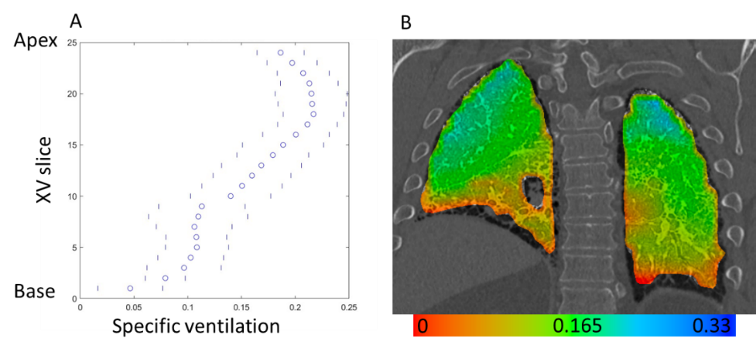
Figure 1: A representative example of specific ventilation gradient from apex to base in an ILD subject (A) Mean (o) and IQR (|) specific ventilation for each XV slice from apex to base. (B) Coronal slice showing decreased specific ventilation at the lung bases as depicted by red/orange areas.
Conclusion: This study demonstrates that low ventilation, as determined by XV imaging, relates to standard clinical markers of disease (FVC) in ILD. Furthermore, XV technology can quantify and visualise regional and spatial ventilation abnormalities. This research furthers our understanding of the pathophysiology of ILD and highlights the potential value of quantifying regional ventilation using XV.
DECLARATION OF INTEREST: N. Eikelis, K. Nilsen, J. Kirkness, P. Pirakalathanan, A. Fouras are employees of 4DMedical.
KEYWORDS: ILD, ventilation defects, regional ventilation, x-ray velocimetry
Word Count: 299/300

