Emphysema affects lung expansion and ventilation in COPD patients
G. Snell¹, B.Levvey¹, G.Westall¹, D.Bushell¹, A. Fouras², J.P. Kirkness², P. Pirakalathanan², K. Nilsen², N. Eikelis²
¹Alfred Health, Melbourne, Victoria
²4DMedical Limited, Carlton, Victoria
Introduction: Emphysema results in hyperinflation of the lungs due to increased air trapping, reducing ventilation efficiency and leading to dyspnea. Current diagnostic techniques, such as computed tomography (CT) and pulmonary function tests (PFTs), provide limited functional information at a regional lung level. This study aims to quantify the effects of emphysema on lung expansion and ventilation in patients with Chronic Obstructive Pulmonary Disease (COPD) using X-ray Velocimetry (XV). The proposed approach is hypothesised to provide a more comprehensive understanding of pulmonary function at a regional level.
Methods: A cross-sectional examination was performed on patients with advanced COPD who were being assessed for lung transplantation. To evaluate regional ventilation measures, XV (4DMedical Limited, Australia) was employed, which utilises fluoroscopic lung images of tidal breathing co-registered to each subject’s CT chest scan, measuring voxel-wise ventilation and ventilation defects. Regions of emphysema were identified, quantified, and spatially registered from inspiratory CT (i.e. CT-based emphysema scoring using % <-950 Hounsfield Unit) using an automated algorithm (MATLAB).
Results: Nineteen COPD patients (aged 52-71 years, 68% females) underwent PFTs and XV imaging. The participants presented with an average value of 24 for FEV₁% predicted and a FEV₁/FVC ratio of 35. The average emphysema score was 19% of the total lung volume. The lung regions affected by emphysema showed a significantly slower expansion rate compared to non-emphysema regions (0.049±0.016 vs 0.055±0.016 ml/sec, p=0.013). Further, lung tissues with emphysema tended to have lower specific ventilation, which can be both quantified (0.087±0.024 vs 0.093±0.018) and visualised using XV technology (Figure 1).
Conclusion: The results of this study show quantifiable differences in differential lung expansion in patients with COPD. The research underscores the potential value of quantifying regional ventilation defects to enhance our understanding of the pathophysiology of COPD, facilitate clinical phenotyping, and monitor treatment responses.

Declaration of Interest: N. Eikelis, K. Nilsen, J. Kirkness, P. Pirakalathanan, A. Fouras are employees of 4DMedical.
Key Words: COPD, ventilation defects, regional ventilation, X-ray Velocimetry
Word Count: 298/300
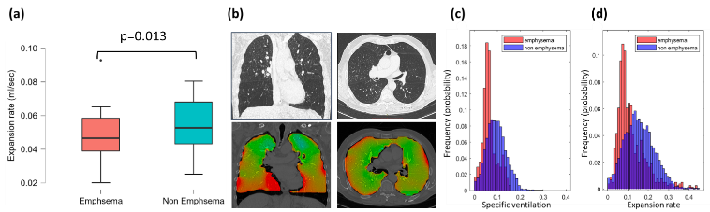
Figure 1: (a) Reduced expansion rates were found in lung regions affected by emphysema compared to regions not affected by emphysema. A representative ventilation map of a COPD patient with red areas depicting regions of relative low ventilation (b, bottom images) that correspond to lung regions affected by emphysema on CT (b, top images), frequency distribution of specific ventilation demonstrating lower ventilation in lung regions affected by emphysema (c, red bars) compared to lung regions not affected by emphysema (c, blue bars) and reduction in lung expansion rate in lung tissue affected by emphysema (d, red bars) compared to lung tissue not affected by emphysema (d, blue bars).

