A Rare Chest Computed Tomography Finding of Melioidosis
Reditta Tumali^{1,2}, Stephanie Henderson^{1,2}, Louis Chhor¹, Andrew McDonald², Su Wei Khung¹
¹Department of Respiratory Medicine, Barwon Health, Geelong VIC Australia
²Department of General Medicine, Barwon Health, Geelong VIC Australia
Introduction/Aim: Melioidosis is an infectious disease caused by Burkholderia pseudomallei. This organism is usually found in soil or fresh water and is endemic in Southeast Asia and northern Australia in wet season. The most common presentation is pneumonia. Chest radiography typically demonstrates diffuse or patchy consolidation, pulmonary lesions, and cavitation. Occasionally, these pulmonary parenchymal changes are associated with pleural effusion and mediastinal lymphadenopathy. We present a case of melioidosis which presented primarily with pleural abnormalities and minimal lung parenchymal changes. This rare presentation has only been reported once¹ and has never been described in Australia.

Methods: We performed a single medical file review.

Results: A 50-year-old male presented to hospital with syncope associated with fever and 2-3 weeks of constitutional symptoms. He resided in Queensland, Australia and had travelled to Papua New Guinea 10 months prior, coinciding with the end of the wet season. Initial work up revealed elevated inflammatory markers and chest x-ray findings of multiple lobulated pleural thickenings of the right hemithorax. Chest computed tomography showed multifocal, irregular pleural lesions associated with peribronchial thickening, right pleural effusion, and necrotic ipsilateral and mediastinal lymphadenopathy (Figure 1). He underwent ultrasound-guided pleural aspiration, bronchoscopy, and alveolar lavage. Both specimens subsequently grew Burkholderia pseudomallei and a diagnosis of melioidosis was confirmed.

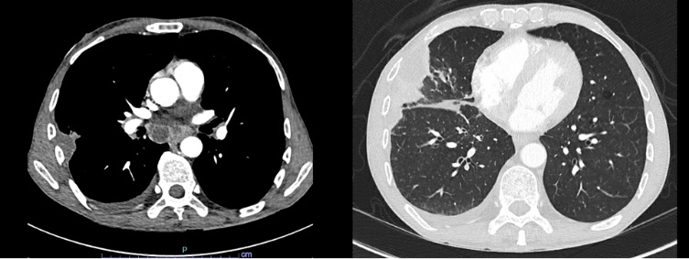
Figure 1. Chest computed tomography axial images demonstrating A) necrotic mediastinal lymphadenopathy and B) multifocal irregular pleural lesions associated with peribronchial thickening and right-sided pleural effusion.
B
A

Conclusion: Pneumonia is the most common presentation of melioidosis. In published literature to date, there are only two confirmed cases of melioidosis where there was minimal pulmonary parenchymal changes and pleural effusion was the main finding on chest computed tomography¹. We describe the first melioidosis case in Australia where pleural abnormalities were the predominant features instead of pulmonary parenchymal changes.

Grant Support: N/A

Reference: 1. Dao-Thi et al. Melioidosis presenting as thoracic empyema. Journal of Global Infectious Disease. 2022 Mar 21;14(2):87-89.

