**Human Pancreatic Extracellular Matrix Enhances Stem Cell-Derived Islet Function in Scaffolds**

Background:

Scaffolds are used to deliver encapsulated human pluripotent stem cell-derived islets to diabetic recipients. However, islets in scaffolds function less effectively than those implanted directly into the peritoneal cavity (ip), likely due to insufficient nutrient access.

Aim:

To evaluate whether extracellular matrix (ECM) from decellularised human pancreas can enhance nutrient supply and improve islet function in scaffolds implanted in diabetic mice. Method:

Encapsulated human pluripotent stem cell-derived islets were placed in ECM and seeded into a polycaprolactone scaffold made by melt electrowriting. This was implanted ip in diabetic mice and compared to encapsulated islets implanted ip without scaffolds. Capsules (600 µm diameter) were made from 2.2% UPMVG alginate, with 3500 islets implanted in 1750 microcapsules in each mouse.

Results:

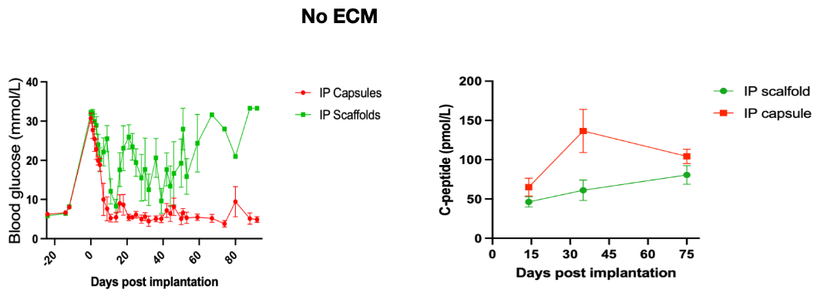Without ECM, mice with scaffolds had higher blood glucose (Figure a) and islets in scaffolds produced less human C-peptide than islets implanted directly (Figure b). However, with ECM, scaffold-implanted islets matched the function of directly implanted islets in both C-peptide production (Figure c) and glucose control.

a b c

Conclusion:

ECM from the human pancreas allows encapsulated islets in scaffolds to function as effectively as encapsulated islets implanted alone.