Paper
The Kwajalein Atoll Sustainability Laboratory: Blending Western and Indigenous Knowledge for Pacific Island Climate Adaptation and Cultural Preservation

In 2019, in the remote northern reaches of the Marshall Islands, the Kwajalein Atoll Local Government (KALGOV), a local STEM Summer School, and two scientists from the U.S. Office of Naval Research (ONR) partnered with indigenous high school students on Ebeye Island to conduct an anonymous survey assessing household and community safety. Ebeye, one of the world’s most densely populated islands, served as a critical case study. The survey, conducted via Android devices already in use on the island, employed an app fully translated into Marshallese and was administered by young Marshallese citizen scientists. The collected responses—mapped with 10x10-foot geospatial coordinate squares—uncovered under-recognized challenges related to potable water, emergency communications, nighttime lighting, overcrowding, emigration, unreported illness, and ongoing dental needs.
These findings led to the formation of an international collaboration, leveraging digital tools like the survey app to identify and adapt global climate resilience strategies for the Marshall Islands. The U.S. Office of Naval Research, recognizing the initiative’s potential, provided formal support for a dedicated research effort in adaptation sciences. The COVID-19 pandemic temporarily halted progress, but as global operations resumed, a hybrid adaptation science laboratory emerged—combining ONR scientists with indigenous Marshallese community managers.
That laboratory, now known as the Kwajalein Atoll Sustainability Laboratory (KASL), operates as a Marshallese non-governmental organization (NGO) with a dedicated research division supported by ONR. More than a dozen leading institutions—including MIT, the Johns Hopkins Applied Physics Laboratory, NREL, and the University of Washington School of Engineering—have since engaged with KASL, proposing potential adaptation solutions tailored to the region and the economy.
After a year of evaluations, KASL hosted a two-day workshop in Honolulu, convening more than 130 participants from eight nations. The event featured 16 in-depth presentations and 22 live lightning-round demonstrations showcasing adaptation technologies from four countries and seven U.S. states. Many of the adaptation technologies introduced in those brief talks are now undergoing real-world implementation in the Marshall Islands.
We propose KASL as a scalable, global model for inclusive, indigenous-led, civil-military adaptation science research and development—one designed to support highly vulnerable, low-resource populations in the face of accelerating climate challenges.

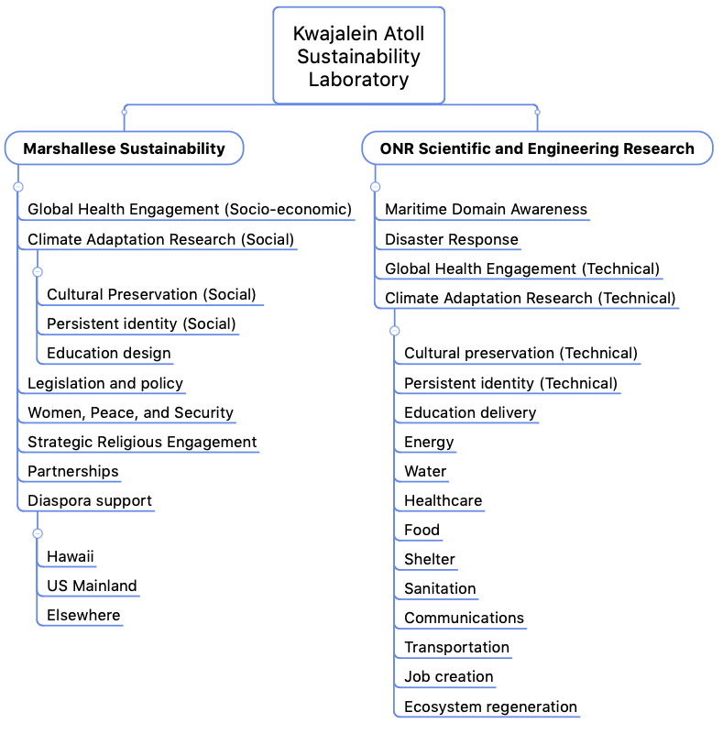
Significance of the work for policy and practice
Each of these initiatives aligns with the broader objective of enhancing physical safety, water security, food sovereignty, and healthcare delivery within the Marshall Islands while finding nature-based solutions for adaptation engineering and job generation.
The research findings emerging from KASL demonstrate that our efforts benefit from a holistic, integrated approach that incorporates:
- local engagement,
- technological innovation specifically designed for the need,
- the environment,
- the culture, and
- scalable solutions that are affordable and accessible to those who need them most.

Through continued field testing and cross-sector collaboration, KASL is refining its methodologies and expanding its impact, ensuring that the insights gained contribute not only to regional resilience but to global adaptation strategies.

