Non-invasive assessment of collateral ventilation for Bronchoscopic lung volume reduction using X-ray Velocimetry
Eikelis N¹, Nilsen K¹, Marchetti N², Rashid M², Walia P², Criner H², Hatt C¹, Criner GJ²
¹4DMedical Limited, Melbourne, Australia, ²Temple University Hospital, PA, USA
Introduction/Aim: Bronchoscopic lung volume reduction (BLVR) utilising endobronchial valves (EBV) has demonstrated significant efficacy in improving the quality of life for patients with emphysema. However, success diminishes in patients with incomplete lobar fissure integrity, as collateral ventilation (CV) can negate the occlusive effect of EBVs by preventing atelectasis. Current non-invasive methods for evaluating CV rely on estimating fissure integrity from static CT scans, a proxy for CV that does not always align with in-situ CV measurements (i.e. Chartis). X-ray Velocimetry (XV) captures 4D (3D+time) images of the lungs, enabling time-resolved measurement of regional lung ventilation. This study aims to assess the predictive value of XV in detecting CV non-invasively, potentially improving patient selection for BLVR. Methods: In the prospective study conducted at Temple University Hospital, participants suitable for current or potential clinical evaluations for BLVR procedure were recruited (n=39). A Chartis assessment was performed to identify CV-positive subjects. XV technology was employed to analyse lung mechanics through voxel-wise ventilation measurements which included evaluating the rates of inspiration and expiration in the target and adjacent lobes, along with assessing the quantitative CT-based emphysema scores and fissure integrity measurements. Results: 11 participants were CV-positive as measured by Chartis. The model utilised three imaging biomarkers: the target-to-ipsilateral lobes inspiration expiration rates ratio, quantitative emphysema score within a 1-cm distance of the fissure, and quantitative fissure integrity score. It predicted CV likelihood with a p-value of 0.032, an AUC of 0.840, and an accuracy rate of 0.767. Implementing a probability threshold of 0.5 resulted in a specificity of 0.900 (Figure 1). Conclusion: This study highlights the potential of XV in assessing lung mechanics for the detection of CV and offers several advantages over the traditional Chartis method. XV assessment imposes minimal burden on patients, a low radiation dose and eliminates the need for anaesthesia.

Key Words: Bronchoscopic lung volume reduction (BLVR), endobronchial valve (EBV), collateral ventilation (CV), regional ventilation, X-ray Velocimetry (XV)
Nomination for New Investigator Award: No
Grant Support: Supported by a grant from 4DMedical
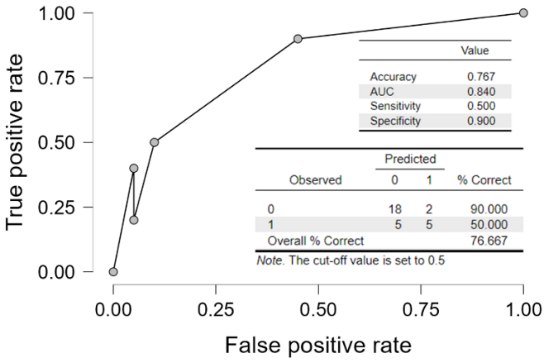
Figure 1. This figure demonstrates the predictive performance of a model used to evaluate the likelihood of collateral ventilation (CV). When a probability threshold of 0.5 is applied, the specificity increases to 0.900, demonstrating the model's strong ability to correctly identify true negatives.

