**Impact of Re-Cellularization via Electroporation Therapy Therapy on Continuous Glucose Monitoring (CGM) Metrics in Type 2 Diabetes: Insights from the REGENT-1 Trial**

**Aim:** The REGENT-1 trial evaluated the Re-Cellularization via Electroporation Therapy (ReCET™) System, which uses pulsed electric fields (PEF) to regenerate duodenal mucosa and submucosa. Continuous glucose monitoring (CGM) offers insights into glycaemic control and variability in type 2 diabetes (T2D) not provided by HbA1c. We examined the effect of ReCET™ across energy dose cohorts on CGM metrics.

**Methods:** REGENT-1 is a multi-center, open-label study of endoscopic PEF therapy at three doses in T2D adults on 1-4 non-insulin agents. Group 1) Gen 1 catheter 600V, single treatment (n=12); Group 2) Gen 1 catheter, 600V, double treatment (n=18); and Group 3) Gen 2 catheter (increased treated surface area [TSA]), double treatment 750V (n=21). CGM data were collected using a Medtronic system (Guardian 3)

**Results:** Fifty-one participants (mean age 52.9 years, BMI 31.4 kg/m², HbA1c 8.7% [72±9mmol/mol]) underwent PEF therapy. A dose-response effect was evident, with Group 3 yielding the greatest benefit in day and night glucose levels and reduced glycaemic variability. Improvements in Group 3 CGM metrics emerged by week 4, peaked by week 24, and were sustained through week 48 (**Figure 1**). Double treatment with Gen 1 (Group 2) results were intermediate between Groups 1 and 3.

**Conclusions:** ReCET™ treatment was followed by a dose dependent improvement in glycaemia. Benefits at the highest dose appeared by week 4 and were durable. Findings highlight PEF-induced duodenal regeneration as a promising approach to improve glycemic control in T2D.

**Figure 1: REGENT-1 CGM Metrics for Energy Dose Groups 1 and 3 over time**

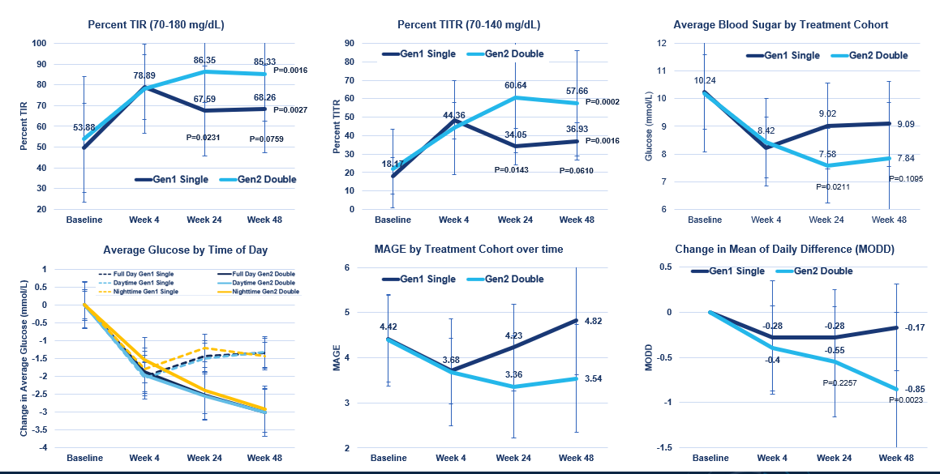

Legend: Measures of glycemic control and glucose variability as assessed by CGM following ReCET therapy.