Abstract

Title:
Impact of a standardised diabetes educator-led virtual review model on service delivery in a tertiary low-risk gestational diabetes service

Background & Aim:
Westmead Hospital implemented the Health2Sync(H2S) app-dashboard platform in 2024 to support virtual monitoring of blood glucose levels (BGLs) in women with diet-controlled gestatonal diabetes. Diabetes nurse educators(DNEs) use H2S to review BGLs and escalate women to dietitian follow-up or pharmacotherapy to the endocrinologist-led high-risk clinic. While H2S improved visibility of glycaemic data, its impact on DNE workload was unclear. This evaluation examined changes in review volume and care pathways following a standardised H2S review model, alongside revised GDM diagnostic criteria.

Methods:
A retrospective service evaluation compared four two-month periods: pre-H2S (June-July 2024; email-based BGL reporting) and three periods in 2025 (June-November) representing early H2S use, post-standardised H2S review implementation, and post-revised GDM diagnostic criteria. Service activity data were extracted from electronic booking systems and medical records. Outcomes included weekly DNE review occasions of service(OOS), new GDM referrals, high-risk clinic referrals, dietitian follow-up, and insulin initiation.

Results:
Following H2S implementation, mean weekly DNE review OOS increased from 57.5 to 91 (+58%). Introduction of a standardised H2S practice reduced weekly OOS by 6%, with a further 18% reduction after revision of GDM diagnostic criteria. New GDM referrals decreased by 27%, and overall review OOS decreased by 32%. Absolute DIP referrals, insulin initiation, and dietitian follow-up rates remained stable.
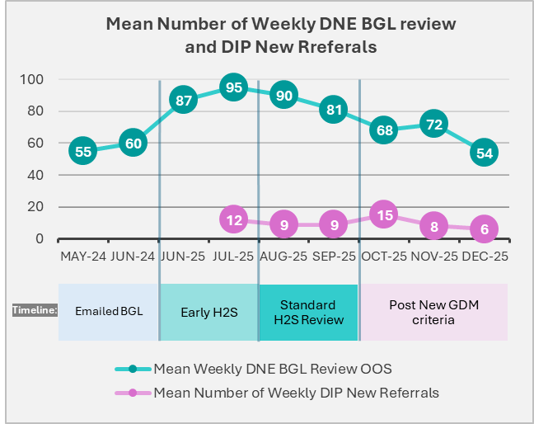

Discussion / Conclusion:
Digital monitoring improved identification of women requiring follow-up but increased DNE workload. A standardising DNE-led glucose review model improved service sustainability without compromising escalation or multidisciplinary care.

