The Impact of Automated Insulin Delivery on Glucose Control in People with Diabetes and Advanced Chronic Kidney Disease

Background and aims: Chronic kidney disease (CKD) complicates insulin dosing and increases glycemic instability in diabetes. We aimed to compare feasibility, safety, and efficacy of automated insulin delivery (AID) with usual care in people with diabetes and advanced CKD.

Materials and methods: In this multicenter, randomised, crossover trial, adults with type 1 or type 2 diabetes receiving multiple daily insulin injections or open-loop pump therapy and with stage ≥3b chronic kidney disease underwent two 8-weeks interventions in random order: continuous glucose monitoring (CGM; Medtronic Guardian™ 3 or 4) with usual care or AID (MiniMed™ 780G), followed by crossover. Primary analyses used CGM data from the final 3-weeks of each phase. Psychosocial, cognitive, and functional assessments were conducted at the completion of each phase.

Results: Forty participants (24 type 1 diabetes, 16 type 2 diabetes; median [IQR] age 60 [55, 69] years; HbA1c 64 [54, 73] mmol/mol (8.0 [7.1, 8.8] %); eGFR 30 [18, 37]) mL/min/1.73m2) were enrolled: 33 not on dialysis, 4 on peritoneal dialysis, and 3 on hemodialysis. AID significantly improved all hyperglycemic CGM metrics compared to usual care. Time in range (3.9-10.0 mmol/L) improved from 60 (51, 66)% at the end of usual care to 73 (65, 78)% at the end of AID (p<0.001) (Figure 1). Participants were predominantly pre-frail at baseline and remained stable on-trial. No serious adverse events were attributed to the study devices. Nonetheless, 25% of participants experienced hospital admissions during the trial period for medical issues unrelated to device use.

Conclusion: AID is feasible, safe, and compared with usual care provides superior glucose control in predominantly pre-frail people with diabetes complicated by advanced CKD.

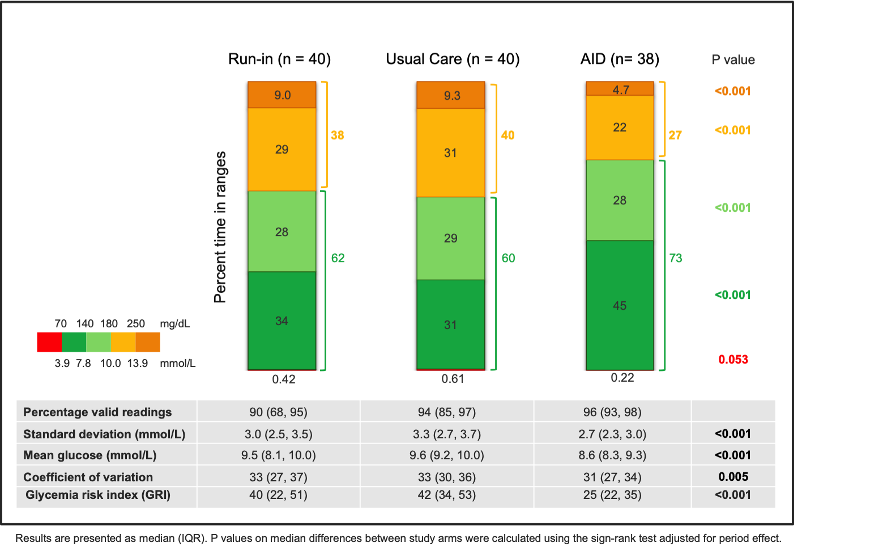
Figure 1: Primary and secondary glycemic outcomes.

