X-ray Velocimetry detects peripheral lung ventilation defects in βENaC mice
Reyne N¹⁻³, Cmielewski P¹⁻³, Smith R¹⁻³, Eikelis N⁴, Nilsen K⁴, Mall M⁵, Parsons D¹⁻³ and Donnelley M¹⁻³
¹Adelaide Medical School, The University of Adelaide, South Australia, Australia.
²Robinson Research Institute, The University of Adelaide, South Australia, Australia.
³Respiratory and Sleep Medicine, Women’s and Children’s Hospital, South Australia, Australia.
⁴4DMedical, Victoria, Australia
⁵Dept of Paediatric Pulmonology, Immunology and Critical Care Medicine, Charité - Universitätsmedizin Berlin, Berlin, Germany
Introduction: The βENaC mice model over-expresses the β-subunit of the epithelial sodium channel, resulting in mucus dehydration, reduced mucociliary clearance, and altered lung function, similar to cystic fibrosis. While previous studies have explored lung function in βENaC mice, a comprehensive assessment using novel lung imaging technology, X-ray Velocimetry (XV), has not been undertaken. This study aimed to evaluate the ability for XV imaging’s to precisely locate and quantify ventilation defects in these mice compared to control mice.
Methods: βENaC mice and their wildtype (WT) littermates underwent XV scans using the Permetium XV scanner (4DMedical). For comparative lung mechanics, lung function assessments were conducted with the flexiVent system.
Results: FlexiVent analysis: βENaC mice displayed a significantly increased inspiratory capacity (p<0.0001), along with an upward shift in the pressure-volume loops compared to WT mice. Interestingly, FEV0.05 was significantly higher in the βENaC mice (p<0.0001). XV imaging results: Ventilation defect percentage, mean specific ventilation, and ventilation heterogeneity were significantly higher in βENaC mice than WT mice (p<0.0001 for all measures). Qualitative analysis of the ventilation maps revealed greater variability in specific ventilation in the βENaC mice compared to the WT mice (Figure 1). Spatial analysis of the ventilation maps indicated ventilation variability was more pronounced in peripheral regions of the lungs.
Conclusion: Our study demonstrates that βENaC mice have regions of altered ventilation in the peripheral regions of the lungs. These results provide valuable insights into the understanding of the lung function in this lung disease animal model and the potential of XV imaging in assessing airway ventilation defects.
Grant Support: MRFF
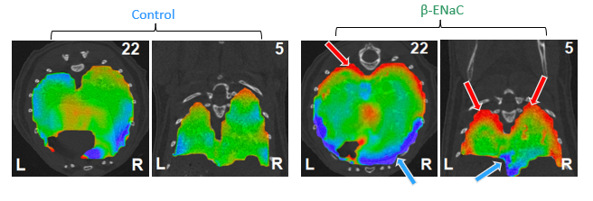
Figure 1: Example XV ventilation maps. 4D mid-lung ventilation maps (axial (22) and coronal (5) slice numbers shown) in βENaC mice and control. Green = mean ventilation, red = below average, blue = above average. βENaC mice showed concentrations of extremes of ventilation in peripheral regions. (‘L’ refers to left lung and ‘R’ refers to right lung in the ventilation maps).

