Acute tacrolimus toxicity due to Paxlovid successfully managed with phenytoin
White CJ^{1,2}, Bailey S¹, Murnion B^{2,3}, Plit M^{1,2}, Darley D^{1,2}
¹ Lung Transplant & Thoracic Medicine Unit, St Vincent’s Hospital, Sydney, NSW Australia
² St Vincent’s Clinical School, The University of New South Wales, Sydney, NSW Australia
³ Clinical Pharmacology Department, St Vincent’s Hospital, Sydney, NSW Australia
Introduction/Aim:
Tacrolimus, a calcineurin inhibitor, is often used after lung transplantation and is a substrate for cytochrome P450 (CYP) 3A4. We present the case of a 68 year-old female 7 years after lung transplant who developed significant tacrolimus toxicity following administration of Paxlovid (ritonavir-nirmaltrevir), a potent CYP3A4 inhibitor, and was successfully managed with phenytoin.
Case Report:
This 68 year-old female underwent lung transplant for emphysema in 2017 and had stable allograft function. Medications included tacrolimus slow release 3.5mg daily. She presented in August 2023 to a peripheral hospital with increasing confusion, headache and tremors. Investigations demonstrated acute kidney injury with a creatinine rise from 80µmol/L to 234µ mol/L and a tacrolimus concentration of >60ng/ml. She had recently contracted COVID-19 and completed 3 days of Paxlovid therapy with a community practitioner without adjustment of tacrolimus dose. Phenytoin, a CYP3A4 inducer, was administered with a loading dose of 15mg/kg and continued orally for three days with close therapeutic drug monitoring. This resulted in an immediate reduction in her tacrolimus concentration and serum creatinine with symptomatic improvement over two days. Tacrolimus was reintroduced after two days to maintain therapeutic levels. Renal function returned to baseline and she was discharged once tacrolimus was at steady state within the therapeutic range.
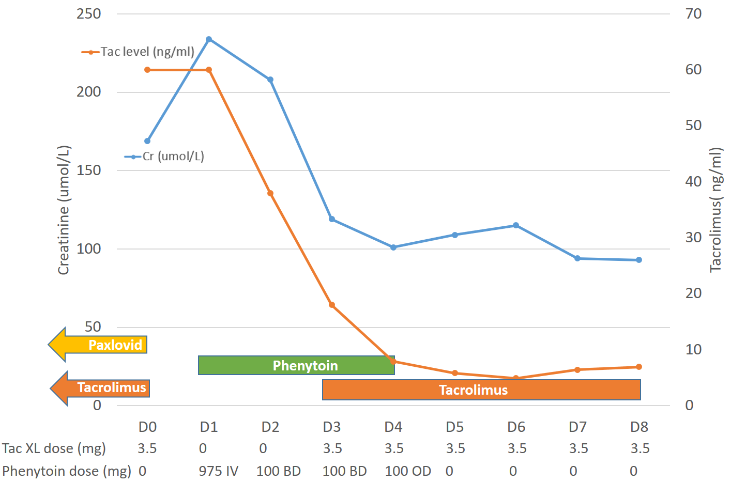
Figure 1: Graphical timeline of tacrolimus concentration and creatinine level. Presented to hospital day 0.
Conclusion:
We report the successful use of phenytoin, a potent CYP3A4 inducer, to enhance the metabolism of tacrolimus following administration of Paxlovid, a strong CYP3A4 inhibitor. We add to the body of evidence that phenytoin appears to be a safe and effective strategy to manage severe tacrolimus toxicity. Future research is needed to understand ideal dosing and duration of phenytoin and the degree to which it hastens recovery.
Grant Support:
Nil

