Glucagon-Like-Peptide-1 Receptor Agonists Are Effective In Patients With Cystic Fibrosis

Guidelines for cystic fibrosis related diabetes (CFRD) suggest management with insulin monotherapy to reduce respiratory infection and aide in weight gain. Since the introduction of highly effective modulator therapy, respiratory function has improved and obesity increased. Glucagon like peptide 1 receptor agonist (GLP-1RA) are a logical choice given the demonstrated incretin defect in CFRD. The effect of GLP-1RA on glycaemia and pulmonary function in this population remains unclear.

We performed a retrospective longitudinal cohort study comparing pulmonary function and glycaemia between individuals who received either GLP-1RA therapy or continued on insulin monotherapy for CFRD. Pulmonary function and glycaemia were compared from 24 months prior and 3 monthly for 12 months after initiation of GLP-1RA or continuation of insulin monotherapy.

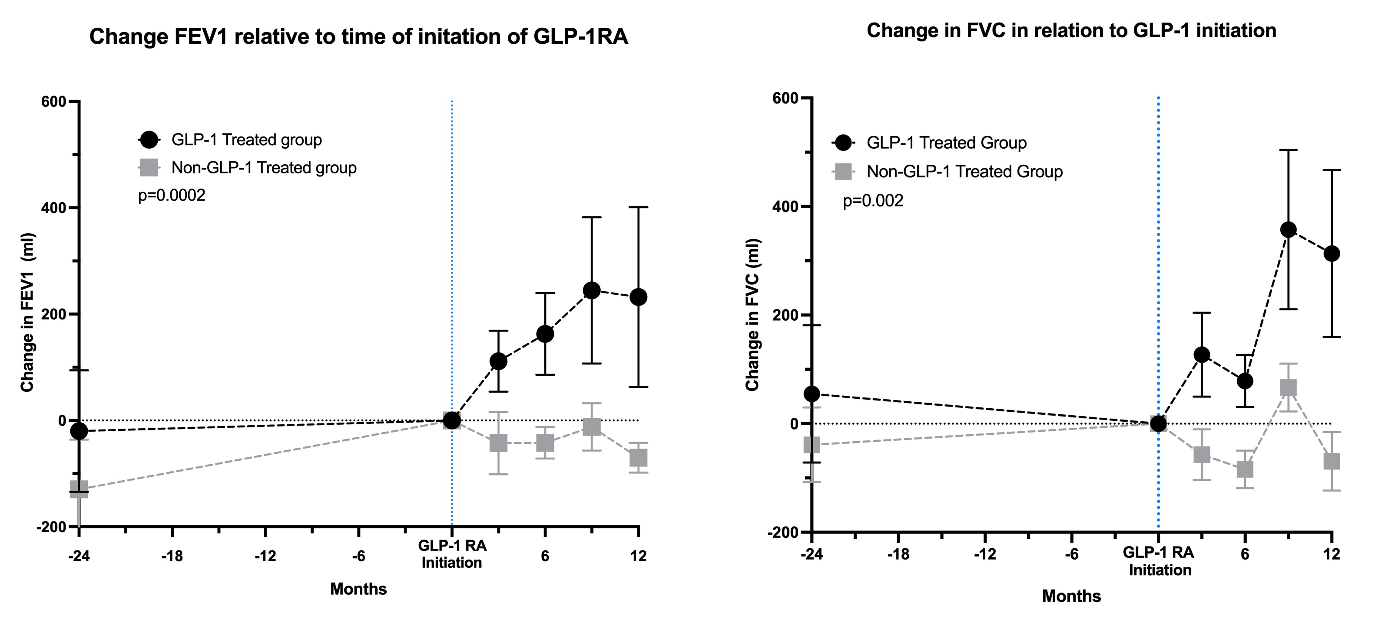

10 pwCFRD using GLP-1RA, 15 insulin treated pwCFRD were identified. Forced Expiratory volume (FEV1) was stable for the 24 months prior to baseline measurement in both groups. The FEV1 in the GLP-1 group was significantly increased over the 12 months following initiation compared to control (p=0.002). At 6 months, the FEV1 increased by 204ml more than control. At 6 months, HbA1c reduced (-1.7%, p=0.017), time in range increased (+29%, p=0.016) and the total daily insulin dose reduced (-12.5 units, p=0.004) in GLP-1 group, all measures were unchanged in the control group.

In pwCFRD treated with maximal modulator therapy, GLP-1RA therapy was associated with clinically meaningful improvement in pulmonary function compared to non-GLP-1RA exposed individuals. GLP-1RA therapy was associated with improved glycaemia.

