|  |
| --- |
| **Nationwide airborne laser scanning based models for leaf area index mapping in Finland** |
| **Introduction/Aim:**  Leaf area index (LAI) is an important parameter that describes the characteristics of forest ecosystems. It measures the amount of leaf material present in the canopy and is often used as an input in various biosphere-atmosphere models that describe mass and energy exchange processes (Ryu et al., 2011). In many countries, airborne laser scanning is routinely used to estimate forest attributes on national scale following an area-based approach (Maltamo et al., 2021). This technology has been successfully applied for the estimation of LAI as well (Solberg et al., 2009). Nevertheless, nationwide LAI maps are still absent, although they could be constructed based on nationwide ALS data acquisitions. This study aimed to assess the comparability of national and regional LAI regression models using ALS data.  **Methods:**  We collected digital hemispherical photographs as field reference data from 178 plots across five regions in Finland. Effective LAI was estimated from the photographs based on the Beer-Lambert law. We fitted nationwide and regional models using Ordinary Least Squares regression with two ALS-based predictors. All possible predictor combinations were tested and the ones that yielded the smallest relative root mean square error (RMSE%) were selected. The nationwide model was validated using leave-one-region-out and the regional models using leave-one-plot-out cross-validation.  **Results:**  The results showed that the nationwide and regional models yielded comparable results, but overall, the regional models provided slightly higher accuracy. The nationwide model had a cross-validated RMSE% of 19.9% while the regional model RMSEs ranged from 9.5% to 20.9%. When the nationwide model results were analysed by region, the RMSE% were 0.9%–10.3% larger compared to regional models. The regional models had better accuracy especially for larger effective LAI values. The most selected ALS predictors included logarithmic transformations of canopy penetration indices derived from either first and single or all echoes.  **Conclusion:**  Although different ALS acquisition settings may have an influence on the results, it is still possible to obtain reasonably accurate predictions with nationwide LAI models trained without local calibration data. However, on average the local models 4.5% smaller RMSE% than the nationwide model in all regions, which is consistent with previous findings of nationwide forest volume and biomass models (Kotivuori et al., 2016). |

Table 1. Nationwide and regional effective LAI model accuracy

|  |  |  |  |
| --- | --- | --- | --- |
|  | **Nationwide model** | **Regional models** | **Nationwide model by region** |
| **Pello** | 19.5% | 10.5% | 12.0% |
| **Merikarvia** | 20.9% | 21.8% |
| **Outokumpu** | 9.5% | 19.8% |
| **Heinola** | 19.3% | 23.8% |
| **Hyytiälä** | 13.3% | 18.8% |

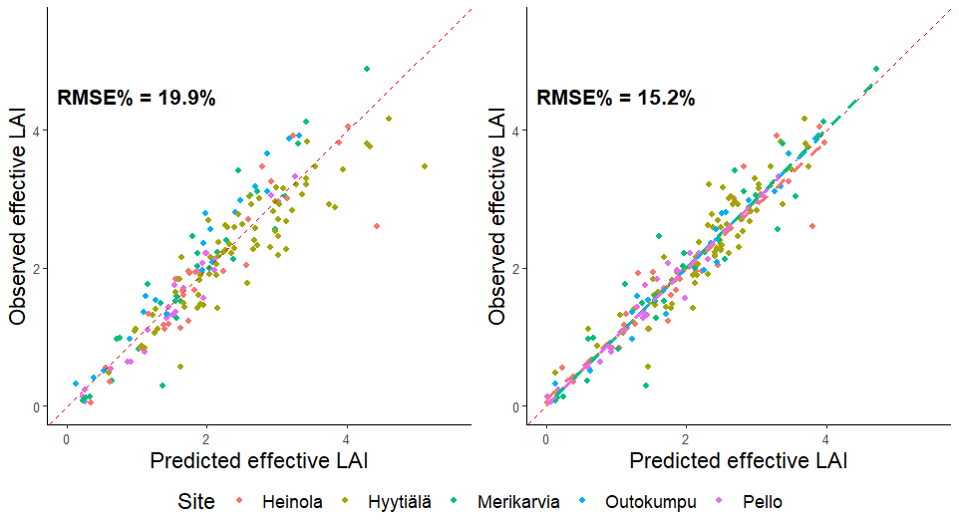

Figure 1. Effective LAI predicted by nationwide (left) and regional (right) models against observed counterparts.

**References**

Kotivuori, E., Korhonen, L., & Packalen, P. (2016). Nationwide airborne laser scanning based models for volume, biomass and dominant height in Finland. *Silva Fennica*, *50*(4).

Maltamo, M., Packalen, P., & Kangas, A. (2021). From comprehensive field inventories to remotely sensed wall-to-wall stand attribute data—a brief history of management inventories in the Nordic countries. *Canadian Journal of Forest Research*, *51*(2), 257-266.

Ryu, Y., Baldocchi, D. D., Kobayashi, H., Van Ingen, C., Li, J., Black, T. A., ... & Roupsard, O. (2011). Integration of MODIS land and atmosphere products with a coupled‐process model to estimate gross primary productivity and evapotranspiration from 1 km to global scales. *Global Biogeochemical Cycles*, *25*(4).

Solberg, S., Brunner, A., Hanssen, K. H., Lange, H., Næsset, E., Rautiainen, M., & Stenberg, P. (2009). Mapping LAI in a Norway spruce forest using airborne laser scanning. *Remote Sensing of Environment*, *113*(11), 2317-2327.