Impact of acute and chronic glycaemic control on mortality post cardiac surgery

Aims
In the critically ill, with and without diabetes, hyperglycaemia and glycaemic variability are associated with adverse outcomes, but the strength of this association is attenuated by premorbid hyperglycaemia. The cardiac surgical population is a demographically and physiologically distinct cohort, where the relationships between glucose metrics and outcomes are poorly defined.
The study aimed to characterise the relationship of acute mortality with acute dysglycaemia and chronic hyperglycaemia, in a cardiac surgical population.
Methods
A dataset of cardiac surgical patients from 2008 to 2019, comprising adults post coronary artery bypass grafting (CABG), valvular surgery, or a combined procedure, was compiled using the Medical Information Mart for Intensive Care IV v1.0 (MIMIC IV-v1.0) database. Multivariate analysis was performed to assess the independent effect of glucose metrics on mortality while controlling for potential confounders. Prior hyperglycaemia was determined by preoperative measurement of glycated haemoglobin (HbA_{1c}) ≥6.5% and hypoglycaemia was defined as a BGL <3.90cmmol/L.
Results
The analysis included 9132 patients and 296,941 blood glucose values. Both the mean, cumulative dose of hyperglycaemia and coefficient of variation of blood glucose level increased (P<0.001) with greater pre-operative HbA_{1c}. Acute hyperglycaemia was strongly associated with mortality (OR 5.88, 95% CI, 3.03 to 10.6), and this effect was diminished by chronic hyperglycaemia (HbA_{1c} ≥6.5%). More frequent hypoglycaemic events were strongly associated with mortality irrespective of premorbid glycaemic control.

Figure 1. Marginal model predictions (with 95% confidence bands) for in-hospital death for pre-defined chronic glycaemia sub-groups: well controlled (HbA_{1c} <6.5%), adequately controlled (HbA_{1c} 6.5% - 7.9%), and poorly controlled (HbA_{1c} ≥ 8.0%), for
A) Cumulative dose hyperglycaemia, B) Number of Hypoglycaemic events
A. Cumulative dose hyperglycaemia B. Number of Hypoglycaemic events
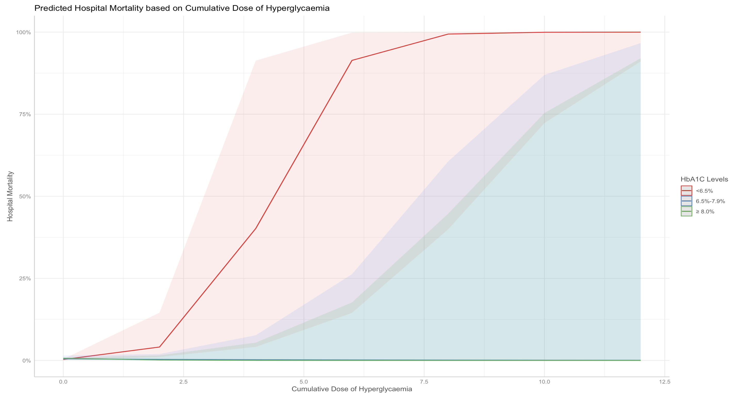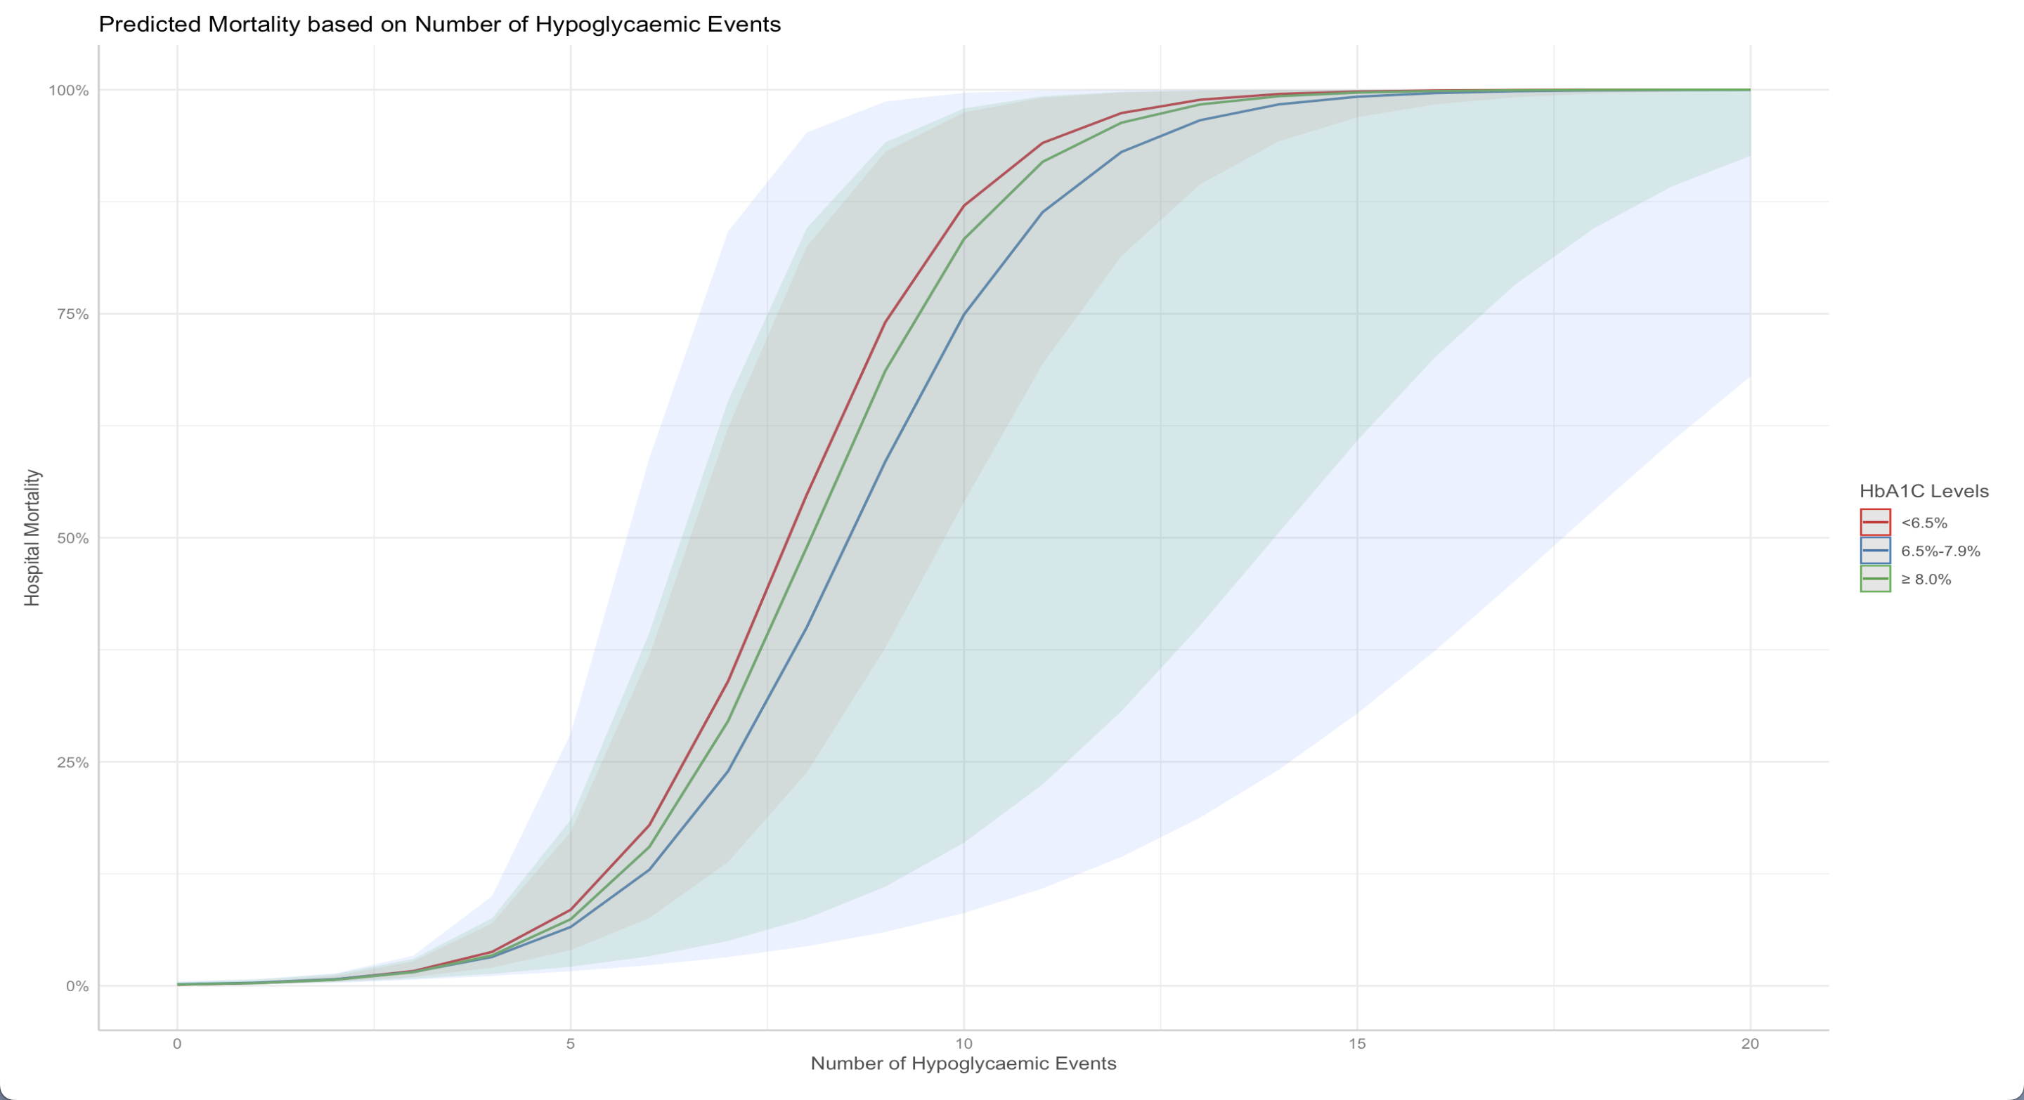

Conclusions
Chronic hyperglycaemia attenuates the adverse impact of acute hyperglycaemia, but not hypoglycaemia, on mortality in the cardiac surgical population. Accordingly, there are potential benefits in relaxing glycaemic targets pre-operatively and in the peri-operative period.

