TEXOB1 (Tirzepatide ± Exercise in Adults with Overweight/Obesity and Type 1 Diabetes): Preliminary Findings from a Randomised Trial

Aims:
Data on tirzepatide use in type 1 diabetes (T1D) are limited⁽¹⁾. This pilot trial evaluates the efficacy and safety of tirzepatide ± a resistance–aerobic exercise program in adults with T1D and overweight/obesity, with preliminary findings reported here.

Methods:
We conducted an open-label individually-randomised pilot trial (modified stepped-wedge design) in adults with T1D and overweight/obesity (Figure 1). Co-primary outcomes were change in %body weight and CGM-derived %time-in-range (TIR).

Results
After 12 weeks of tirzepatide (up to 5mg/week, n=10), the mean (SD) change in weight was -8.0% (4.8) versus +1.8% (0.8) in controls (n=10); the difference in mean change was -9.8% (95%CI -13.3 to -6.3). The mean (SD) change in %TIR was +16.2 (15.4) with tirzepatide versus -1.9 (7.4) in controls; the difference in mean change between groups was +18.1% (95%CI 6.4 to 29.8). Compared to tirzepatide, tirzepatide+exercise resulted in numerically greater %weight loss [difference in mean change 3.7 (95%CI -0.4 to 7.8)] but a smaller increase in %TIR [difference in mean change 2.6 (95%CI -11.9 to 17.1)] in our sample. There were no major adverse events.

Conclusions:
In people with T1D and overweight/obesity, tirzepatide was superior to usual care with significantly greater %weight loss and increased %TIR. Adding exercise to tirzepatide resulted in numerically greater weight loss but a smaller increase in TIR in this pilot sample.
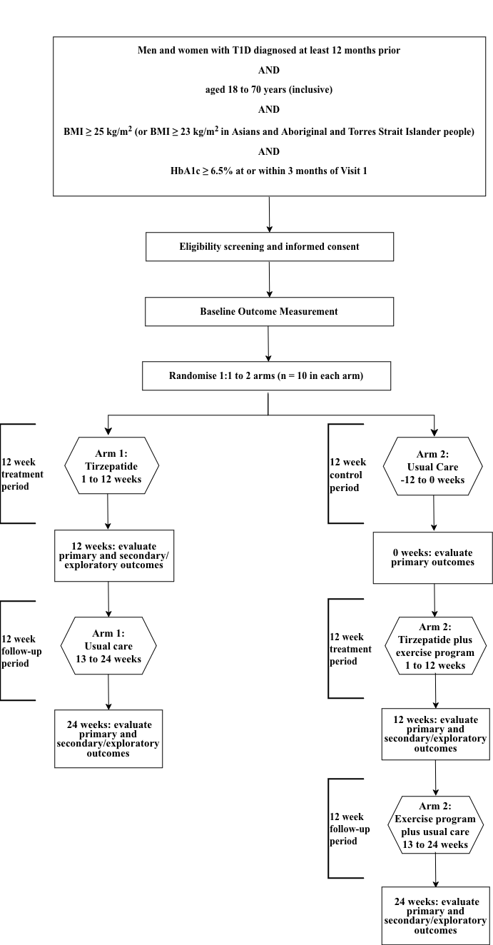
Figure 1. Study flowchart

References

1. Snaith JR, Frampton R, Samocha-Bonet D, Greenfield JR. Tirzepatide in Adults With Type 1 Diabetes: A Phase 2 Randomized Placebo-Controlled Clinical Trial. Diabetes Care. 2026 Jan 1;49(1):161–70.

