Wānanga/Talanoa/Dialogue or Workshop
Collective exploration of cascading risk - do archetypes of cascading risk exist?

Introduction
There is increasing evidence that climate change impacts and implications will propagate as cascades across physical and human systems moving across time and space compounding and combining to generate new impacts and risks or exacerbate existing risks (Lawrence et al 2020: Anderson et al 2024, Logan et al., 2023). Cascades arise from the interdependencies between elements within coupled natural and socio-economic systems.

Current risk assessment practices tend to focus on the direct effects of a single hazard, completely missing indirect risks and the chain of cause and effect hazard events (e.g., floods) or slow onset change (i.e., sea level rise) can trigger (Brunner et al., 2024; Thompson et al., 2024).
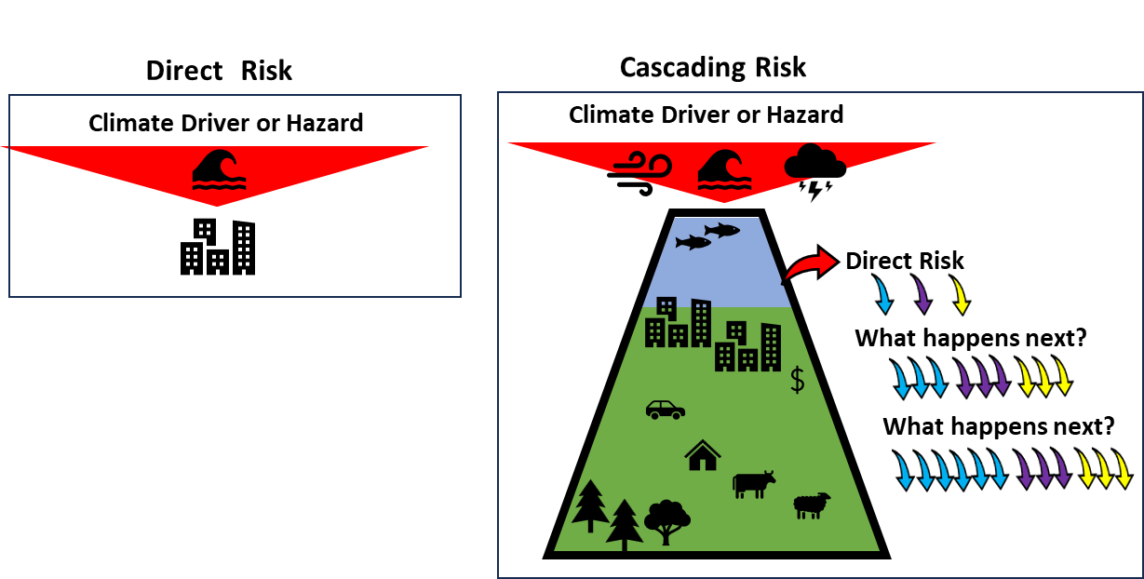

A failure to consider and account for cascading risks will lead to risk being underestimated, resulting in an inadequate adaptation response. The isolation risk from transportation network disruption (Anderson et al., 2022; Best el al., 2023), for example, significantly increases the expected burden from sea-level rise beyond what direct exposure assessments capture (Logan et al., 2023) and can exacerbate distributional injustices (Anderson et al., 2024).

Understanding describing and evaluating cascading risk is the next frontier in climate change risk assessments. However, at present we are working with highly descriptive case-by-case examples of risk cascades which, although grounded in place, can be paralyzingly complex. Based on research in Aotearoa-NZ, we have identified three archetypes of cascading risk that we hypothesise could be generally applicable and simple enough to apply in a range of settings and scales.

This co-creation session will introduce cascading risks, describe several known cascading risks archetypes, and test the hypothesis that archetypes can be identified and are useful to extend and support further enquiry at various spatial scales.

The purpose of the session is to bring together participants from different places, cultures, and disciplines to co-create and co-think through cascades based on their experience and contribute to the collective search for archetypes.

The format:
First, the authors will deliver a presentation to provide the context for the subsequent discussion by demonstrating the cascading risks archetypes identified in Aotearoa-NZ. We will explore the hypothesis that archetypes of cascading risk exist and are useful as a means to further explore the nuance of cascading risks describing our examples as a straw person.

Next, the participants will be placed in country or region-specific facilitated groups. Groups will be presented with a visual representation of hypothetical community to ground their discussion. The community can be modified to represent features that each group decides are important components of their places and culture.

Once any adjustments are complete, groups will be assigned a set of climate-related changes or hazards and provided with a series of questions:

Question 1: What are the cascading risks resulting from your assigned hazards?
Groups will complete a visual exercise, either a collective rich picture or mind map to interrogate the cascading risks. The questioning will begin with what are the direct impacts of the hazard, followed by what happens next, what happens next and so on until the line of inquiry is exhausted or creates a feedback loop.

Group feedback on cascades.

Question 2: Based on the feedback session are any common patterns or potential archetypes emerging?
Based on the feedback, can any archetypes can be identified and how they related to the ones presented earlier.

Feedback session whole group discussion.

We will conclude with a short discussion regarding the next steps and potential outcomes.

Outcomes:
- Exchange of ideas regarding the nature and type of cascades.
- Rich detail on risk cascades around the globe.
- Validate or modify the existing cascading risk archetypes and provide a starting point for researchers/practitioners to undertake their own cascading risk exploration.
- Identify opportunities to incorporate these archetypes into risk assessment and visualisation tools/approaches to improve the adaptation planning process.
Information will be collated, distributed with interested participants and used to underpin a discussion document on globally relevant cascading risk archetypes. Identification of internationally relevant archetypes of cascading risk will support the next evolution of climate change risk assessments to ensure we do not underestimate risk and adaptation needs.

Anderson, M. J., Conrow, L., Hobbs, M., Paulik, R., Blackett, P., & Logan, T. (2024). Distributional justice and climate risk assessment: An analysis of disparities within direct and indirect risk. Risk Analysis: An Official Publication of the Society for Risk Analysis. https://doi.org/10.1111/risa.17664
Anderson, M. J., Kiddle, D. A. F., & Logan, T. M. (2022). The underestimated role of the transportation network: Improving disaster & community resilience. Transportation Research Part D: Transport and Environment, 106(103218), 103218. https://doi.org/10.1016/j.trd.2022.103218
Brunner, L. G., Peer, R. A. M., Zorn, C., Paulik, R., & Logan, T. M. (2024). Understanding cascading risks through real-world interdependent urban infrastructure. Reliability Engineering & System Safety, 241(109653), 109653. https://doi.org/10.1016/j.ress.2023.109653
Logan, T. M., Anderson, M. J., & Reilly, A. C. (2023). Risk of isolation increases the expected burden from sea-level rise. Nature Climate Change, 1–6. https://doi.org/10.1038/s41558-023-01642-3
Thompson, D. A., Glenn, D. E., Trethewey, L. L., Blackett, P., & Logan, T. M. (2024). Capturing cascading consequences is required to reflect risk from climate change and natural hazards. Climate Risk Management, 100613. https://doi.org/10.1016/j.crm.2024.100613
Best, K., He, Q., Reilly, A. C., Niemeier, D. A., Anderson, M., & Logan, T. (2023). Demographics and risk of isolation due to sea level rise in the United States. Nature Communications, 14(1), 7904. https://doi.org/10.1038/s41467-023-43835-6
Lawrence, J., Blackett, P., & Cradock-Henry, N. A. (2020). Cascading climate change impacts and implications. Climate Risk Management, 29, 100234. https://doi.org/10.1016/j.crm.2020.100234

PARTICIPANTS

Participant 1
Full Name: Dr Paula Blackett
Organisation: Urban Intelligence
Bio: Paula is Research Director at Urban Intelligence with over 20 years of experience in climate risk and adaptation. She specialises in systems thinking and participatory methodologies. Paula has led climate risk assessments at various scales across Aotearoa-NZ, published seminal work on cascading risks, and is currently pioneering research on identifying and applying cascading risk archetypes to enhance adaptation planning.

Contribution: Paula will facilitate the workshop and lead the participants through the activities listed

Participant 2
Full Name: Dr Tom Logan
Organisation: Urban Intelligence/University of Canterbury
Bio: Tom is a Rutherford Discovery Fellow, Senior Lecturer Above the Barand CTO at Urban Intelligence. His research focuses on climate risk assessment and adaptation planning, with expertise in developing digital tools that support evidence-based decision-making. He leads a 3-year research project on cascading risks from climate change.
Contribution: Tom will co-present on ongoing cascading risk research, with Paula, and lead one of the discussion groups.

Participant 3
Full Name: Dr Mitch Anderson
Organisation: Urban Intelligence
Bio: Mitch is CEO at Urban Intelligence. He specialises in climate risk assessment methodologies and infrastructure resilience. Mitchell has led numerous projects with local governments and infrastructure providers to implement digital tools for adaptation planning across New Zealand.
Contribution: Mitch will facilitate a group discussion and lead the feedback session. He will connect theoretical risk archetypes to practical applications in infrastructure and community adaptation planning.

Additional Support: Each table will have a facilitator and note taker, they will comprise PhD students from the University of Canterbury

